T E N T E R D E N K E N T

Parish Priest: Fr Behruz Rafat Telephone 01580 762785 Mobile: 07903 986646
Address: The Presbytery, 47 Ashford Road, Tenterden, Kent TN30 6LL.
Parish E-mail behruzrafat@rcaos.org.uk Parish Website: www.standrewstenterden.org
Deacon: Rev. Jolyon Vickers Telephone: 01580 766449 Email: jolyonvickers@rcaos.org.uk Hire of Parish Hall: Lesley McCarthy 07791 949652 E-mail: bookings.standrews@talktalk.net
Newsletter Editor: Patricia Sargent 01233 850963 E-mail: sargentpat51@gmail.com

Newsletter for the week commencing 14th March 2021
Fourth Sunday of Lent – Laetare Sunday (B)

Entrance antiphon: Rejoice, Jerusalem, and all who love her. Be joyful, all who were in mourning; exult and be satisfied at her consoling breast.
First Reading: 2nd Chronicles 36: 14-16; 19-23
Psalm 136 Response: O let my tongue cleave to my mouth if I remember you not!
Second Reading: St Paul to the Ephesians 2: 4-10
Acclamation: Glory and praise to you, O Christ! God loved the world so much that he gave his only Son; everyone who believes in him has eternal life. Glory and praise to you, O Christ!
Gospel: John 3: 14-21

Father Behr writes:
Dear Parishioners

On Friday the 19 March we celebrate the Solemnity of St Joseph Husband of the Blessed Virgin Mary. We have Holy Mass at 10am. It is a great feast day for all Christians and especially husbands and fathers!

As you know Pope Francis dedicated this year to St Joseph and later on in the year we will have some special devotions at St Andrew’s.
There are many reasons why Pope Francis thought it was so important to have a Holy Year dedicated to Saint Joseph. I won’t try to summarise the letter as I think it is well worth reading. However this quotation is important:

I would like to share some personal reflections on this extraordinary figure, so close to our own human experience. For, as Jesus says, “out of the abundance of the heart the mouth speaks” (Mt 12:34). My desire to do so increased during these months of pandemic, when we experienced, amid the crisis, how “our lives are woven together and sustained by ordinary people, people often overlooked. People who do not appear in newspaper and magazine headlines, or on the latest television show, yet in these very days are surely shaping the decisive events of our history. Doctors, nurses, storekeepers and supermarket workers, cleaning personnel, caregivers, transport workers, men and women working to provide essential services and public safety, volunteers, priests, men and women religious, and so very many others. They understood that no one is saved alone… How many people daily exercise patience and offer hope, taking care to spread not panic, but shared responsibility. How many fathers, mothers, grandparents and teachers are showing our children, in small everyday ways, how to accept and deal with a crisis by adjusting their routines, looking ahead and encouraging the practice of prayer. How many are praying, making sacrifices and interceding for the good of all”.[6] Each of us can discover in Joseph – the man who goes unnoticed, a daily, discreet and hidden presence – an intercessor, a support and a guide in times of trouble. Saint Joseph reminds us that those who appear hidden or in the shadows can play an incomparable role in the history of salvation. A word of recognition and of gratitude is due to them all.

This Apostolic letter from the Holy Father, Patris Corde, is very worthwhile and makes for good spiritual reading for Lent.

http://www.vatican.va/content/francesco/en/apost_letters/documents/papa-francesco-lettera-ap_20201208_patris-corde.html

Fr Behr
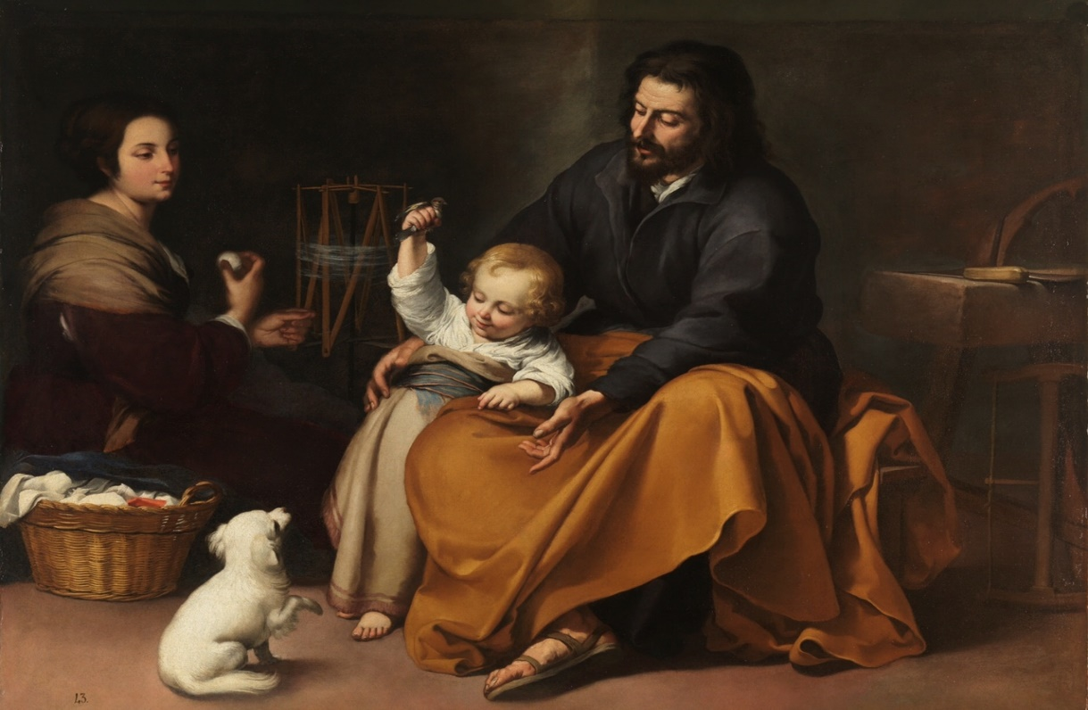
Holy Family with bird, c. 1650, by Bartolomé Esteban Murillo

Hail, Guardian of the Redeemer,
Spouse of the Blessed Virgin Mary.
To you God entrusted his only Son;
in you Mary placed her trust;
with you Christ became man.

Blessed Joseph, to us too,
show yourself a father
and guide us in the path of life.
Obtain for us grace, mercy and courage,
and defend us from every evil. Amen.

We have received our instructions from Archbishop John for Holy Week.
Chrism Mass
This year only clergy can attend due to social distancing measures. We will let you know the link for the livestream as soon as it becomes available.

Maundy Thursday Mass of the Lord’s Supper at 8pm
No reception of oils
No washing of feet
No Altar of Repose
No Watching

Good Friday service at 3pm
No individual veneration of the Cross

Easter Vigil
No votive candles
No sprinkling of water after renewal of Baptismal promises

Easter Sunday
As per the Vigil
No congregational singing is allowed at any Mass for the time being.
Your Prayers are asked for:
Those recently deceased:
Those ill or infirm: David Green, Charlotte Elliot (daughter of Maureen Davidson), Jennifer Jorden, Joe Adams, Ellie Lawrence, Anne Bryant, Patricia Hook, Elena Peck (senior), Marjorie Dumbleton, Josie Payne, Pat Holland and all those self-isolating or suffering from COVID-19.
Those whose anniversaries of death occur at this time: Mary Hastings, John Bryant, John-Paul Beirne, William Roche, Daniel Nesbitt, Thomas Blair, Geraldine Keating, Phyllis Broughton, Eileen Thompson, Julia Shipton and Canon Hopetown Currie

This week’s services (14th - 20th March 2021), Feasts and Mass intentions during the week.

Sunday 14th March  10 am Mass  12 midday EF Mass (Latin) | Fourth Sunday of Lent (B)  Laetare Sunday  People of the parish | Thursday 18th March  10 am Mass | Feria
Monday 15th March  10 am Mass | Feria | Friday 19th March  10 am Mass | ST JOSEPH Spouse of the Blessed Virgin Mary  Canon Hopetown Currie (Foundation Mass)
Tuesday 16th March  10 am Mass | Feria | Saturday 20th March  10 am Mass | Feria  Ron Basher RIP
Wednesday 17th March  10 am Service of the Word and Holy Communion | St Patrick, Bishop, Patron of Ireland | Sunday 21st March  10 am Mass  12 midday EF Mass (Latin) | Fifth Sunday of Lent (B)  (Deacon Jolyon to preach)
No flowers in Lent

White Flower Appeal
This Sunday (14 March) we have the SPUC White Flower Appeal at the 10am Mass.
As you know SPUC have been involved in protecting the lives of unborn children for many years. There will be an opportunity to contribute to the work of SPUC through a retiring collection.

Minutes of the Finance Committee Meeting (26th January 2021)
The Minutes for this meeting can be found on the Parish website for you to have a look at and see how our finances are doing.
The next Finance meeting will be held on 12th April 2021

And last but not least…Happy Mothers’ Day to all mums!

