T E N T E R D E N K E N T

Parish Priest: Fr Behruz Rafat Telephone 01580 762785 Mobile: 07903 986646
Address: The Presbytery, 47 Ashford Road, Tenterden, Kent TN30 6LL.
Parish E-mail behruzrafat@rcaos.org.uk Parish Website: www.standrewstenterden.org
Deacon: Rev. Jolyon Vickers Telephone: 01580 766449 Email: jolyonvickers@rcaos.org.uk Hire of Parish Hall: Lesley McCarthy 07791 949652 E-mail: bookings.standrews@talktalk.net
Newsletter Editor: Patricia Sargent 01233 850963 E-mail: sargentpat51@gmail.com

Newsletter for the week commencing 14th March 2021
Fifth Sunday of Lent (B)

Entrance antiphon: Give me justice, O God, and plead my cause against a nation that is faithless. From the deceitful and cunning rescue, me, for you, O God, are my strength.
First Reading: Jeremiah 31: 31-34
Psalm 50 Response: A pure heart create for me, O God.
Second Reading: Hebrews 5: 7-9
Acclamation: Glory to you, O Christ, you are the Word of God! If a man serves me, says the Lord, he must follow me, wherever I am, my servant will be there too. Glory to you, O Christ, you are the Word of God!
Gospel: John 12: 20-33
Communion antiphon: Has no-one condemned you, woman? No one, Lord. Neither shall I condemn you. From now on, sin no more.

Father Behr writes:
Dear Parishioners

On March 25 the Solemnity of the Annunciation the church celebrates the great mystery of the Incarnation.

O God, who willed that your Word
should take on the reality of human flesh
in the womb of the Virgin Mary,
grant, we pray,
that we, who confess our Redeemer to be God and man,
may merit to become partakers even in his divine nature.
Who lives and reigns with you in the unity of the Holy Spirit,
one God, for ever and ever.

The Dominican Blessed Fra Angelico (1395-1455) has left us with some of the most sublime paintings on the theme of the life of Christ including the Annunciation. The paintings were produced, not primarily for decoration, but as an aid to meditation.

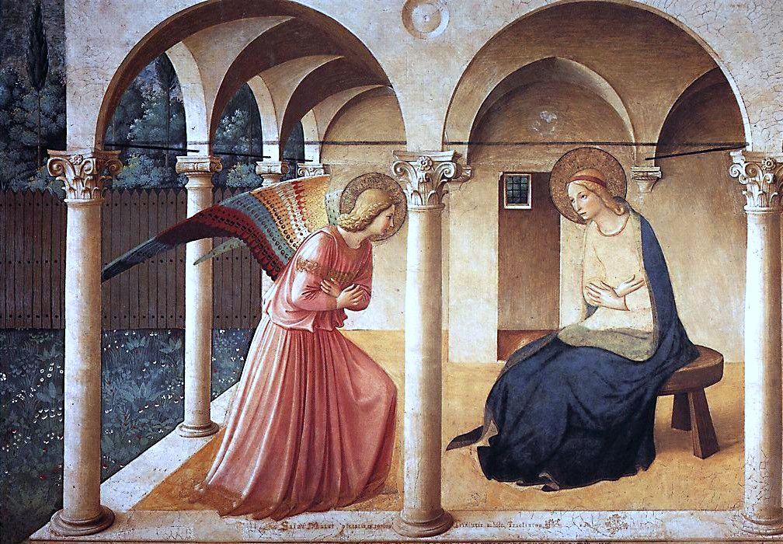

For more on the Florentine master see
http://www.all-art.org/early_renaissance/fra_angelico1.html

Fr Behr

Your Prayers are asked for:
Those recently deceased:
Those ill or infirm: David Green, Charlotte Elliot (daughter of Maureen Davidson), Jennifer Jorden, Joe Adams, Ellie Lawrence, Anne Bryant, Patricia Hook, Elena Peck (senior), Marjorie Dumbleton, Josie Payne, Pat Holland and all those self-isolating or suffering from COVID-19.
Those whose anniversaries of death occur at this time: Gertrude Julia Barclay, George Hyland, Peter Webbe-Wood, Elizabeth Trevor and Ann Clark.

This week’s services (21st – 27th March 2021), Feasts and Mass intentions during the week.

Sunday 21st March  10 am Mass  12 midday EF Mass (Latin) | Fifth Sunday of Lent (B)  People of the parish  (Deacon Jolyon to preach) | Thursday 25th March  10 am Mass | THE ANNUNCIATION OF THE LORD  Well-being of Fr Michael Woodgate
Monday 22nd March  10 am Mass | Feria  Well-being of Fr Anthony White | Friday 26th March  10 am Mass | Feria  Dennis Picknett RIP
Tuesday 23rd March  10 am Mass | Feria  Gertrude Barclay: Foundation Mass: “Foundress of St Andrews” | Saturday 27th March  10 am Mass | Feria
Wednesday 24th March | Private Requiem Mass  for David Lloyd-Thomas  followed by burial | Sunday 28th March  10 am Mass | Sixth Sunday of Lent (B)  PALM SUNDAY OF THE PASSION OF THE LORD
No flowers in Lent

Easter Flowers and Social Distancing
Although Covid restrictions are gradually easing we are still being asked to follow the guidelines regarding social distancing. So, to minimise the amount of time the flower arrangers would be in the church and to limit their numbers, we are asking again for help with the flower arrangements to make our church look beautiful for Easter. Fr Behr was very impressed at Christmas!

The arrangements/vases will be for the window ledges that are not above the radiators and the colour scheme is gold/yellow/white, with greenery. They can be a bunch in a vase or an arrangement and should be brought to the church either after the Good Friday service or on Holy Saturday when Frances will be in church between 10 and 12.

Any questions please contact Frances (01233 732657 f.lawrence999@btinternet.com

The Parish Council Meeting scheduled for Thursday 25th March has been postponed until sometime in Eastertida, date to be advised.

We have received our instructions from Archbishop John for Holy Week.
Chrism Mass
This year only clergy can attend due to social distancing measures. We will let you know the link for the livestream as soon as it becomes available.

Maundy Thursday Mass of the Lord’s Supper at 8pm
No reception of oils
No washing of feet
No Altar of Repose
No Watching

Good Friday service at 3pm
No individual veneration of the Cross

Easter Vigil
No votive candles
No sprinkling of water after renewal of Baptismal promises
Easter Sunday
As per the Vigil
No congregational singing is allowed at any Mass for the time being.

