**Parish Priest:** Fr Behruz Rafat **Telephone** 01580 762785 **Mobile**: 07903 986646

**Address:** The Presbytery, 47 Ashford Road, Tenterden, Kent TN30 6LL.

**Parish E-mail** behruzrafat@rcaos.org.uk **Parish Website:** www.standrewstenterden.org

**Deacon:** Rev. Jolyon Vickers **Telephone:** 01580 766449 **Email:** jolyonvickers@rcaos.org.uk **Hire of Parish Hall:** Lesley McCarthy 07791 949652 **E-mail:** bookings.standrews@talktalk.net

**Newsletter Editor:** Patricia Sargent 01233 850963 **E-mail:** sargentpat51@gmail.com

**Newsletter for the weeks commencing 11th – 17th April 2021**

**Second Sunday of Easter (B)**

**Divine Mercy**

**Entrance antiphon: Like new-born infants, you must long for the pure, spiritual milk, that in him you may grow to salvation. Alleluia.**

**First Reading: Acts of the Apostles 4: 32-35**

**Psalm 117 Response: Give thanks to the Lord for he is good, for his love has no end,**

**Second Reading: First letter of St John 5: 1-6**

**Acclamation: Alleluia, alleluia! Jesus said: “You believe because you can see me. Happy are those who have not seen and yet believe.” Alleluia!**

**Gospel: John 20:19-31**

**Communion antiphon: Bring your hand and feel the place of the nails, and do not be unbelieving but believing, alleluia.**

**Father Behr writes:**

**Dear Parishioners**

This Sunday is Divine Mercy Sunday. God truly works in marvellous ways. Through the faithful witness of St. Faustina Kowalska  (d 1938) Our Lord has given us a powerful devotion that has quickly spread through the whole world.



St Faustina

There are many great and wonderful prayers and promises associated with the devotion. I would recommend that everyone should have an image of the Divine Mercy in their home.  Here is the promise Our Lord made regarding the image.

“I promise that the soul that will venerate this image (of Divine Mercy) will not perish. I also promise victory over (its) enemies already here on earth, especially at the hour of death. I Myself will defend it as My own glory.”

(Diary of St. Faustina, 48)

The church will be open from 2.50pm on Sunday for those who would like to pray the Chaplet of Divine Mercy at 3pm and spend some time in Eucharistic Adoration.

For a summary of other promises see this article.

https://www.churchpop.com/2020/11/27/14-amazing-promises-jesus-made-to-those-who-pray-the-divine-mercy-chaplet/

Best wishes

Father Behr

**Your Prayers are asked for:**

**Those recently deceased:**

**Those ill or infirm:** Father Michael Woodgate, David Green, Charlotte Elliot (daughter of Maureen Davidson), Jennifer Jorden, Joe Adams, Ellie Lawrence, Anne Bryant, Patricia Hook, Elena Peck (senior), Marjorie Dumbleton, Josie Payne, Pat Holland and all those self-isolating or suffering from COVID-19.

**Those whose anniversaries of death occur at this time:** Ethel Klemen, Edgar Beard, Florence Amor, Eric Beresford, Mary Goulding, Frederick Collison, Eric Booth, Elizabeth Booth, Susanna Davis, John Keane, Catherine Beard, Gerald Salmon, Elizabeth Armstrong, Vera Wade (Hilda) and Ellen Marren.

|  |  |  |  |
| --- | --- | --- | --- |
| **This week’s services (11th – 17th April 2021), Feasts and Mass intentions during the week.** | | | |
| **Sunday 11th April**  10 am Mass  12 Midday Traditional Latin Mass | **Second Sunday of Easter**  **(or of Divine Mercy)**  *People of the parish* | **Thursday 15th April**  10 am Mass | Feria  *Boddington Family* |
| **Monday 12th April**  10 am Mass | Feria  *Father John Hagreen RIP* | **Friday 16th April**  10 am Service | Feria |
| T**uesday 13th April**  10 am Mass | St Martin, Pope and Martyr  *Hilda Bache, wellbeing* | **Saturday 17th April**  10 am Mass  6 pm Vigil Mass | Feria  *Ellen Marren RIP (6th anniversary)* |
| **Wednesday 14th April**  10 am Service of the Word and Holy Communion | Feria | **Sunday 18th April**  10 am Mass  12 midday Traditional Latin Mass | **Third Sunday of Easter** |
| **Flowers: General tweaking of the Easter arrangements** | | | |

There is a **second collection** this weekend for the **Maintenance of St George’s Cathedral.**

**Please see the attached sheet with a message from Deacon Jolyon**

**And finally…**

From this Saturday onwards the 6pm Evening Mass is back. Please contact Fr Behr directly if you would like to come or turn up and fill in one of the tracking forms.

The doors will be open at 5.45pm. In order to comply with all our current requirements, the windows in the church will be kept open throughout the duration of Mass.

Dear Parishioners.

You may be interested in joining this event organised by our Diocesan Unity Commission, of which I am a member.

Kindest regards, Jolyon

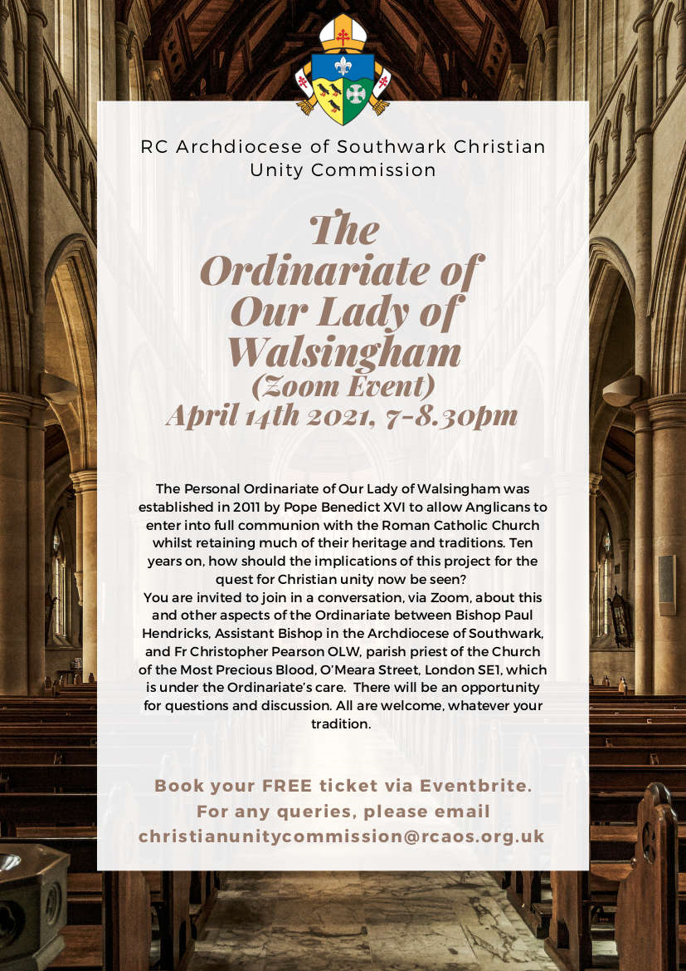

Zoom event about the Ordinariate of Our Lady of Walsingham Tickets, Wed, Apr 14, 2021 at 7:00 PM | Eventbrite

**You might find the Eventbrite website useful for finding other events, which you might enjoy.**