Parish Priest: Fr Behruz Rafat Telephone 01580 762785 Mobile: 07903 986646
Address: The Presbytery, 47 Ashford Road, Tenterden, Kent TN30 6LL.
Parish E-mail behruzrafat@rcaos.org.uk Parish Website: www.standrewstenterden.org
Deacon: Rev. Jolyon Vickers Telephone: 01580 766449 Email: jolyonvickers@rcaos.org.uk Hire of Parish Hall: Lesley McCarthy 07791 949652 E-mail: bookings.standrews@talktalk.net
Newsletter Editor: Patricia Sargent 01233 850963 E-mail: sargentpat51@gmail.com

Newsletter for the week commencing 18th – 24th April 2021
Third Sunday of Easter (B)
Entrance antiphon: Cry out with joy to God, all the earth; O sing to the glory of his name.
O render him glorious praise, alleluia’
First Reading: Acts of the Apostles 3: 13-15, 17-19
Psalm 4 Response: Lift up the light of your face on us, O Lord.
Second Reading: First letter of St John 2: 1-5
Acclamation: Alleluia, alleluia! Lord Jesus, explain the scriptures to us. Make our hearts burn within us as you talk to us. Alleluia!
Gospel: Luke 24: 35-48
Communion antiphon: The Christ had to suffer and on third day rise from the dead; in his name repentance and remission of sins must be preached to all the nations, alleluia.

Father Behr writes:
Dear Parishioners
On Friday 23 April we celebrate the Solemnity of St George, Martyr. Although we do not know much about the life of St George, we do know that he was martyred during the persecution of Diocletian around 303AD.

There are many legends surrounding the life of Saint George most famously his slaying of a dragon. These legends seem to emerge around 11th century. I’m sure that the prayers of St George will be a great help during these challenging times. Perhaps there are ‘dragons’ in our own time which we can ask St George to slay.

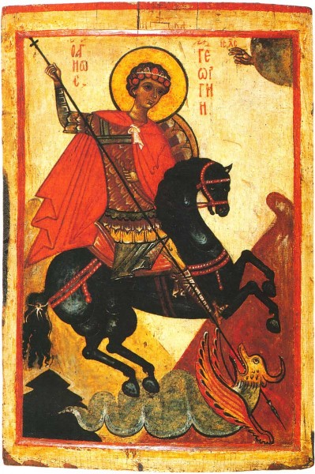
Russian Icon Novgorod 14 century.

There are many ways to mark this special day. We have Holy Mass at 10am.
Because it is a Solemnity here in England we don’t have to abstain from meat as we normally would on a Friday. Perhaps devoting an extra time of family prayer for England at this time would be worthwhile. Whatever we decide it is good to keep this feast day and make it special.

The collect from the Solemnity.
Extolling your might, O Lord,
we humbly implore you,
that, as Saint George imitated the Passion of the Lord,
so, he may lend us ready help in our weakness.
Through our Lord Jesus Christ, your Son,
who lives and reigns with you in the unity of the Holy Spirit,
God, for ever and ever.

Fr Behr

Your Prayers are asked for:
Those recently deceased:
Those ill or infirm: David Green, Charlotte Elliot (daughter of Maureen Davidson), Jennifer Jorden, Joe Adams, Ellie Lawrence, Anne Bryant, Patricia Hook, Elena Peck (senior), Marjorie Dumbleton, Josie Payne, Pat Holland and all those self-isolating or suffering from COVID-19.
Those whose anniversaries of death occur at this time: Joan Carey, Bozena Cloutier Wonska (Chris Lacki’s sister), Nellie Southcott, Elsie Browne, Deborah Burke, Bernard Grayner, John Stanley, Jack Holman, Eileen Rimmer and Margaret Toke-Nicholls.

This week’s services (18th – 24th April 2021), Feasts and Mass intentions during the week.

Saturday 17th April  10 am Mass  6 pm Vigil Mass | Ellen Marren RIP  Fr Christopher Sexton RIP | Thursday 22nd April  10 am Mass | Feria
Sunday 18th April  10 am Mass  12 Midday Traditional Latin Mass | Third Sunday of Easter  People of the parish | Friday 23rd April  10 am Service | ST GEORGE, Martyr & Patron of England  Mark Boddington Intention
Monday 19th April  10 am Mass | St Alphege, Bishop & Martyr  Foundation Mass for Joan Carey (until 2026) | Saturday 24th April  10 am Mass  6 pm Vigil Mass | St Adalbert, Bishop & Martyr  Fr Douglas Perkins RIP
Tuesday 20th April  10 am Mass | Feria  Maria Milton Special Intentions | Sunday 25th April  10 am Mass  12 midday Sung Traditional Latin Mass | Fourth Sunday of Easter
Wednesday 21st April  10 am Service of the Word and Holy Communion | St Anselm, Bishop & Doctor of the Church
Flowers: For 18th April: Suzanne. For St George’s Day & 25th April: Breeda

There is a second collection this weekend for Ecclesiastical Education.

I know it was a long while ago but…
Would those people who took Christmas cards on a pay-later basis please be ready to finally pay for them!
These are the outstanding amounts: Rachel Heinrichsmeier £7.00; Anne Taylor £10.50; Sheila Allen £3.50; Pat Sargent £21.50. Nuala will be at 6 pm Mass on Saturdays from now on and will wait in the porch after Mass for a while. Thank you!

Easter flowers!
A big thank you to all those who brought vases, flowers and arrangements to make our church look beautiful for the Easter celebrations. Your containers/vases have been emptied and are waiting for you to collect in the wet Sacristry.

