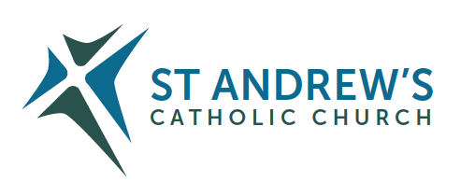
Parish Priest: Fr Behruz Rafat Telephone 01580 762785 Mobile: 07903 986646
Address: The Presbytery, 47 Ashford Road, Tenterden, Kent TN30 6LL.
Parish E-mail behruzrafat@rcaos.org.uk Parish Website: www.standrewstenterden.org
Deacon: Rev. Jolyon Vickers Telephone: 01580 766449 Email: jolyonvickers@rcaos.org.uk Hire of Parish Hall: Lesley McCarthy 07791 949652 E-mail: bookings.standrews@talktalk.net
Newsletter Editor: Patricia Sargent 01233 850963 E-mail: sargentpat51@gmail.com

Newsletter for the week commencing 1st – 8th May 2021
Fifth Sunday of Easter (B)
Entrance antiphon: O sing a new song to the Lord, for he has worked wonders; in the sight of the nations, he has shown his deliverance, alleluia.
First Reading: Acts of the Apostles 9: 26-31
Psalm 21 Response: You, Lord, are my praise in the great assembly.
Second Reading: First letter of St John 3: 18-24
Acclamation: Alleluia, alleluia! Make your home in me, as I make mine in you. Whoever remains in me bears fruit in plenty. Alleluia!
Gospel: John 15: 1-8
Communion antiphon: I am the true vine and you are the branches, says the Lord. Whoever remains in me, and I in him, bears fruit in plenty, alleluia.

Father Behr writes:
Dear Parishioners
On Tuesday we celebrate the Feast of the English Martyrs.
We all have our favourites. Who would you like to meet and what would you say to them?
St John Southworth, St Margaret Clitherow and St Edmund Campion are three of my favourites.
So many great men and women who gave their lives for Christ and for the truth of the Catholic faith, spanning a fascinating period in our nation’s history from 1535-1679.

Below you’ll find a link to a YouTube podcast by Fr Timothy Finigan and an article with a brief summary of the story of the English Martyrs.

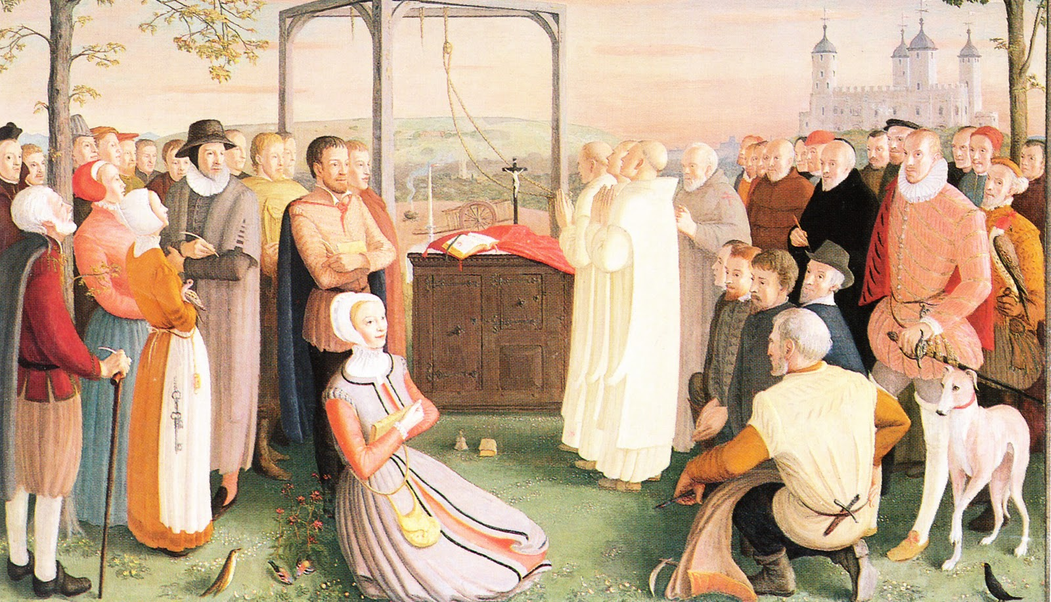

Painting by Daphne Pollen (1904-86) commissioned for the 1970 canonization of the
forty martyrs of England Wales.

https://youtube.com/watch?v=-IbxCF1yjVE&feature=share

Brief summary.

http://www.dioceseofshrewsbury.org/weekly_digests/the-english-martyrs-4th-may-2

Best Wishes,
Father Behr

Your Prayers are asked for:
Those recently deceased:
Those ill or infirm: David Green, Charlotte Elliot (daughter of Maureen Davidson), Jennifer Jorden, Joe Adams, Ellie Lawrence, Anne Bryant, Patricia Hook, Elena Peck (senior), Marjorie Dumbleton, Josie Payne, Pat Holland and all those self-isolating or suffering from COVID-19.
Those whose anniversaries of death occur at this time: Inez Wood, Alonzo Nugent, Fr John Hagreen, Ninette Purcell, John Moriarty, Sue Maxwell-Scott, Claire Claydon, Nigel Collins, Dr Mary Hoogewers, Ninette Newling and Winifred Price.

This week’s services (1st - 8th May 2021), Feasts and Mass intentions during the week.

Saturday 1st May  10 am Mass  6 pm Vigil Mass | St Joseph the Worker  Day of prayer for God’s blessing on human work.  The Holy Father Pope Francis  Fr John O’Callaghan RIP | Thursday 6th May  10 am Mass | Feria  For priests
Sunday 2nd May  10 am Mass  12 Midday Traditional Latin Mass | Fifth Sunday of Easter  People of the parish | Friday 7th May  10 am Mass | Feria
Monday 3rd May  10 am Mass | Sts Phillip & James, Apostles  Boddington Intention | Saturday 8th May  10 am Mass  6 pm Vigil Mass | Feria  Msgr Barry Wymes RIP
Tuesday 4th May  10 am Mass | The English Martyrs  Fr Michael Woodgate, Wellbeing | Sunday 9th May  10 am Mass  12 midday Sung Traditional Latin Mass | Sixth Sunday of Easter
Wednesday 5th May  10 am Service of the Word and Holy Communion | Feria
Flowers: For 9th May – Kathy

There will be a second collection next weekend for World Communications Day which supports the work of the Catholic Communications Network (CNN), the media office of the Bishops’ Conference of England and Wales.

The CNN seeks to be of service both to the World in offering professional channels of communication, and provides support for the Bishops of England and Wales and the wider Church in promoting the Gospel through the media on current issues.
Its office is the focus for media enquiries on national matters, and seeks to develop the public profile of the Church and its teaching.
The CNN provides up-to-date news releases, features and podcasts, information from the Bishops’ Conference of England and Wales, and trains spokesmen and women.

If you are the parent or guardian of a child who is seven years old or more who has not made their first Holy Communion and you would like them to do so, would you please let Fr Behr know. We are hoping to start the preparation for the sacraments of Reconciliation and Holy Communion in June.

A message from Deacon Jolyon…
Ascension Day this year falls on Thursday May 13th.
In keeping with our published information in the Diocesan Directory etc, there will be Masses at
10am and 7:30pm (please note the morning service is on the hour and the evening service on the half hour).
The 10am service will be a BOOKABLE event
As the 7:30pm service has not traditionally had a big attendance, there will be no need to book for this service.
Please let Deacon Jolyon know as soon as possible if you would like to attend.

