**Parish Priest:** Fr Behruz Rafat **Telephone** 01580 762785 Mobile: 07903 986646

**Address:** The Presbytery, 47 Ashford Road, Tenterden, Kent TN30 6LL.

**Parish E-mail** behruzrafat@rcaos.org.uk **Parish Website:** www.standrewstenterden.org

**Deacon:** Rev. Jolyon Vickers **Telephone:** 01580 766449 **Email:** jolyonvickers@rcaos.org.uk **Hire of Parish Hall:** Lesley McCarthy 07791 949652 **E-mail:** bookings.standrews@talktalk.net

**Newsletter Editor:** Patricia Sargent 01233 850963 **E-mail:** sargentpat51@gmail.com

**Newsletter for the week commencing 8th – 15th May 2021**

**Sixth Sunday of Easter (B)**

**Entrance antiphon: Proclaim a joyful sound and let it be heard; proclaim to the ends of the earth: The Lord has freed his people, alleluia.**

**First Reading: Acts of the Apostles 10: 25-26, 34-35, 44-48**

**Psalm 97 Response: The Lord has shown his salvation to the nations.**

**Second Reading: First letter of St John 4: 7-10**

**Acclamation: Jesus said: “If anyone loves me, he will keep my word, and my Father will love him, and we shall come to him.” Alleluia!**

**Gospel: John 15: 9-17**

**Communion antiphon: If you love me, keep my commandments, says the Lord, and I will ask the Father and he will send you another Paraclete, to abide with you forever, alleluia.**

**Father Behr writes:**

Dear Parishioners ,

On Thursday we celebrate the Solemnity of the Ascension of the Lord.

We have Holy Mass at 10am and 7.30pm.

There is also a Traditional Sung Latin Mass at 12pm.

At this time the Ascension is not a holy day of obligation due to the complications caused by the pandemic.

However, the church is a very safe place and this is a great time to come back to Mass.

If you want to come to the 10am and you haven’t booked just email Deacon Jolyon.

If you want to come to the Traditional Latin Mass at 12pm or the 7.30pm Mass, you don’t need to book.

O God, whose Son today ascended to the heavens

as the Apostles looked on,

grant, we pray, that, in accordance with his promise,

we may be worthy for him to live with us always on earth,

and we with him in heaven.

Who lives and reigns with you in the unity of the Holy Spirit,

one God, for ever and ever. Amen.

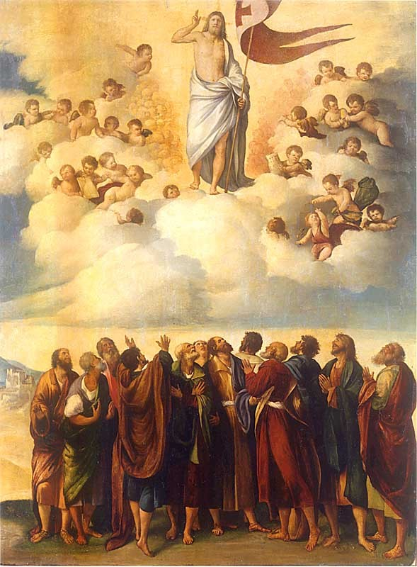

*The Ascension*, Dosso Dossi, 16th century.

**Recent Expenses**

We recently updated our intruder alarm system through Chubb.  The cost was £820

This will mean that we can safely leave our parish church open during the day.

The exact times will be discussed at our next parish council meeting.

**Scam Alert**

Someone is cloning my email address and writing to parishioners.

An email from me will always have rcaos.org.uk.

That is our official diocesan address.

If it doesn’t end with that, please don’t open the email or click on any links as it is not from me.

Best wishes

Father Behruz Rafat

**Your Prayers are asked for:**

**Those recently deceased:**

**Those ill or infirm:** David Green, Charlotte Elliot (daughter of Maureen Davidson), Jennifer Jorden, Joe Adams, Ellie Lawrence, Anne Bryant, Patricia Hook, Elena Peck (senior), Marjorie Dumbleton, Josie Payne, Pat Holland and all those self-isolating or suffering from COVID-19.

**Those whose anniversaries of death occur at this time:** Alfred Kettle, Richard Brennan, Jim Newman, John Smith, Sarah Norris, Eleanore Lynes, Jane Goodman, Sophie Larson and Adrian Wyles.

|  |  |  |  |
| --- | --- | --- | --- |
| **This week’s services (8th – 16th May 2021), Feasts and Mass intentions during the week.** | | | |
| **Saturday 8th May**  10 am Mass  6 pm Vigil Mass | Feria | **Thursday 13th May**  10 am Mass  7.30 pm Mass | **THE ASCENSION OF THE LORD**  *Pro populo*  *Fr Timothy St Clair RIP* |
| **Sunday 9th May**  10 am Mass  12 Midday Sung Traditional Latin Mass | **Sixth Sunday of Easter**  *People of the parish* | **Friday 14th May**  10 am Mass | St Matthias, Apostle  *Lily McChisrey & family, Wellbeing* |
| **Monday 10th May**  10 am Mass | Feria *Pat & Maureen Lynch, Wellbeing* | **Saturday 15th May**  10 am Mass  6 pm Vigil Mass | Feria  *Betty & Jo Robertson, Wellbeing*  *Fr Michael Faben RIP* |
| T**uesday 11th May**  10 am Mass | Feria  *Franco Cleere & family, Wellbeing* | **Sunday 16th May**  10 am Mass  12 midday Sung Traditional Latin Mass | **Seventh Sunday of Easter**  *People of the parish*  **World Communications Day** |
| **Wednesday 12th May**  10 am Service of the Word and Holy Communion | Sts Nereus & Achilleus, Martyrs |  |  |
| **Flowers: For 13th (Ascension)/16th May – Francien** | | | |

There is a **second collection today** for World Communications Day.

**Last call** for a place in church for the **10am Ascension Day Mass** on Thursday 13th May…

If you would like to attend this Mass, please **contact Deacon Jolyon** as soon as possible.

If you have been allocated a place and cannot attend, please let him know so that he can give the space to someone else. His contact details are at the top of the newsletter.

There is no need to book for the 7.30 pm Mass.

And finally, a couple of puns to make you chuckle – or groan!

I stayed up all night to see where the sun went. Then it dawned on me.

What’s the difference between a poorly dressed man on a bicycle and a nicely dressed man on a tricycle? A tire.