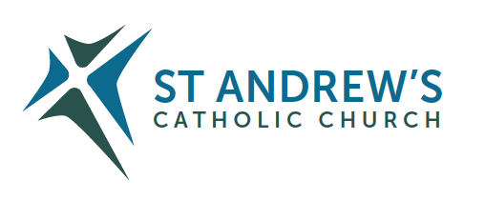
Parish Priest: Fr Behruz Rafat Telephone 01580 762785 Mobile: 07903 986646
Address: The Presbytery, 47 Ashford Road, Tenterden, Kent TN30 6LL.
Parish E-mail behruzrafat@rcaos.org.uk Parish Website: www.standrewstenterden.org
Deacon: Rev. Jolyon Vickers Telephone: 01580 766449 Email: jolyonvickers@rcaos.org.uk Hire of Parish Hall: Lesley McCarthy 07791 949652 E-mail: bookings.standrews@talktalk.net
Newsletter Editor: Patricia Sargent 01233 850963 E-mail: sargentpat51@gmail.com

Newsletter for the week commencing 23^{rd -} 29th May 2021
Pentecost Sunday (B)
Entrance antiphon: The Spirit of the Lord has filled the whole world and that which contains all things understands what is said, alleluia.
First Reading: Acts of the Apostles 2: 1-11
Psalm 103 Response: Send forth your spirit, O Lord, and renew the face of the earth.
Second Reading: First letter of St Paul to the Corinthians 12: 3-7. 12-13
SEQUENCE
Acclamation: Alleluia, alleluia! Come Holy Spirit, fill the hearts of your faithful, and kindle in them the fire of you love. Alleluia!
Gospel: John 20: 19-23
Communion antiphon: They were all filled with the Holy Spirit and spoke of the marvels of God, alleluia.

Father Behr writes:
Dear Parishioners
This weekend we celebrate the Solemnity of Pentecost. There are many wonderful prayers to God the Holy Spirit. This one is very powerful:

Breathe into me, Holy Spirit, that my thoughts may all be holy. Move in me, Holy Spirit, that my work, too, may be holy. Attract my heart, Holy Spirit, that I may love only what is holy. Strengthen me, Holy Spirit, that I may defend all that is holy. Protect me, Holy Spirit, that I may always be holy. Saint Augustine

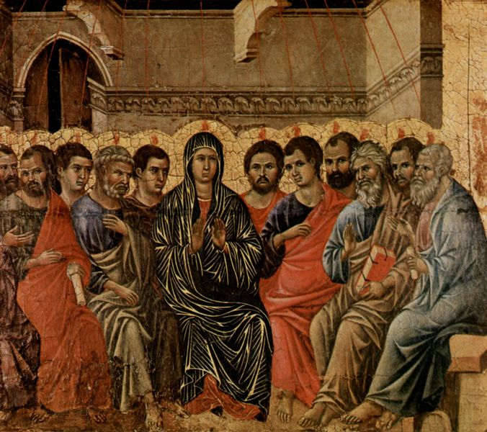

Pentecost. Duccio di Buoninsegna (1308)

Thank you to all those who have taken the time to vote on our statue of Our Lady. There is still time to vote so please get in touch by email or let me know in person.

Mother’s Prayers
From Tuesday 1 June Mother’s Prayers will be meeting in the parish room at 2.30pm. All mums and grannies are welcome. If you would like to find out more, please contact Anne Taylor on 01233 850235.
Mothers Prayers was formed to help those mothers who wished to pray together for their children and grandchildren and to find the support they needed. More info http://www.mothersprayers.org/index.php/en/

Traditional Latin Mass
There is one at St Andrew every Sunday at 12pm. On certain days there is also a polyphony choir.
These are the dates for the Sung Traditional Latin Mass at Tenterden with a polyphony choir: -
30 May / 3 June / 13 June / 27 June / 11 July / 25 July

Best wishes
Father Behruz Rafat

Your Prayers are asked for:

Those recently deceased: Marjorie Dumbleton RIP. Please pray for the repose of ther soul and for the comfort of her family.
Those ill or infirm: David Green, Charlotte Elliot (daughter of Maureen Davidson), Jennifer Jorden, Joe Adams, Ellie Lawrence, Anne Bryant, Patricia Hook, Elena Peck (senior), Josie Payne, Pat Holland and all those self-isolating or suffering from COVID-19.
Those whose anniversaries of death occur at this time: Graham Cunliffe, Katherine Hyland, Elvira Lyndon, Arthur Hesmer, John Browne, Lawrence Appleton and Clare Kirschen
This week’s services (22ND – 29th May 2021), Feasts and Mass intentions during the week.

Saturday 22nd May  10 am Mass  6 pm Vigil Mass | Fr David White RIP  People of the Parish | Thursday 27th May  10 am Mass | Our Lord Jesus Christ, Eternal High Priest  1987 Consecration of St Andrews by Bishop John Jukes
Sunday 23rd May  10 am Mass  12 Midday Sung Traditional Latin Mass | PENTECOST SUNDAY  Rosemary Hale RIP  CaTEW | Friday 28th May  10 am Mass | Feria  Holy Souls
Monday 24th May  10 am Mass | Mary, Mother of the Church  Marjorie Dumbleton RIP | Saturday 29th May  10 am Mass  6 pm Vigil Mass | St Paul VI, Pope  Fr Michael Downey RIP
Tuesday 25th May  10 am Mass | St Bede the Venerable, Priest & Doctor of the Church  Private intention | Sunday 30th May  10 am Mass  12 midday Sung Traditional Latin Mass | THE MOST HOLY TRINITY  People of the Parish
Wednesday 26th May  10 am Service of the Word and Holy Communion | St Philip Neri, Priest
Flowers: For 30th May - Suzanne

This weekend there will be a collection for CaTEW (Catholic Trust for England and Wales).

World Day of Prayer
The postponed event, which should have been held in March, will now be held at 2 pm on
Friday 2nd July. Please put the date in your diaries and come along to support this special event.

An update on the gradual relaxation of COVID restrictions.

Since the recent stage in easing of the restrictions the particular one this week is that
- The "corporate" acknowledgement of the assembled folk to the raising of the host – “the Body of Christ” – “Amen” has been dropped, so
- The minister will remain masked to give out the Sacred Host but will say "the Body of Christ" to each person, which can be acknowledged quietly by the individual "Amen".
- BUT booking for Sunday, open windows, social distancing and masks are still the order of day.

And finally, an invitation to a course…

Dear husband and wife!
An online ‘Building a Better Marriage’ opportunity is being held on JULY 10th 2021 running from 9am -1pm.
The course offered means that you can attend the course from your own living room and there is no group sharing!
A recent Building a Better Marriage course received the following comments from married couples who logged on …
‘The topics were chosen well and we could really relate to them. The personal stories you shared were very insightful and helped us to reflect on our own relationships more deeply… It was relaxed and you put us at ease, being friendly and personable...’
‘We thoroughly enjoyed attending the course and have certainly been practicing a few of the things we learnt already. It puts a smile on our faces when we do because we know that we are certainly richer from participating in the course.’
For further information contact: Carole - Tel: 07983524727 - email: mflkent@rcaos.org.uk

