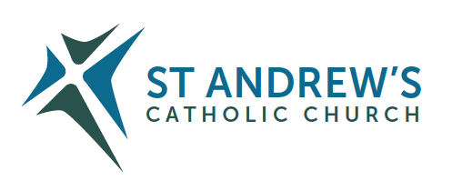
Parish Priest: Fr Behruz Rafat Telephone 01580 762785 Mobile: 07903 986646
Address: The Presbytery, 47 Ashford Road, Tenterden, Kent TN30 6LL.
Parish E-mail behruzrafat@rcaos.org.uk Parish Website: www.standrewstenterden.org
Deacon: Rev. Jolyon Vickers Telephone: 01580 766449 Email: jolyonvickers@rcaos.org.uk Hire of Parish Hall: Lesley McCarthy 07791 949652 E-mail: bookings.standrews@talktalk.net
Newsletter Editor: Patricia Sargent 01233 850963 E-mail: sargentpat51@gmail.com

Newsletter for the week commencing 29th May – 5th June 2021
THE MOST HOLY TRINITY (B)

Entrance antiphon: Blest be God the Father, and the Only Begotten Son of God, and also the Holy Spirit, for he has shown us his merciful love.
First Reading: Deuteronomy 4: 32-34. 39-40
Psalm 32 Response: Happy the people the Lord has chosen as his own.
Second Reading: St Paul to the Romans 8: 14-17
Acclamation: Alleluia, alleluia! Glory be to the Father, and to the Son, and to the Holy Spirit, the God who is, who was, and who is to come. Alleluia!
Gospel: Matthew 28: 16-20
Communion antiphon: Since you are children of God, God has sent into your hearts the Spirit of his Son, the Spirit who cries out: Abba, Father.

Father Behr writes:
Dear Parishioners Trinity Sunday.
The Catechism of the Catholic Church describes the mystery of the Holy Trinity like this.
234. "The mystery of the Most Holy Trinity is the central mystery of Christian faith and life. It is the mystery of God in himself. It is therefore the source of all the other mysteries of faith, the light that enlightens them. It is the most fundamental and essential teaching in the 'hierarchy of the truths of faith'. [GCD 43.] The whole history of salvation is identical with the history of the way and the means by which the one true God, Father, Son and Holy Spirit, reveals himself to men 'and reconciles and unites with himself those who turn away from sin'. [GCD 47.]"

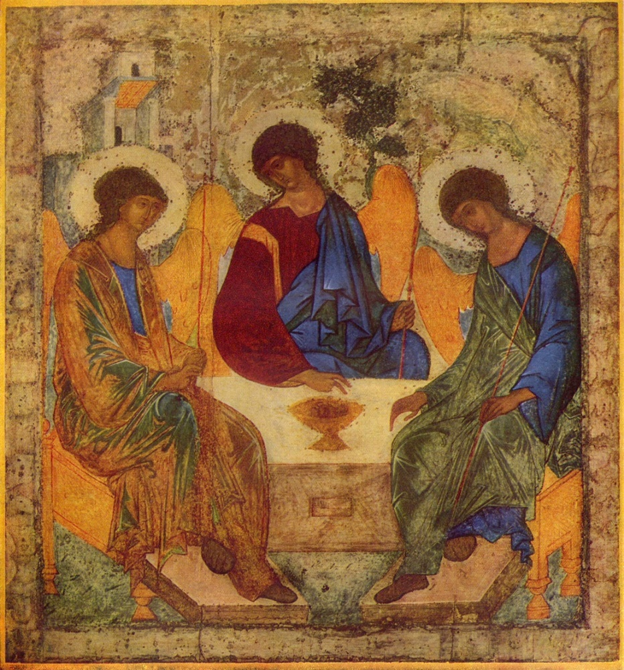
Russian icon by Andrey Rublev, between 1408 and 1425

Congratulations to Finn Lambkin who will be Baptised on Saturday 5 June. Please pray for him and his family.
Best wishes
Father Behr

Your Prayers are asked for:
Those recently deceased: Marjorie Dumbleton RIP & Jennifer Jorden RIP
Those ill or infirm: David Green, Charlotte Elliot (daughter of Maureen Davidson), Joe Adams, Ellie Lawrence, Anne Bryant, Patricia Hook, Elena Peck (senior), Josie Payne, Pat Holland and all those self-isolating or suffering from COVID-19.
Those whose anniversaries of death occur at this time: Elsie Hulse, Henry Balkham, Dorothy Stewart, Desmond Collins, Paul Lamonte, Annie Smith, Matthew Murphy, Colin Dolman, Agnes Cosens and Fanny Porter.

Please pray for the repose of the soul of Jennifer Jorden and for the comfort of her husband Noel and her family.
Jennifer died in the Hospice on the morning of Sunday May 16th.
Her funeral will be on Tuesday 8th June at 2pm (14:00) in Saint Mildred's Church.

This week’s services (29th May – 5th June 2021), Feasts and Mass intentions during the week.

Saturday 29th May  10 am Mass  6 pm Vigil Mass |  | Thursday 3rd June  10 am Mass | St Charles Lwanga & Companions, Martyrs  For Priests
Sunday 30th May  10 am Mass  12 Midday Sung Traditional Latin Mass | THE MOST HOLY TRINITY  People of the Parish | Friday 4th June  10 am Mass | Feria  Holy souls
Monday 31st May  10 am Mass | The Visitation of the Blessed Virgin Mary | Saturday 5th June  10 am Mass  6 pm Vigil Mass | St Boniface, Bishop & Martyr  People of the Parish
Tuesday 1st June  10 am Mass | St Justin, Martyr | Sunday 6th June  10 am Mass  12 midday Sung Traditional Latin Mass | THE MOST HOLY BODY AND BLOOD OF CHRIST (CORPUS CHRISTI)  Ron Basher RIP
Wednesday 2nd June  10 am Service of the Word and Holy Communion | Sts Marcellinus & Peter, Martyrs
Flowers: For 6TH June – Suzanne

Please pray for our new candidates preparing for their First Holy Communion, starting on 5th June.

A plea from Deacon Jolyon…
Could you spare two hours a week to clean/housekeep for an elderly gentleman in Headcorn? Competitive rates offered. Please speak to Deacon Jolyon, if you feel you can help.

