**Parish Priest:** Fr Behruz Rafat **Telephone** 01580 762785 Mobile: 07903 986646

**Address:** The Presbytery, 47 Ashford Road, Tenterden, Kent TN30 6LL.

**Parish E-mail** behruzrafat@rcaos.org.uk P**arish Website:** www.standrewstenterden.org

**Deacon:** Rev. Jolyon Vickers **Telephone:** 01580 766449 Email**:** [jolyonvickers@rcaos.org.uk](mailto:jolyonvickers@rcaos.org.uk) **Hire of Parish Hall:** Lesley McCarthy 07791 949652 E-mail**:** bookings.standrews@talktalk.net

**Newsletter Editor:** Patricia Sargent 01233 850963 **E-mail:** sargentpat51@gmail.com

**Newsletter for the week commencing 13th – 19th June 2021**

**Eleventh Sunday in Ordinary Time (B)**

**Entrance antiphon: O Lord, hear my voice, for I have called to you: be my help. Do not abandon or forsake me, O God, my Saviour.**

**First Reading: Ezekiel 17: 22-24**

**Psalm 91 Response: It is good to give you thanks, O Lord.**

**Second Reading: Second letter of St Paul to the Corinthians 5: 6-10**

**Acclamation: Alleluia, alleluia! I call you friends, says the Lord, because I have made known to you everything I have learnt from my Father. Alleluia!**

**Gospel: Mark 4: 26-34**

**Communion antiphon: There is one thing I ask of the Lord, only this do I seek: to live in the house of the Lord all the days of my life.**

**Father Behr writes:**

Dear Parishioners

As we have just celebrated the Solemnity of the Sacred Heart, I thought it would be good to give you an update on the renovation of our parish Sacred Heart statue and statue of St Anthony with the child Jesus.

We have given the statues to Lewis and Lewis in Liverpool for a complete renovation. It will cost approximately £1300, although we were advised that as they are working on the statues, they may discover more work which will need to be done and so the cost may rise slightly.

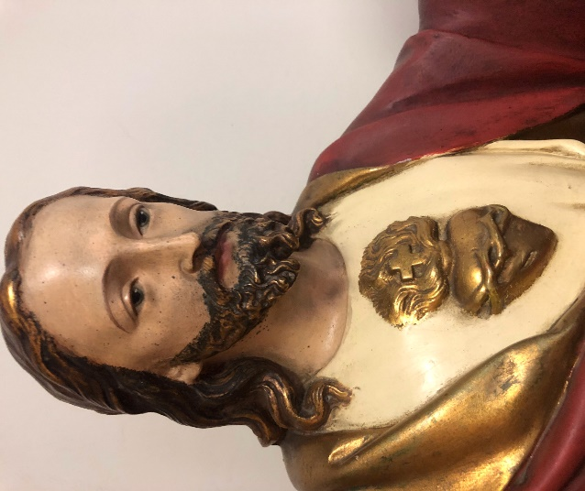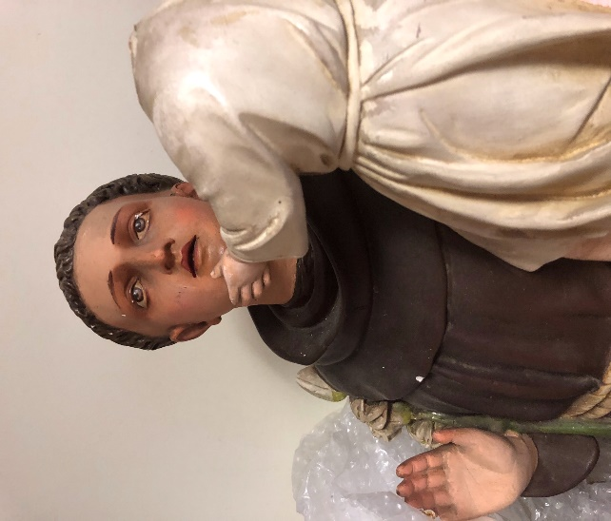

Lewis and Lewis are a Catholic family business and have done work for St Francis in Maidstone. If you would like to see examples of their work see this link.

https://www.jlewisstatues.co.uk

I’m thinking about where to put the statues when they are returned in September and would welcome any suggestions. Ideally, I would like to place the statue of the Sacred Heart on one side of the arch with the new statue of The Blessed Virgin on the other side of the arch.

I think it would be a good idea to move the Baptismal font to the back of our church as that is where it should be traditionally.  It will also create a bit more space around for the votive candle stand.

Best wishes

Father Behr

**Your Prayers are asked for:**

**Those recently deceased:**

**Those ill or infirm:** Charlotte Elliot (daughter of Maureen Davidson), Joe Adams, Ellie Lawrence, Anne Bryant, Patricia Hook, Elena Peck (senior), Josie Payne, Pat Holland and all those self-isolating or suffering from COVID-19.

**Those whose anniversaries of death occur at this time:** Ron Basher**,** Margaret Martin-Sperry, Andree Norman-Taylor, Agnes Venables, Bertha Sharp and Doris Bourne.

|  |  |  |  |
| --- | --- | --- | --- |
| **This week’s services (13th – 19th June), Feasts and Mass intentions during the week.** | | | |
| **Saturday 12th June**  10 am Mass  6 pm Vigil Mass | The Immaculate Heart of the Blessed Virgin Mary | **Thursday 17th June**  10 am Mass | Feria  *Richard Lee Hoskins* |
| **Sunday 13th June**  10 am Mass  12 Midday **Sung** Traditional Latin Mass | **Eleventh Sunday** (B)  *People of the Parish* | **Friday 18th June**  10 am Mass | Feria  *Kathleen Clancy RIP* |
| **Monday 14th June**  10 am Mass | Feria *Elizabeth Nichols wellbeing* | **Saturday 19th June**  10 am Mass  6 pm Vigil Mass | Feria  *Jennifer Jorden RIP*  *Big M* |
| T**uesday 15th June**  10 am Mass | Feria  *Alfred Owen Davis* | **Sunday 20th June**  10 am Mass  12 midday Traditional Latin Mass | **Twelfth Sunday** (B)  **Day of Prayer for Human Life**  *People of the Parish* |
| **Wednesday 16th June**  10 am Service of the Word and Holy Communion | St Richard of Chichester, Bishop |  |  |
| **Flowers: For 20th June - Frances** | | | |

There will be a **second collection next weekend** for **Human Life.**

These are the dates for the Sung Traditional Latin Mass at Tenterden with a polyphony choir.

13 June

27 June

11 July

25 July

**The Holy Father’s Prayer Intention for June** – Let us pray for young people who are preparing for marriage with the support of the Christian community: may they grow in love, generosity, faithfulness and patience.