Parish Priest: Fr Behruz Rafat Telephone 01580 762785 Mobile: 07903 986646
Address: The Presbytery, 47 Ashford Road, Tenterden, Kent TN30 6LL.
Parish E-mail behruzrafat@rcaos.org.uk Parish Website: www.standrewstenterden.org
Deacon: Rev. Jolyon Vickers Telephone: 01580 766449 Email: jolyonvickers@rcaos.org.uk Hire of Parish Hall: Lesley McCarthy 07791 949652 E-mail: bookings.standrews@talktalk.net
Newsletter Editor: Patricia Sargent 01233 850963 E-mail: sargentpat51@gmail.com

Newsletter for the week commencing 20th June 2021
Twelfth Sunday in ordinary Time (B)
Entrance antiphon: The Lord is the strength of his people, a saving refuge for the one he has anointed. Save your people, Lord, and bless your heritage, and govern them for ever.
First Reading: Job 3: 1, 8-11
Psalm 106 Response: O give thanks to the Lord for his love endures for ever.
Second Reading: Second letter of St Paul to the Corinthians 5: 14-17
Acclamation: Alleluia, alleluia! May the Father of our Lord Jesus Christ enlighten the eyes of our mind, so that we can see what hope his call holds for us. Alleluia!
Gospel: Mark 4: 35-41
Communion antiphon: The eyes of all look to you, Lord, and you give them their food in due season.

Father Behr writes:
Dear Parishioners
Sunday 20 June is the Day for Life. Bishop John Sherrington has written about the main theme for this year.

Assisted Dying
‘Against this backdrop of loving care, we are now faced with the very real threat of the legalisation of ‘assisted suicide’ in our country. It is not a question of ‘if’ this challenge will come, it is now a question of ‘when?’ There is now a Private Members Bill in the House of Lords on so-called ‘Assisted Dying’ and it is only a matter of time before the issue is back in the House of Commons.
This year’s theme for Day for Life focuses on assisted suicide and the respect owed to life. The online resources are produced to inform Catholics about this threat to life and to share with people our response to such a threat: a true compassion as the just response to the immense value of the human person.’

You can read the whole letter here on this useful website and get involved in the defence of life.

https://www.dayforlife.org

Right to Life
righttolife.org.uk/assisted-suicide

Right to Life is an excellent pro-life organisation that works to defend human life.

Prayer to St Joseph Patron Saint of the Dying
Faithful Joseph, with the fulfilment of the Lord’s promise,
you peacefully leave this world in Jesus and Mary’s hands.
Your faith transforms death into the sowing of life;
thus, God considers you to be a just man.
Your heart overflows in the presence of the Lord.
With your hands outstretched to God, your night is filled with prayers.
Surrounded by the living, you embark upon the great march to the promise Land.
Open our eyes that we may glimpse the road to Life that lies beyond death.
May nothing, not denial, anger, nor depression, separate us from the Love of God.
Strengthen our faith in God who always finds ways of preserving us in his friendship.
Be beside us to hold our hands when we take our first steps toward the Eternal Kingdom.
Amen

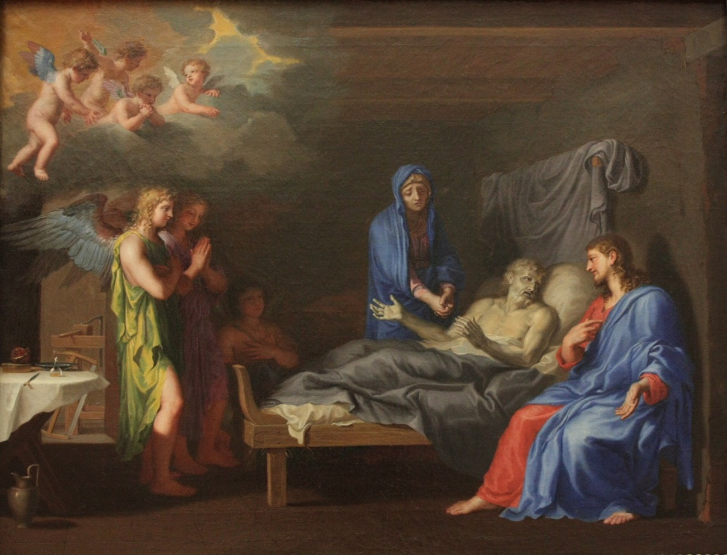
Death of Saint Joseph. Jacques Stella, 1650s

Best wishes,
Father Behr

Your Prayers are asked for:
Those recently deceased:
Those ill or infirm: Charlotte Elliot (daughter of Maureen Davidson), Joe Adams, Ellie Lawrence, Anne Bryant, Patricia Hook, Elena Peck (senior), Josie Payne, Pat Holland and all those self-isolating or suffering from COVID-19.
Those whose anniversaries of death occur at this time: Palas Blair-Drummond, Catherine Harre-Young, Stan Walczak, Lovemore Dzimati and Diana Wood.

This week’s services (19th – 26th June 2021 ), Feasts and Mass intentions during the week.

Saturday 19th June  10 am Mass  6 pm Vigil Mass | Feria  Jennifer Jorden RIP  Big M | Thursday 24th June  10 am Mass | THE NATIVITY OF ST JOHN THE BAPTIST  Micky and Family
Sunday 20th June  10 am Mass  12 Midday Traditional Latin Mass | Twelfth Sunday (B)  Day of Prayer for Human Life  People of the Parish | Friday 25th June  10 am Mass | Feria  Private Intention
Monday 21st June  10 am Mass | St Aloysius Gonzaga  Peter Larrigan RIP | Saturday 26th June  10 am Mass  6 pm Vigil Mass | The Blessed Virgin Mary  The Melling Family
Tuesday 22nd June  10 am Mass | Sts John Fisher, Bishop, & Thomas More, Martyrs  Carol Schoran RIP | Sunday 27th June  10 am Mass  12 midday Traditional Latin Mass | Thirteenth Sunday (B)  People of the Parish
Wednesday 23rd June  10 am Service of the Word and Holy Communion | St Etheldreda (Audrey), Abbess
Flowers: For 27th June – Kathy Gibbs

There will be a second collection this weekend for Human Life.

World Day of Prayer will be held here at Saint Andrew’s at 2 pm on Friday 2nd July.
Every year a different country prepares this lovely service and we get a tiny insight into how the people of the country live, some of their traditions and some of the challenges they have to face.
Please support this special event.
Come along and spend an hour or so with people you know and some you don’t – yet!

