T E N T E R D E N K E N T

**Parish Priest:** Fr Behruz Rafat **Telephone** 01580 762785 Mobile: 07903 986646

**Address:** The Presbytery, 47 Ashford Road, Tenterden, Kent TN30 6LL.

**Parish E-mail** behruzrafat@rcaos.org.uk **Parish Website:** www.standrewstenterden.org

**Deacon:** Rev. Jolyon Vickers **Telephone:** 01580 766449 **Email:** jolyonvickers@rcaos.org.uk **Hire of Parish Hall:** Lesley McCarthy 07791 949652 **E-mail:** bookings.standrews@talktalk.net

**Newsletter Editor:** Patricia Sargent 01233 850963 **E-mail:** sargentpat51@gmail.com

**Newsletter for the week commencing 29th November 2020**

**First Sunday of Advent (B)**

**Entrance antiphon: To you, I lift up my soul, O my God. In you, I have trusted; let me not be put to shame. Nor let my enemies exult over me; and let none who hope in you be put to shame.**

**First Reading: Isaiah 63: 16-17; 64: 1, 3-8**

**Psalm 79 Response: God of hosts, bring us back; let your face shine on us and we shall be saved.**

**Second Reading: First letter of St Paul to the Corinthians 1: 3-9**

**Acclamation: Alleluia, alleluia! Let us see, O Lord, your mercy and give us you saving help. Alleluia!**

**Gospel: Mark 13: 33-37**

**Communion antiphon: The Lord will bestow his bounty, and our earth shall yield its increase.**

**Father Behr writes:**

Dear Parishioners,

November 30th is the Feast day of St Andrew the Apostle, the Patron Saint of our parish.  Although we are not able to have Mass together due to the lockdown, I would like to offer a few suggestions for private prayer.

A Patron Saint is a friend and intercessor.  St Andrew cares about all the people in our parish.  We should never underestimate the power of the prayers of the Saints. Our patron Saint has been given a particular role by the Lord in caring for our parish. Don’t miss this opportunity to ask him for his help for all your intentions.  Please also remember to pray for one of these intentions on Monday and throughout the octave of his feast day.

For the young people and children of our parish.

For the sick and housebound in our parish.

For those facing hardship due to Coronavirus.

For the renewal of traditional family life.

For the renewal of the spiritual and liturgical life of our parish.

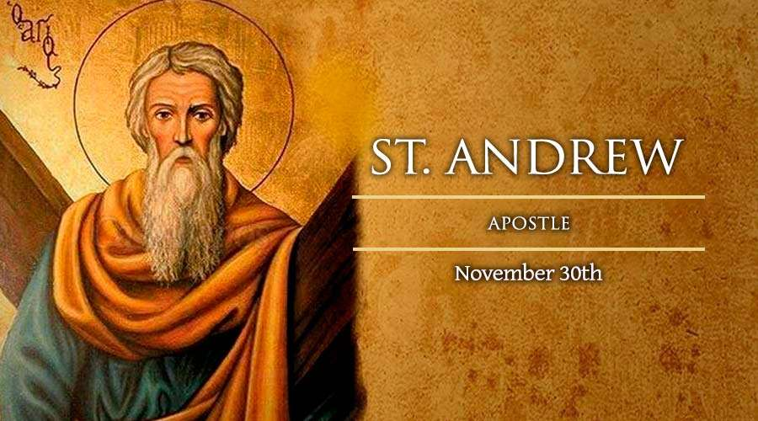

**Prayer to St Andrew**

Brother of Simon Peter,

you heard John the Baptist say:

"Behold the Lamb of God,"

and you chose to follow Jesus.

Leaving your nets,

you became a successful fisher of souls.

Lover of the Crucified Christ,

you too were crucified like him.

Teach us to live and suffer for Him

and to win many souls for Christ.

Amen.

**From the Bishop’s Conference**

The government has confirmed that collective worship can resume in churches and other places of worship, when the national lockdown expires on 2 December. This decision applies across all three tiers of COVID-19 restrictions in England.

On behalf of the Bishops, the General Secretary of the Catholic Bishops’ Conference of England and Wales, Canon Christopher Thomas, commented:

“The Catholic Community in England is delighted at the Government’s decision to allow the resumption of collective worship following the national lockdown in all three tiers.

This decision reflects the importance of the right of all people to express their faith in worship, but more importantly, it is an acknowledgement of the active collaboration the church has had with public officials in developing COVID-secure protocols in our churches.

As we move forward, it is incumbent on all who come to worship God in our churches to play their part in keeping themselves and others safe by following all of the guidance that has been prepared.

Through our encounter with Christ in the Eucharist and other sacraments celebrated in the Church, the works of charity which have been expressed through Catholic charities and communities over the last nine months finds its source and goal.”

Best wishes

Father Behr

07903986646

**This weekend** (29th November) there is a **second collection** for **Holy Places**. As before, please keep your offering safe and hand it in after lockdown.

During the month of November, we remember all the faithful departed.  Eternal rest grant unto them and let perpetual light shine upon them.  May they rest in peace.

The Cycle of Prayer for Advent and Christmas Time: Openness to the Word of God; Migrants and Refugees; Expectant Mothers.

**Your Prayers are asked for:**

**Those recently deceased**: Joe Venables RIP. Funeral details will be available soon

**Those ill or infirm:** Charlotte Elliot (daughter of Maureen Davidson), Jennifer Jorden, Joe Adams, Ellie Lawrence, Anne Bryant, Patricia Hook, Elena Peck (senior), Marjorie Dumbleton, Josie Payne, Pat Holland and all those self-isolating or suffering from COVID-19.

**Those whose anniversaries of death occur at this time:** Irene Balkham,Jimmy Hodson, Christopher Crofton, Catherine Broughton, Theresa Maloney, John Leonard, David Daniels, Marie Witham, Ethel Currie, Rose Hewer-Hearst, Edith Margaret Corbett, Alex Mickle, Elizabeth de Blaby and Agnes Finnan.

**This week’s feasts (29th November- 5th December) until lockdown is relaxed.**

**Next Sunday is the start of Advent and also Year (B).**

|  |  |  |  |
| --- | --- | --- | --- |
| **Mass will be said daily by Father Behr until the end of lockdown on 2nd December when it will revert to 10am daily.** | | | |
| **Feasts during the week** | | | |
| Sunday 29th November | **First Sunday of Advent (B)** | Thursday 3rd December  10am Mass | St Francis Xavier, Priest |
| Monday 30th November | **St Andrew, Apostle** | Friday 4th December  10am Mass | St John Damascene, Priest |
| Tuesday 1st December | Feria | Saturday 5th December  10am Mass | Feria |
| Wednesday 2nd December | Feria | Sunday 6th December  10am Mass  12 midday Latin Mass | **Second Sunday of Advent (B)** |

**Private Prayer Session**

**There is no expectation that you stay for a whole hour, please come and go as you wish**

|  |  |  |  |  |
| --- | --- | --- | --- | --- |
| **Day** | **Date** | **Celebrant** | **Steward** | **Cleaners** |
| Wednesday | 02/12/2020 | Dcn Jolyon | Martin & Rachel H | Martin & Rachel H |

**Christmas Flowers and Social Distancing**

To minimise the amount of time the flower arrangers would be in the church and to limit their numbers we ask that parishioners would help us by bringing a vase or arrangement of flowers to the church on the afternoon of 23rd December, 2pm to 4pm. We need ten for the window ledges - not above the radiators - in bright red, gold/yellow and white with greenery. Please let me know if you could prepare one and if you would need a holder and oasis. Seasonal evergreens and anything with berries e.g. holly, yew, ivy, cotoneaster would be gratefully received on the weekend 19/20 December and can be left in buckets in the courtyard outside the 'wet' Sacristy.  
Frances Lawrence 01233 732657    f.lawrence999@btinternet.com

**Don’t forget this event… “INTERFAITH AND INTERCHURCH DIALOGUE: HOW ARE THEY DIFFERENT?”**

A **free** event organised by the R.C. Archdiocese of Southwark Christian Unity Commission at 6pm to 7.30 pm **Monday 30 November** 2020, **online via Zoom (please register) For** further details, please email: **christianunitycommission@rcaos.org.uk**

**A message from Deacon Jolyon about seat booking for services**

I am most grateful to everyone who has responded to my recent emails.

But just to clarify**, I do need positive confirmation** of which Sunday services, you will be attending and an early indication of your Christmas attendance wishes.

You will appreciate I do not know whether you are self-isolating or in quarantine, following a COVID positive contact or preparing to make a family visit etc.

Perhaps anyone wishing to attend **Mass on Sunday December 6th** could **let me know by Monday November 30th**.

I would be most grateful.

Thanks, Jolyon



Dear Fellow Hungry Breakfasters,

Once again, our breakfast has to be cancelled and we shall miss the opportunity for meeting up.

However, news on the virus front does give some encouragement that we may be able to meet again sometime next year. We can look forward to seeing each other, enjoying fellowship over a meal and being challenged in our faith by the speaker. If there is anyone who needs help in the meantime please let us know and we can see what can be done.

Christmas is on the horizon - a time of joy and celebration of Jesus birth However there will be those who will struggle through the school holidays or find it an even lonelier time. Just a thought – we will all be saving the £10 cost of our breakfast perhaps each of us could consider giving it to help. You probably have your own charities but some local ones include: Tenterden Family Foodbank, The Old Schoolhouse Larder (providing hot meals), Christmas Cheer

With very best wishes,

Chris