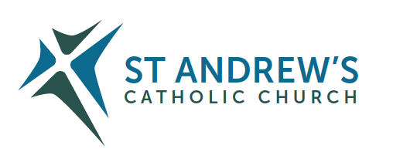
Parish Priest: Fr Behruz Rafat Telephone 01580 762785 Mobile: 07903 986646
Address: The Presbytery, 47 Ashford Road, Tenterden, Kent TN30 6LL.
Parish E-mail behruzrafat@rcaos.org.uk Parish Website: www.standrewstenterden.org
Deacon: Rev. Jolyon Vickers Telephone: 01580 766449 Email: jolyonvickers@rcaos.org.uk Hire of Parish Hall: Lesley McCarthy 07791 949652 E-mail: bookings.standrews@talktalk.net
Newsletter Editor: Patricia Sargent 01233 850963 E-mail: sargentpat51@gmail.com

Newsletter for the week commencing 25th – 31st July 2021
Seventeenth Sunday in Ordinary Time (B)
Entrance antiphon: God is in his holy place, God who unites those who dwell in his house: he himself gives strength and might to his people.
First Reading: 2nd Book of Kings 4: 42-44
Psalm 144 Response: You open wide your hand, O Lord, and grant our desires.
Second Reading: St Paul to the Ephesians 4: 1-6
Acclamation: Alleluia, alleluia! Your words are spirit, Lord, and they are life; you have the message of eternal life. Alleluia!
Gospel: John 6: 1-15
Communion antiphon: Bless the Lord, O my soul, and never forget all his benefits.

Father Behr writes:
Dear Parishioners
Sunday July 25
Pope Francis has instituted a World Day for Grandparents and the Elderly. Identifying with the more senior members of our society, he says “The whole Church is close to you – to us – and cares about you, loves you and does not want to leave you alone!”
You can read the whole message here:
https://www.cbcew.org.uk/home/events/world-day-grandparents-elderly-2021/popes-message-to-grandparents-and-the-elderly-2021/

Cardinal Vincent Nichols has made a video about the special day.
https://www.cbcew.org.uk/cardinal-on-grandparents-and-the-elderly/

A YouTube film from Canon Christopher Whitehead telling the story of St Joachim and St Anne, the grandparents of Jesus.
https://www.cbcew.org.uk/saint-joachim-and-saint-anne-grandparents-of-jesus/

Lord Jesus,
you were born of the Virgin Mary.
the daughter of Saints Joachim and Anne.
Look with love on grandparents the world over.
Protect them! They are a source of enrichment for families, for the Church and for all of society.
Support them as they grow older.
May they continue to be for their families strong pillars of Gospel faith,
guardians of noble domestic ideals, living treasuries of sound religious traditions.
Make them teachers of wisdom and courage,
that they may pass on to future generations the fruits of their mature human and spiritual experience.

Best wishes
Father Behr

Your Prayers are asked for:
Those recently deceased:
Those ill or infirm: David Green, Charlotte Elliot (daughter of Maureen Davidson), Joe Adams, Ellie Lawrence, Anne Bryant, Patricia Hook, Elena Peck (senior), Josie Payne, Pat Holland and all those self-isolating or suffering from COVID-19.
Those whose anniversaries of death occur at this time: Gilbert Rahr, Derek Carpenter, Susan Rahr, Michael McDermott, Bessie King, Lilliana Mortimer and Peter Taylor.

This week’s services (24th – 31st July), Feasts and Mass intentions during the week.
Seventeenth Sunday in Ordinary Time (B)
Saturday 24th July  10 am Mass  6 pm Vigil Mass | St Sharbel Makhluf, Priest  Paul Fox RIP  Marguerite Burrows-Thissen RIP | Thursday 29th July  10 am Mass | St Martha  Eva & Peter Osborne RIP
Sunday 25th July  10 am Mass  12 Midday Sung Traditional Latin Mass | Seventeenth Sunday (B)  People of the Parish | Friday 30th July  10 am Mass | St Peter Chrysologus, Bishop & Doctor of the Church  Holy Souls
Monday 26th July  10 am Mass | Sts Joachim & Anne, Parents of the Blessed Virgin Mary Deceased relatives (Maureen Saunders) | Saturday 31st July  10 am Mass  6 pm Vigil Mass | St Ignatius of Loyola, Priest  Special Intention (Maureen Saunders)
Tuesday 27th July 10 am Mass | Feria  Nicholls Family | Sunday 1st August  10 am Mass  12 midday Traditional Latin Mass | Eighteenth Sunday (B)  People of the Parish
Wednesday 28th July 10 am Service of the Word and Holy Communion | Feria
Flowers: For 1st August - Breeda

Although Covid restrictions have officially been lifted the government advice is to continue to check in to church using the QR code or signing in as before, for the time being. Should there be an outbreak of coronavirus involving two or more people at the same service attendees will be notified through NHS Track and Trace.
You are also asked to continue wearing your mask whilst at Mass for the protection of others.

Notice about recent unplanned presbytery costs
Recently Fr Behr had to have some work done on the heating system of the presbytery which came to over £800.

Thinking about studying the Catholic Faith?
The Archbishop’s Certificate (ArchCert) is an online course for all in Southwark who wish to know their Catholic faith more deeply.
Participants will take a two-year journey through the Church’s teaching to understand their faith in a more profound way and be able to share it with both confidence and joy.
The course will commence in October 2021 and the cost will be £365 per year. Registration must be completed in advance. Further details can be found here: https://aec.rcaos.org.uk/archcert

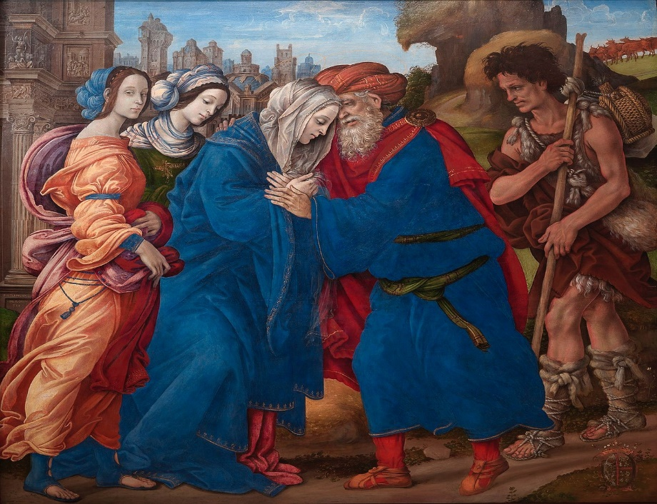
St Joachim and St Ann Filippino Lippi, 1497

