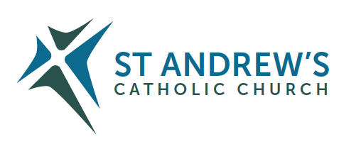
T E N T E R D E N K E N T

Parish Priest: Fr Behruz Rafat Telephone 01580 762785 Mobile: 07903 986646
Address: The Presbytery, 47 Ashford Road, Tenterden, Kent TN30 6LL.
Parish E-mail behruzrafat@rcaos.org.uk Parish Website: www.standrewstenterden.org
Deacon: Rev. Jolyon Vickers Telephone: 01580 766449 Email: jolyonvickers@rcaos.org.uk Hire of Parish Hall: Lesley McCarthy 07791 949652 E-mail: bookings.standrews@talktalk.net
Newsletter Editor: Patricia Sargent 01233 850963 E-mail: sargentpat51@gmail.com

Newsletter for the week commencing 20th December 2020
Fourth Sunday of Advent (B)

Also included are the Mass times for the week commencing 27th December 2020

Entrance antiphon: Drop down dew from above, you heavens, and let the clouds rain down the Just One; let the earth be opened and bring forth a Saviour.
First Reading: Samuel 7: 1-5; 8-12; 14, 16
Psalm 88 Response: I will sing forever of your love, O Lord.
Second Reading: St Paul to the Romans 16: 25-27
Acclamation: Alleluia, alleluia! I am the handmaid of the Lord: let what you have said be done to me. Alleluia!
Gospel: Luke 1: 26-38
Communion antiphon: Behold, a Virgin shall conceive and bear a son; and his name will be called Emmanuel.

Father Behr writes:

Dear Parishioners,

The entrance antiphon for the fourth Sunday of Advent captures the sense of anticipation and joyful expectancy that we all feel as we approach Christmas Day.
Ant. ad introitum
Is 45,8 Roráte, cæli, désuper, et nubes pluant iustum;
aperiátur terra et gérminet Salvatórem.
Entrance Antiphon
Cf. Is 45: Drop down dew from above, you heavens,
and let the clouds rain down the Just One;
let the earth be opened and bring forth a Saviour.

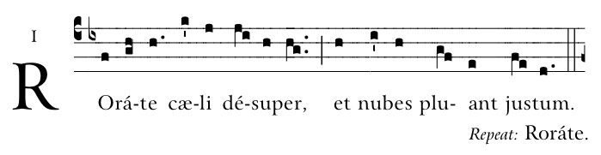
In the midst of what has been a difficult year for everyone we have the consolation of knowing that our faith in Jesus will get us through all the challenges we face.

I’d like to wish you all a joyful and peaceful Christmas. Thank you for your cards and gifts, it’s much appreciated.

Best wishes
Father Behr

Your Prayers are asked for:

Those recently deceased: Jo Venables RIP
Those ill or infirm: Maggie Urquhart, Charlotte Elliot (daughter of Maureen Davidson), Jennifer Jorden, Joe Adams, Ellie Lawrence, Anne Bryant, Patricia Hook, Elena Peck (senior), Marjorie Dumbleton, Josie Payne, Pat Holland and all those self-isolating or suffering from COVID-19.
Those whose anniversaries of death occur at this time: Alex Karras, Norah Wrigley, Joan Gray, Mary Hounsell, Joanna Powell, Mary Stevenson, Rosina Cordell, Richard Diedo and Liz Goodwin.

Please pray for Maggie Urquhart who is in the William Harvey Hospital.

This week’s services (20th – 27th December) until social distancing is relaxed:
Mass will be held daily at 10am except on Wednesday when there will be
a Service of the Word and Holy Communion at 10am
Feasts during the week
Sunday 20th December 10am Mass  12 midday Latin Mass | Fourth Sunday of Advent  People of the Parish |  | Thursday 24th December  First Mass of Christmas 6pm  Mass during the Night 9pm | Feria
Monday 21st December  10am Mass | Feria |  | Friday 25th December  Mass during the Day 10am  Latin Mass 12 midday | THE NATIVITY OF THE LORD
Tuesday 22nd December  10am Mass | Feria |  | Saturday 26th December  10am Mass | St Stephen, the first Martyr  Sue Goodman RIP (1st anniversary) - Jolyon
Wednesday 23rd December  10am Service of the Word and Holy Communion | Feria |  | Sunday 27th December  10am Mass | THE HOLY FAMILY OF JESUS, MARY & JOSEPH
Flowers for Sunday 27th December |  | Hilary Edwards

There is a second collection this weekend for the Apostleship of the Sea Social Media.

Please remember that all the offerings at the Christmas Masses are your personal gift to the parish priest. If you are a Gift Aider do use your numbered envelope and, if donating by cheques, please make it payable to ‘St Andrew’s Church’

Fr Behr will be on a post-Christmas break from late on Sunday 27th December 2020 to the morning of Saturday 2nd January 2021. Deacon Jolyon will be available at home on 01580 766449.

Mass times for the week beginning 28th December 2020 until 2nd January 2021
Sunday 27th December  10am | THE HOLY FAMILY OF JESUS, MARY & JOSEPH | Thursday 31st December  NO MASS | Seventh day within the Octave of the Nativity of the Lord
Monday 28th December  10am Mass. Fr John to celebrate | The Holy Innocents, Martyrs | Friday 1st January  10 am Mass. Fr John to celebrate | Mary, the Holy Mother of God
Tuesday 29th December  NO MASS | St Thomas of Canterbury, Bishop and Martyr | Saturday 2nd January  10 am Mass | Feria
Wednesday 30th December  10am Service of the Word and Holy Communion | Sixth day within the Octave of the Nativity of the Lord | Sunday 3rd January  10am Mass  12 midday Latin Mass | Feria

Wishing everyone a holy and peaceful Christmas and a healthy and happy New Year.

