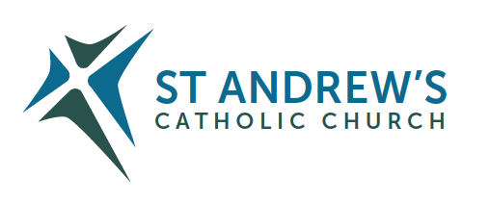
Parish Priest: Fr Behruz Rafat Telephone 01580 762785 Mobile: 07903 986646
Address: The Presbytery, 47 Ashford Road, Tenterden, Kent TN30 6LL.
Parish E-mail behruzrafat@rcaos.org.uk Parish Website: www.standrewstenterden.org
Deacon: Rev. Jolyon Vickers Telephone: 01580 766449 Email: jolyonvickers@rcaos.org.uk Hire of Parish Hall: Lesley McCarthy 07791 949652 E-mail: bookings.standrews@talktalk.net
Newsletter Editor: Patricia Sargent 01233 850963 E-mail: sargentpat51@gmail.com

Newsletter for the weeks commencing 1st – 7th/8th – 14th August 2021
Eighteenth/Nineteenth Sundays in Ordinary Time (B)

Week One: Eighteenth Sunday
Entrance antiphon: O God, come to my assistance; O Lord, make haste to help me! You are my rescuer, my help; O Lord, do not delay.
First Reading: Exodus 16: 2-4, 12-15
Psalm 77 Response: The Lord gave them bread from heaven.
Second Reading: St Paul to the Ephesians 4: 17, 20-24
Acclamation: Alleluia, alleluia! I am the Way, the Truth and the Life, says the Lord; no one can come to the Father except through me. Alleluia!
Gospel: John 6: 24-35
Communion antiphon: You have given us, O Lord, bread from heaven, endowed with all delights and sweetness in every taste.

Father Behr writes:

Dear Parishioners

Next weekend we welcome Father Tom Ryan a Columban Missionary who will be celebrating Mass for us and making an appeal on behalf of the Columban Missionary Society.
Columbans work in Britain, Australia, New Zealand, Chile, China, Hong Kong, Fiji, Ireland, Japan, Korea, Myanmar, Pakistan, Peru, the Philippines, Taiwan and the United States of America.
We should all feel a tremendous sense of gratitude towards missionary Fathers and sisters who make so many sacrifices to bring the gospel to distant lands.
If you would like to find out more about the Columban Missionaries please visit this site.
https://columbans.co.uk

Best wishes
Father Behr

Your Prayers are asked for:
Those recently deceased:
Those ill or infirm: David Green, Charlotte Elliot (daughter of Maureen Davidson), Joe Adams, Ellie Lawrence, Anne Bryant, Patricia Hook, Elena Peck (senior), Josie Payne, Pat Holland and all those self-isolating or suffering from COVID-19.
Those whose anniversaries of death occur at this time: Philomena Parker, Patricia O’Hea, Andrew Iglinski and Anne Morton.

Week One’s services (1st – 7th August 2021), Feasts and Mass intentions during the week.

Saturday 31st July  10 am Mass  6 pm Vigil Mass | St Ignatius of Loyola, Priest  Special intention (Maureen Saunders) | Thursday 5th August  No Mass | Feria
Sunday 1st August  10 am Mass  12 Midday Traditional Latin Mass | Eighteenth Sunday (B)  People of the Parish | Friday 6th August  No Mass | The Transfiguration of the Lord
Monday 2nd August No Mass | St Eusebius of Vercelli, Bishop | Saturday 7th August  No Mass  6 pm Vigil Mass | Feria
Tuesday 3rd August  10 am Mass | Feria  Holy Souls | Sunday 8th August  10 am Mass | Nineteenth Sunday (B)  People of the Parish
Wednesday 4th August  10 am Service of the Word and Holy Communion | St John Vianney, Priest
Flowers: For 8th August - Frances

Week Two: Nineteenth Sunday
Entrance antiphon: Look to your covenant, O Lord, and forget not the life of your poor ones for ever. Arise, O God, and defend your cause, and forget not the cries of those who seek you.
First Reading: 1 Kings 19: 4-8
Psalm 33 Response: Taste and see that the Lord is good.
Second Reading: St Paul to the Ephesians 4: 30 – 5: 2
Acclamation: Alleluia, alleluia! If anyone loves me he will keep my word, and my Father will love him, and we shall come to him. Alleluia!
Gospel: John 6: 41-51
Communion antiphon: O Jerusalem, glorify the Lord, who gives you your fill of finest wheat.

Your Prayers are asked for:
Those recently deceased:
Those ill or infirm: David Green, Charlotte Elliot (daughter of Maureen Davidson), Joe Adams, Ellie Lawrence, Anne Bryant, Patricia Hook, Elena Peck (senior), Josie Payne, Pat Holland and all those self-isolating or suffering from COVID-19.
Those whose anniversaries of death occur at this time: Anne Morton, Joseph Corcoran, Sylvia Ulph, Ronald Carey, Linda Wolff, David Collard, Eva Ford, Evelyn Robertson, Joseph Puxty, Catherine Lista, Alex Holmes, Philomena Curtin and Ann Finn.

Week Two’s services (8th – 14th August 2021), Feasts and Mass intentions during the week.

Saturday 7th August  6 pm Vigil Mass | Feria | Thursday 12th August  No Mass | St Jane Frances de Chantal, Religious
Sunday 8th August  10 am Mass | Nineteenth Sunday (B)  People of the Parish | Friday 13th August  No Mass | Sts Pontian, Pope & Hippolytus, Priest, Martyrs
Monday 9th August No Mass | St Teresa Benedicta of the Cross, Virgin & Martyr | Saturday 14th August  10 am Mass  6 pm Vigil Mass | St Maximillian Mary Kolbe, Priest & Martyr
Tuesday 10th August  No Mass | St Lawrence, Deacon & Martyr | Sunday 15th August  10 am Mass | THE ASSUMPTION OF THE BLESSED VIRGIN MARY  People of the Parish
Wednesday 11th August  10 am Service of the Word and Holy Communion | St Clare, Virgin
Flowers: For 15th August - Kathy
Thinking about study?
The Archbishop’s Certificate (ArchCert) is an online course for all in Southwark who wish to know their Catholic faith more deeply.
Participants will take a two-year journey through the Church’s teaching to understand their faith in a more profound way and be able to share it with both confidence and joy.
The course will commence in October 2021 and the cost will be £365 per year. Registration must be completed in advance. Further details can be found here: https://aec.rcaos.org.uk/archcert

Ride+Stride
Friends of Kent Churches
Saturday 11th September 2021, 10am – 6pm
Keep fit and raise money!
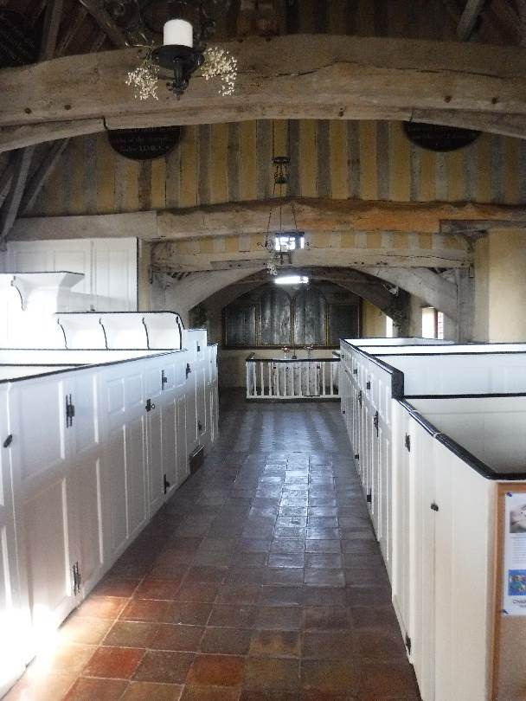
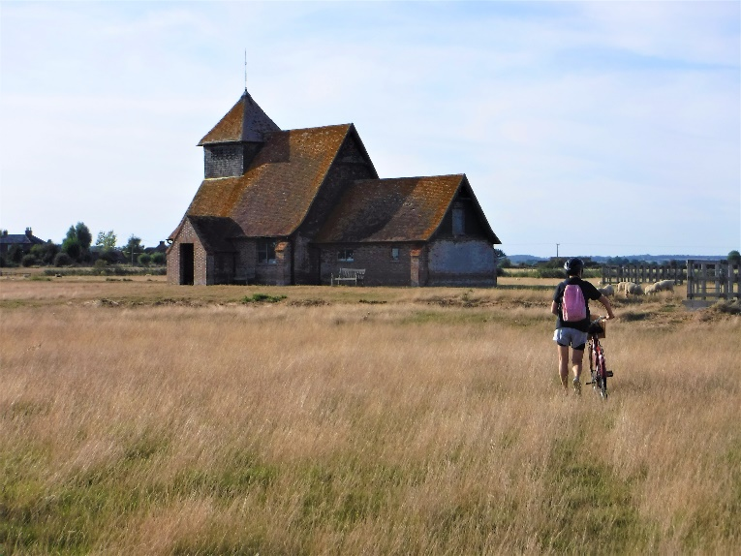
The annual Ride and Stride takes place on Saturday 11th September 2021 from 10.00am to 6.00pm. Why not forget Covid-19, get out into the fresh air and enjoy the local countryside, towns and villages by taking part in this year’s event?

Photos © Cathryn Ramsden 2019

As you discover Kent's churches by bicycle or on foot you’ll be helping to support the Church – and getting fit at the same time!
Money raised by sponsorship will be divided equally between the Friends of Kent Churches and the Parish Centre.
A list of churches and sponsorship forms are available for download at the Friends of Kent Churches website at https://www.kentrideandstride.co.uk/downloads
or from Rachel Heinrichsmeier at heinrichsmeier@btinternet.com.
P.S. We would like to open the Church to visitors this year, at least partially, and offer our usual refreshments if possible. There will be a list of volunteers for this at the back of the Church from 6th August.

