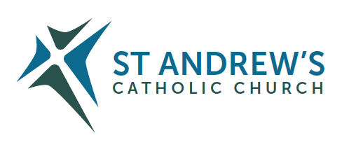
Parish Priest: Fr Behruz Rafat Telephone 01580 762785 Mobile: 07903 986646
Address: The Presbytery, 47 Ashford Road, Tenterden, Kent TN30 6LL.
Parish E-mail behruzrafat@rcaos.org.uk Parish Website: www.standrewstenterden.org
Deacon: Rev. Jolyon Vickers Telephone: 01580 766449 Email: jolyonvickers@rcaos.org.uk Hire of Parish Hall: Lesley McCarthy 07791 949652 E-mail: bookings.standrews@talktalk.net
Newsletter Editor: Patricia Sargent 01233 850963 E-mail: sargentpat51@gmail.com

Newsletter for the week commencing 22nd – 28th August 2021
Twenty-First Sunday in Ordinary Time (B)
Entrance antiphon: Turn your ear, O Lord, and answer me; save the servant who trusts in you, my God. Have mercy on me; O Lord, for I cry to you all the day long.
First Reading: Joshua 24: 1-2; 15-18
Psalm 33 Response: Taste and see that the Lord is good.
Second Reading: St Paul to the Ephesians 5: 21-32
Acclamation: Alleluia, alleluia! Your words are spirit, Lord, and they are life: you have the message of eternal life. Alleluia!
Gospel: John 6: 60-69
Communion antiphon: Whoever eats my flesh and drinks my blood has eternal life, says the Lord, and I will raise him up on the last day.

Father Behr writes:
Dear Parishioners,
The example and witness of St Monica
St Monica was born in Thagaste, modern day Algeria in AD 332. Monica was the mother of Augustine of Hippo. As a young man he led a wayward life and grieved his mother. She continually prayed for his conversion and a bishop whom she confided in said to her, "The child of those tears shall never perish." Her prayers were answered when Augustine was baptised by Ambrose of Milan. Augustine was eventually recognised as a saint.

We all have friends and family, who for different reasons, have fallen away from the practice of the Catholic faith, so on the feast day of Saint Monica Friday 27 August, we can make a special effort to go to Mass and ask for the prayers of St Monica for our loved ones.

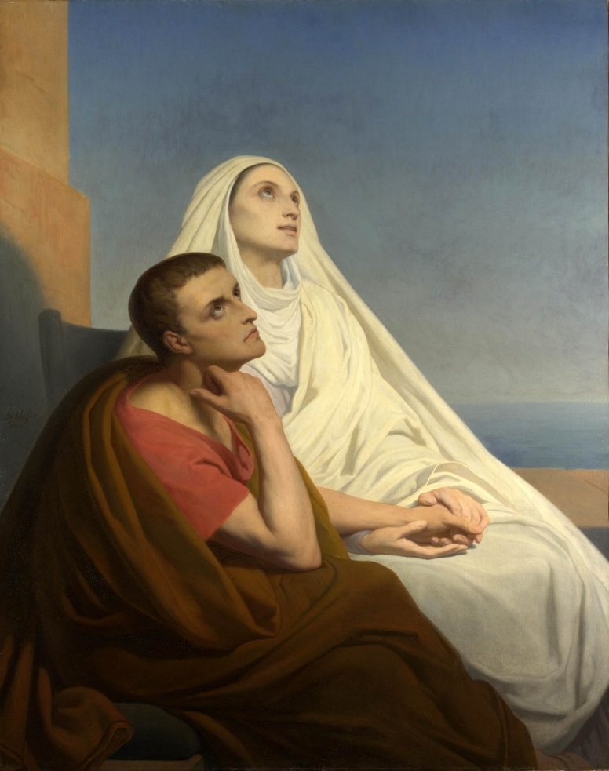
Saint Augustine and his mother, Saint Monica (1846) by Ary Scheffer
CAFOD is responding to significant crises across the world this week. We are working with local Church organisations in Haiti to deliver emergency aid to people affected by the catastrophic earthquake and tropical storm. In the tragic situation in Afghanistan, we are working to ensure the safety of our local partners and their communities. We are supporting local aid workers to deliver urgent food and water supplies to hundreds of thousands of people facing extreme hunger in Tigray in Ethiopia, South Sudan and north-east Nigeria. You can read more about how we can all express solidarity with our sisters and brothers affected by these emergencies on the CAFOD website: https://cafod.org.uk/News/Emergencies-news. Your compassion, generosity and prayers have helped us to stand together and enable us to continue to support communities in these difficult times. Thank you.

Congratulations to Anne and Michael Delaney who are getting married at St Andrew’s on Monday 30 August. We wish them every blessing for their future together.

Best Wishes,
Father Behr

Your Prayers are asked for:
Those recently deceased:
Those ill or infirm: David Green, Charlotte Elliot (daughter of Maureen Davidson), Joe Adams, Ellie Lawrence, Anne Bryant, Patricia Hook, Elena Peck (senior), Josie Payne, Pat Holland and all those self-isolating or suffering from COVID-19.
Those whose anniversaries of death occur at this time: Ernest Venables, Pat Wood, Teresa White, Edith Cooper, Vera Gibson, Martin Saunders, Mary Roche, Duncan Bryant, Anne Williams, Rosalie Robertson, Audrey Clark, Hester Rositer and Kevin Thornton.

This week’s services ( 22nd – 28th August ), Feasts and Mass intentions during the week.

Saturday 21st August  10 am Mass  6 pm Vigil Mass | St Pius X, Pope  Thanksgiving (Milton)  David Cockayne wellbeing | Thursday 26th August  No Mass | Feria  Holy Souls
Sunday 22nd August  10 am Mass  12 Midday Traditional Latin Mass | Twenty-First Sunday (B)  People of the Parish | Friday 27th August  No Mass | St Monica  Holy Souls
Monday 23rd August No Mass | St Rose of Lima, Virgin | Saturday 28th August  6 pm Vigil Mass | St Augustine, Bishop & Doctor of the Church
Tuesday 24th August No Mass | St Bartholomew, Apostle | Sunday 29th August  10 am Mass | Twenty-Second Sunday (B)
Wednesday 25th August 10 am Service of the Word and Holy Communion | Feria
Flowers: For 29th August - Francien

On Saturday 28th and Sunday 29th August Fr Liam Gallagher will be covering Mass on Saturday evening and Sunday morning.

