Parish Priest: Fr Behruz Rafat Telephone 01580 762785 Mobile: 07903 986646
Address: The Presbytery, 47 Ashford Road, Tenterden, Kent TN30 6LL.
Parish E-mail behruzrafat@rcaos.org.uk Parish Website: www.standrewstenterden.org
Deacon: Rev. Jolyon Vickers Telephone: 01580 766449 Email: jolyonvickers@rcaos.org.uk Hire of Parish Hall: Lesley McCarthy 07791 949652 E-mail: bookings.standrews@talktalk.net
Newsletter Editor: Patricia Sargent 01233 850963 E-mail: sargentpat51@gmail.com

Newsletter for the week commencing 29th August – 4th September 2021
Twenty-Second Sunday in Ordinary Time (B)
Entrance antiphon: Have mercy on me, O Lord, for I cry to you all day long. O Lord, you are good and forgiving, full of mercy to all who call to you.
First Reading: Deuteronomy 4: 1-2’ 6-8
Psalm 14 Response: Lord, who shall be admitted to your tent?
Second Reading: St James 1: 17-18;21-22;27
Acclamation: Alleluia, alleluia! By his own choice the Father made us his children by the message of the truth, so that we should be a sort of first-fruits of all that he created. Alleluia!
Gospel: Mark 7: 1-8, 14-15, 21-23
Communion antiphon: How great is the goodness, Lord, that you keep for those who fear you.

Father Behr writes:
Dear Parishioners
In the build up to the feast of the birthday of the Blessed Virgin Mary on 8 September you may like to consider what birthday present you would like to give Our Lady. Some people will offer a novena; others will promise to make the effort to go to confession, while some may choose to help the poor or choose some other gift, such as an act of kindness, to offer the Blessed Mother.
If you decide to pray the novena, then it starts on Tuesday 31August.
This is one suggestion for the Novena.
http://www.dailycatholic.org/sepdevo.htm#nativitybvm1

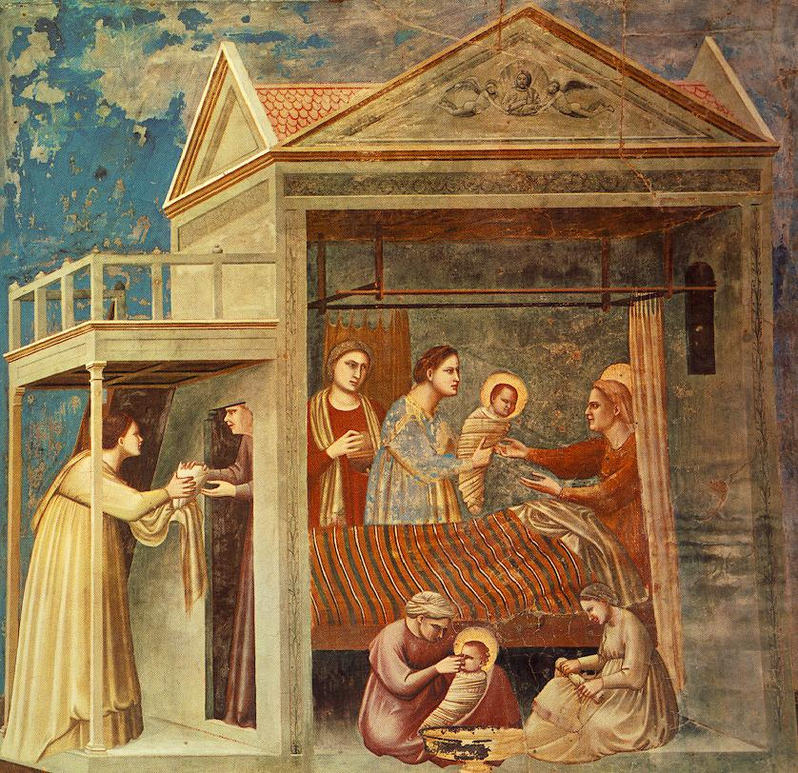
The Birth of the Blessed Virgin Mary
by Giotto, in the Scrovegni Chapel
Padua, Italy (c. 1305)
Best wishes
Father Behr

Your Prayers are asked for:
Those recently deceased:
Those ill or infirm: Charlotte Elliot (daughter of Maureen Davidson), Joe Adams, Ellie Lawrence, Anne Bryant, Patricia Hook, Elena Peck (senior), Josie Payne, Pat Holland and all those self-isolating or suffering from COVID-19.
Those whose anniversaries of death occur at this time: Dorothy Taylor, Violet Bruce-Norton, Mary Sheehan, Joseph Langley, Doris Diego and Barbara Winter.

This week’s services ( 28th August – 4th September), Feasts and Mass intentions during the week.

Saturday 28th August  6 pm Vigil Mass | St Augustine, Bishop and Doctor of the Church | Thursday 2nd September  10 am Mass | Feria  Holy Souls
Sunday 29th August  10 am Mass  12 midday Traditional Latin Mass | Twenty-Second Sunday  People of the Parish | Friday 3rd September  10 am Mass | St Gregory the Great, Pope & Doctor of the Church.  Patrick Andria RIP
Monday 30th August  10 am Mass | Sts Margaret Clitherow, Anne Line & Margaret Ward, Martyrs Catherine Lista | Saturday 4th September  10 am Mass  6 pm Vigil Mass | St Cuthbert, Bishop  Monsignor Canon Cyril Murtagh RIP  Marie Freeman RIP
Tuesday 31st August  10 am Mass | St Aidan & the Saints of Lindisfarne.  Mark Boddington intentions | Sunday 5th September  10 am Mass  12 midday Traditional Latin Mass | Twenty-Third Sunday  People of the Parish
Wednesday 1st September  10 am Service of the Word and Holy Communion | Feria
Flowers: For 5th September - Hilary

Fr Liam Gallagher will be covering Mass on Saturday evening (28th) and Sunday morning (29th).

This is advance notice that Tenterden Methodist Church stewards are planning an Organ Recital and Tea & Cakes on the afternoon of Remembrance Sunday this year (Sunday 14 November at 3pm). There will be half an hour of organ music and then the tea and cakes. The organist will be Ian Verran. The recently refurbished pipe organ is registered as a World War I memorial.
The recital is part of the Churches Together in Tenterden initiative and everyone is welcome.

A reminder – don’t forget the Stride and Ride on 11th September! The details are on the notice board in the porch and outside.

