Parish Priest: Fr Behruz Rafat Telephone 01580 762785 Mobile: 07903 986646
Address: The Presbytery, 47 Ashford Road, Tenterden, Kent TN30 6LL.
Parish E-mail behruzrafat@rcaos.org.uk Parish Website: www.standrewstenterden.org
Deacon: Rev. Jolyon Vickers Telephone: 01580 766449 Email: jolyonvickers@rcaos.org.uk Hire of Parish Hall: Lesley McCarthy 07791 949652 E-mail: bookings.standrews@talktalk.net
Newsletter Editor: Patricia Sargent 01233 850963 E-mail: sargentpat51@gmail.com

Newsletter for the week commencing 5th September 2021
Twenty-third Sunday in Ordinary Time (B)
Entrance antiphon: You are just, O Lord, and your judgement is right; treat your servant in accord with your merciful love.
First Reading: Isaiah 35: 4-7
Psalm 145 Response: My soul, give praise to the Lord.
Second Reading: St James 2: 1-5
Acclamation: Alleluia, alleluia! Speak, Lord, your servant is listening: you have the message of eternal life. Alleluia!
Gospel: Mark 7: 31-37
Communion antiphon: Like the deer that yearns for running streams, so my soul is yearning for you, my God; my soul is yearning for God, the living God.

Father Behr writes:
Dear Parishioners
Prayer for the feast of the Birthday of the Blessed Virgin on 8 September.

Impart to your servants, we pray, O Lord,
the gift of heavenly grace,
that the feast of the Nativity of the Blessed Virgin
may bring deeper peace
to those for whom the birth of her Son
was the dawning of salvation.
Through our Lord Jesus Christ, your Son,
who lives and reigns with you in the unity of the Holy Spirit,
one God, for ever and ever.

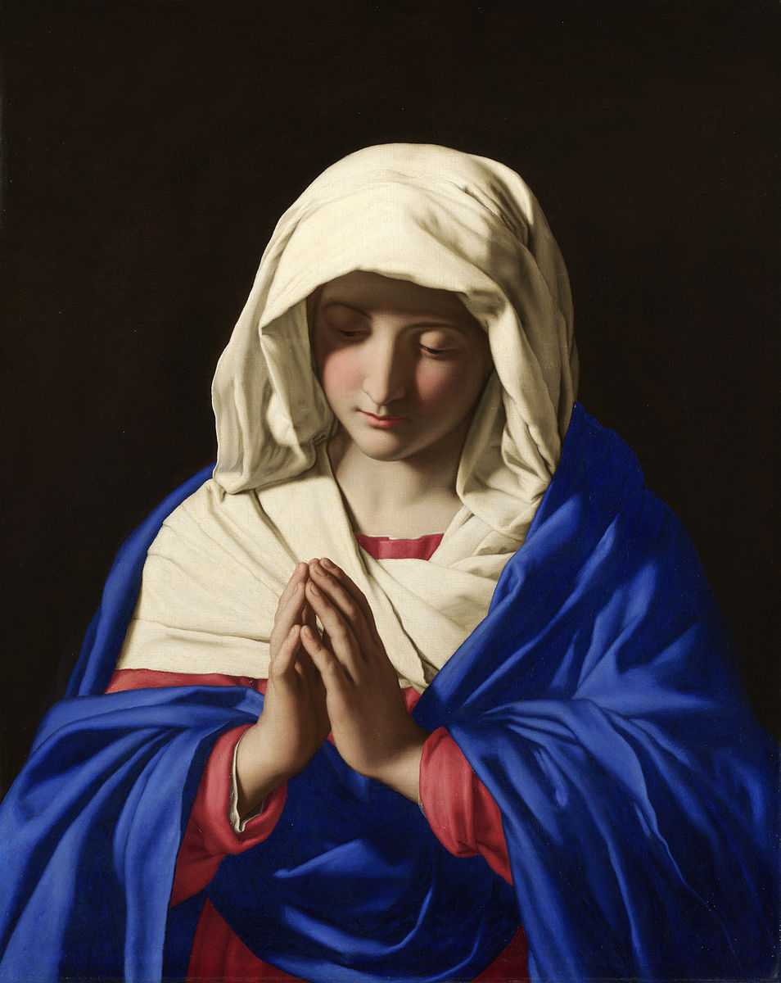
The Virgin in Prayer Giovanni Battista Salvi da Sassoferrato
Retrouvaille is an excellent organisation that will be of benefit to couples going through difficult times.

Covid 19—a very challenging time for many marriages.
So much uncertainty around, health, income, employment, vulnerable family members, children, housing. Different ways of seeing things, coping with change, managing fears can be a source of conflict and stress. It can be difficult to talk, to listen to support and comfort when there is so much uncertainty. Being together all the time, brings different challenges. You wonder would we be better apart?
Retrouvaille is a programme to support couples, it brings a positive focus, new hope and helps nourish and grow your marriage ….and you don’t need to leave home, it comes to you!
For confidential information about Retrouvaille’, or to register for the next programme, a Virtual weekend commencing 24th October 21st- 2021 Call or text 086 8211795.
Email: info@retrouvaille.ie –
or visit
www.retrouvaille.ie

Best wishes,
Father Behr

Your Prayers are asked for:
Those recently deceased:
Those ill or infirm: Wayne (Liz Dumbleton’s husband), Charlotte Elliot (daughter of Maureen Davidson), Joe Adams, Ellie Lawrence, Anne Bryant, Patricia Hook, Elena Peck (senior), Josie Payne, Pat Holland and all those self-isolating or suffering from COVID-19.
Those whose anniversaries of death occur at this time: George Goodman, Ena Dowson, Matilda Hannah, Mary Nolan, Helena Gilkerson, Alan John Catlow, Anne Holmes and ‘Bunny’ Horton.

This week’s services (5th – 11th September), Feasts and Mass intentions during the week.

Saturday 4th September  10 am Mass  6 pm Vigil Mass | St Cuthbert, Bishop  Marie Freeman RIP. | Thursday 9th September  No Mass | St Peter Claver, Priest
Sunday 5th September  10 am Mass  12 Midday Traditional sung Latin Mass | Twenty-third Sunday (B)  People of the Parish | Friday 10th September  No Mass | Feria
Monday 6th September No Mass | Feria | Saturday 11th September  No Mass  6 pm Vigil Mass | The Blessed Virgin Mary
Tuesday 7th September No Mass | Feria | Sunday 12th September  10 am Mass  12 midday Traditional Latin Mass | Twenty-fourth Sunday (B)  People of the Parish
Wednesday 8th September 10 am Service of the Word and Holy Communion | The Nativity of the Blessed Virgin Mary
Flowers: For 12th September - Suzanne

A request… One of our number from Biddenden is having orthopaedic surgery and once she is recuperating, would appreciate a lift into church for the 10am Mass on Sundays. Please could you let Jolyon know if you could be part of a rota to assist. Thank you.

This is advance notice that Tenterden Methodist Church stewards are planning an Organ Recital and Tea & Cakes on the afternoon of Remembrance Sunday this year (Sunday 14 November at 3pm). There will be half an hour of organ music and then the tea and cakes. The organist will be Ian Verran. The recently refurbished pipe organ is registered as a World War I memorial.
The recital is part of the Churches Together in Tenterden initiative and everyone is welcome.

A reminder – don’t forget the Stride and Ride on 11th September! The details are on the notice board in the porch and outside.
And a final plea from Rachel and Martin …
Volunteers sought to welcome Riders & Striders
We would like to open the Church to visiting Riders and Striders this year, at least partially, and offer our usual refreshments if possible. Duties are very light - welcoming riders and striders; entering their name on a list and signing their form; and offering them light refreshments (these will be provided). If you can spare an hour of your time on Saturday 11th September, please put your name on the list in the porch (pinned to the noticeboard). Please include your contact details (telephone or email) in case of changes or problems. Thank you!

