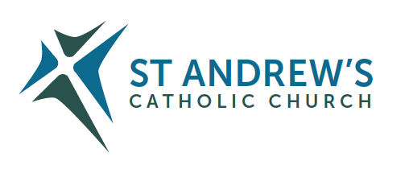
Parish Priest: Fr Behruz Rafat Telephone 01580 762785 Mobile: 07903 986646
Address: The Presbytery, 47 Ashford Road, Tenterden, Kent TN30 6LL.
Parish E-mail behruzrafat@rcaos.org.uk Parish Website: www.standrewstenterden.org
Deacon: Rev. Jolyon Vickers Telephone: 01580 766449 Email: jolyonvickers@rcaos.org.uk Hire of Parish Hall: Lesley McCarthy 07791 949652 E-mail: bookings.standrews@talktalk.net
Newsletter Editor: Patricia Sargent 01233 850963 E-mail: sargentpat51@gmail.com

Newsletter for the week commencing 3rd October 2021
Twenty-seventh Sunday in Ordinary Time (B)
Entrance antiphon: Within your will, O Lord, all things are established, and there is none that can resist your will. For you have made all things, the heaven and the earth, and all that is held within the circle of heaven; you are the Lord of all.
First Reading: Genesis 2: 18-24
Psalm 127 Response: May the Lord bless us all the days of our life.
Second Reading: Hebrews 2: 9-11
Acclamation: Alleluia, alleluia! Your word is truth, O Lord, consecrate us in the truth. Alleluia!
Gospel: Mark 10: 2-16
Communion antiphon: The Lord is good to those who hope in him, to the soul that seeks him.

Father Behr writes:
Dear Parishioners
October is the month of the Holy Rosary. We have the feast of Our Lady of the Rosary on Thursday. Thursday is also the fifteenth anniversary of my ordination to the priesthood. Please join me in praying the Rosary on Thursday before Mass. We will pray for all our priests and for vocations.
9.40am Rosary for Priests and Vocations
10am Mass Intention for all the Priests

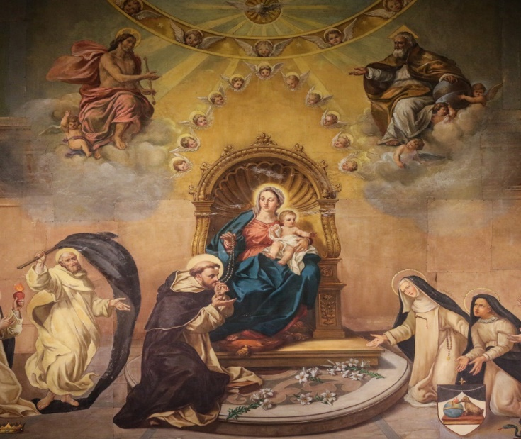
Prayer to Mary, Queen of the Clergy O Mary, august Queen of the Clergy, Thou who were given to Saint John as his mother the day following his priestly consecration, who presided over the unanimous and persevering prayer of the Holy Apostles and Disciples on the day of Pentecost; do Thou pray once more for the successors of the Apostles; for the Pope, for bishops, for priests, so that Their holy army might multiply and, after the example of Thy Divine Son, our Lord Jesus Christ, they may work tirelessly and fruitfully to support the weak, to console the afflicted, to convert sinners, and to extend the reign of the Kingdom of God on this earth, He who lives for ever and ever. Amen.
Best wishes
Father Behr

Your Prayers are asked for:
Those recently deceased:
Those ill or infirm: Charlotte Elliot (daughter of Maureen Davidson), Joe Adams, Ellie Lawrence, Anne Bryant, Patricia Hook, Elena Peck (senior), Josie Payne, Pat Holland and all those self-isolating or suffering from COVID-19.
Those whose anniversaries of death occur at this time: Catherine Young, Honora Scanlon, David Strivens, Agnes Mary Nolan, Mary McHugh, Anne Wickham, Arthur McMullan, John Lorimar, Kenneth Stacey, Freddie Ryan and Fred Paynter.

Please pray for our First Holy Communion candidates, Ann Delaney, Margaret Connors and Mary Connors, who are receiving the Sacrament for the first time on Saturday 9th October.

Prayer for England
O blessed Virgin Mary, Mother of God and our most gentle Queen and Mother, look down in mercy upon England thy "Dowry" and upon us all who greatly hope and trust in thee. By thee it was that Jesus our Saviour and our hope was given unto the world; and He has given thee to us that we might hope still more. Plead for us thy children, whom thou didst receive and accept at the foot of the Cross, O sorrowful Mother. Intercede for our separated brethren, that with us in the one true fold they may be united to the supreme Shepherd, the Vicar of thy Son. Pray for us all, dear Mother, that by faith fruitful in good works we may all deserve to see and praise God, together with thee, in our heavenly home.
Amen
Coffee Morning
It would be good to have a tea/coffee after Mass on Sunday. Let me know if you would like to help. We should aim to have tea and coffee after Mass on Sunday 10 October.

Loose Change for St Andrew
Eric Leenders, Managing Director of Personal Finance at UK Finance said:
“The public has stored over £50 million of loose change over the course of the pandemic and as UK is opening up post-lockdown every pound and penny that can be spared for worthy causes will make a tremendous difference.”
Would you like to bring your loose change to St Andrew ? Our team of counters will turn your loose change from the back of your sofa into funds to pay for the heating and lighting of our parish church.

Don’t forget our repository in the porch where you can buy cards and gifts for Holy Communion and other occasions as well as rosaries, candles and other items. I will be there at the end of 10 am Mass on Sunday for anyone who may want to have a look. Pat Sargent

This week’s services (2nd – 9th October 2021), Feasts and Mass intentions during the week.

Saturday 2nd October  10am Mass  6pm Vigil Mass | The Holy Guardian Angels  John and Emmy RIP | Thursday 7th October  10am Mass | Our Lady of the Rosary  Mass for Priests
Sunday 3rd October  10am Mass  12 Midday Traditional Latin Mass | Twenty-seventh Sunday (B)  People of the Parish | Friday 8th October  No Mass | Feria
Monday 4th October  10am Mass | St Francis of Assisi Private intention | Saturday 9th October  10am Mass  6pm Vigil Mass | St John Henry Newman, Priest  Leeper Family  Big M
Tuesday 5th October 10am Mass | St Faustina Kowalska, Virgin  Private intention | Sunday 10th October  10 am Mass  12 midday Traditional Latin Mass | Twenty-eighth Sunday (B)  People of the Parish
Wednesday 6th October 10am Service of the Word and Holy Communion | St Bruno, Priest
Flowers: For 10th October – Pat

