T E N T E R D E N K E N T

**Parish Priest:** Fr Behruz Rafat **Telephone** 01580 762785 Mobile: 07903 986646

**Address:** The Presbytery, 47 Ashford Road, Tenterden, Kent TN30 6LL.

**Parish E-mail** behruzrafat@rcaos.org.uk **Parish Website:** www.standrewstenterden.org

**Deacon:** Rev. Jolyon Vickers **Telephone:** 01580 766449 **Email:** jolyonvickers@rcaos.org.uk **Hire of Parish Hall:** Lesley McCarthy 07791 949652 **E-mail:** bookings.standrews@talktalk.net

**Newsletter Editor:** Patricia Sargent 01233 850963 **E-mail:** sargentpat51@gmail.com

**Newsletter for the week commencing 17th January 2021**

**Second Sunday in Ordinary Time (B)**

**Entrance antiphon: All the earth shall bow down before you, O God, and shall sing to you, shall sing to your name, O Most High.**

**First Reading: First book of Samuel 3: 3-10, 19**

**Psalm 39 Response: Here I am Lord! I come to do your will.**

**Second Reading: First letter of St Paul to the Corinthians 6: 13-15, 17-20**

**Acclamation: Alleluia, alleluia! Speak, Lord, your servant is listening: you have the message of eternal life. Alleluia!**

**Gospel**: **John 1: 35-42**

**Communion antiphon: You have prepared a table before me, and how precious is the chalice that quenches my thirst.**

**Father Behr writes:**

Dear Parishioners

The Octave of prayer for Christian Unity is from Monday 18 to Monday 25 January. It is no accident that this week is also part of our 40 Days of Prayer which we are sharing with other Christians in our area.

The special time of prayer for Christian Unity culminates in the celebration of the feast of the Conversion of St Paul. It is fitting, as St Paul was fearless in his proclamation of the good news of salvation in Jesus Christ. In a letter he wrote to the Corinthians he listed some of things he endured out of love for Jesus.

*I have worked much harder, been in prison more frequently, been flogged more severely, and been exposed to death again and again. Five times I received from the Jews the forty lashes minus one. Three times I was beaten with rods, once I was pelted with stones, three times I was shipwrecked, I spent a night and a day in the open sea, I have been constantly on the move. I have been in danger from rivers, in danger from bandits, in danger from my fellow Jews, in danger from Gentiles; in danger in the city, in danger in the country, in danger at sea; and in danger from false believers.  I have laboured and toiled and have often gone without sleep; I have known hunger and thirst and have often gone without food; I have been cold and naked. Besides everything else, I face daily the pressure of my concern for all the churches. (NIV 2 Cor 11: 23-28)*

As we face great challenges in 2021, we are inspired by St Paul and the witness and prayers of countless Christians throughout history, that with faith in Christ nothing will happen that can separate us from the love of God. (Cf Rom 8:38)

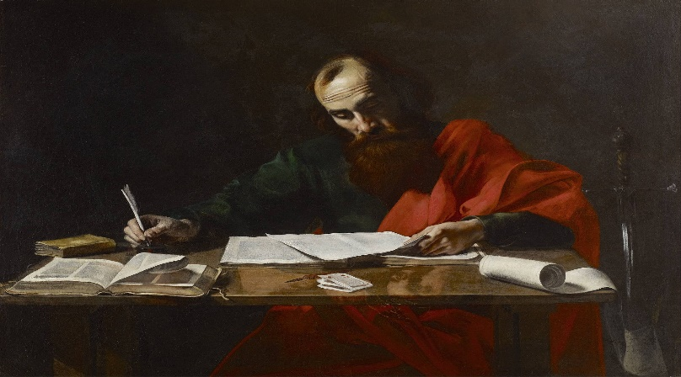

As part of the week of prayer the Mass on Friday 22 January will be for Christian Unity.  We also have a joint Zoom Unity service on Sunday 24th January at 6pm. Invitations will be sent out nearer the time.

Please join me in praying for this important intention:

Almighty ever-living God,

who gather what is scattered

and keep together what you have gathered,

look kindly on the flock of your Son,

that those whom one Baptism has consecrated

may be joined together by integrity of faith

and united in the bond of charity.

Through our Lord Jesus Christ, your Son,

who lives and reigns with you in the unity of the Holy Spirit,

God, for ever and ever.  Amen

Fr Behr

**Your Prayers are asked for:**

**Those recently deceased**: Maggie Urquhart RIP, Trevor Leney RIP, Wilhelmina Franklin RIP, Alan Dorey RIP

**Those ill or infirm:** Charlotte Elliot (daughter of Maureen Davidson), Jennifer Jorden, Joe Adams, Ellie Lawrence, Anne Bryant, Patricia Hook, Elena Peck (senior), Marjorie Dumbleton, Josie Payne, Pat Holland and all those self-isolating or suffering from COVID-19.

**Those whose anniversaries of death occur at this time:** Alexander Watt, William Syer, Douglas Fowler, Adela de Heveningham, Michael Vickers, Margaret Lewis, Arthur Wood, Nora Crouzet, May Scroope and Archibald Donald.

**Trevor Leney** is being received into the church this Sunday, 17th January, in the afternoon. There will be the extra-ordinary form **Requiem Mass at 11:00 on Monday, 18th January** followed by internment in Tenterden Cemetery.

**Maggie Urquhar**t is being received into the church on the afternoon of Wednesday, 20th January. Her **Requiem Mass** will be at **10am on Thursday, 21st January** (please book seat with Deacon Jolyon) followed by a Funeral Service at **Charing Crematorium at 4pm**. This service will be streamed and the link and password will be made available to parishioners. The service will make use of Maggie's chosen music and hymns. A subsequent Requiem Mass and Internment will follow at Totland on the Isle of Wight later in the year.

**The funeral service for Alan Dorey** will be on **Thursday, January 28th at 12:15** at **Charing Crematorium Chapel**.

**The funeral service for Wilhelmina Franklin** (of Woodchurch) will be on **Thursday, February 4th at 1pm (13:00)** at

**Wealden Crematorium Chapel, Horam.**

**This week’s services (17th – 23rd January), Feasts and Mass intentions during the week.**

|  |  |  |  |
| --- | --- | --- | --- |
| **Sunday 17th Jan**  10 am Mass  12 midday EF Latin Mass | **Second Sunday of the Year Peace Day** | **Thursday 21st Jan**  10 am Requiem Mass for  Maggie Urquhart | St Agnes, Virgin & Martyr |
| **Monday 18th Jan**  **9 am Mass**  **11 am EFM Requiem Mass** | Feria  Beginning of Octave of Prayer for Christian Unity | **Friday 22nd Jan**  10 am Mass | St Vincent, Deacon & Martyr |
| **Tuesday 19th Jan**  **No Mass today** | St Wulstan, Bishop | **Saturday 23rd Jan**  10 am Mass | The Blessed Virgin Mary |
| **Wednesday 20th Jan**  10 am Service of the Word and Holy Communion | St Fabian, Pope & Martyr | **Sunday 24th Jan**  10 am Mass | **Third Sunday of the Year (B)** |
| **Flowers for 24th Jan – Francien Foster** | | | |