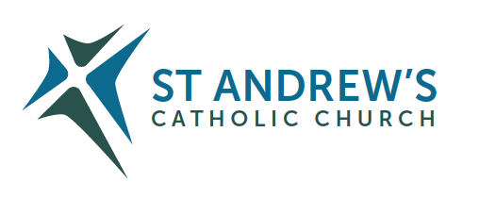
Parish Priest: Fr Behruz Rafat Telephone 01580 762785 Mobile: 07903 986646
Address: The Presbytery, 47 Ashford Road, Tenterden, Kent TN30 6LL.
Parish E-mail behruzrafat@rcaos.org.uk Parish Website: www.standrewstenterden.org
Deacon: Rev. Jolyon Vickers Telephone: 01580 766449 Email: jolyonvickers@rcaos.org.uk Hire of Parish Hall: Lesley McCarthy 07791 949652 E-mail: bookings.standrews@talktalk.net
Newsletter Editor: Patricia Sargent 01233 850963 E-mail: sargentpat51@gmail.com

Newsletter for the week commencing 31st October 2021
All Saints
Entrance antiphon: Let us rejoice in the Lord, as we celebrate the feast day in honour of all the Saints, at whose festival the Angels rejoice and praise the Son of God.
First Reading: Apocalypse 7: 2-4;9-14
Psalm23 Response: Such are the men who seek your face, O Lord.
Second Reading: First letter of St John 3:1-3
Acclamation: Alleluia, alleluia! Come to me, all you who labour and are overburdened, and I will give you rest, says the Lord. Alleluia!
Gospel: Matthew 5: 1-12
Communion antiphon: Blessed are the clean of heart, for they shall see God. Blessed are the peacemakers, for they shall be called the children of God. Blessed are they who are persecuted for the sake of righteousness, for theirs is the Kingdom of Heaven.

November is the month of Holy Souls
Blessing of graves at Tenterden cemetery on Sunday 7 November at 11.30am.
Special sequence of music and scripture Friday 12 November at 10.30am
Remembrance service on Sunday 21 November at 3pm.

Father Behr writes:
Dear Parishioners

All Souls
As you know November is the month of the Holy Souls in Purgatory. The holy souls need our prayers so that they can enjoy the complete happiness of Heaven.

The Catechism speaks of Purgatory as the final purification and teaches

All who die in God’s grace and friendship, but still imperfectly purified, are indeed assured of their eternal salvation; but after death they undergo purification, so as to achieve the holiness necessary to enter the joy of heaven. (CCC 1030)

From the beginning the Church has honoured the memory of the dead and offered prayers in suffrage for them, above all the Eucharistic sacrifice, so that, thus purified, they may attain the beatific vision of God. The Church also commends almsgiving, indulgences, and works of penance undertaken on behalf of the dead: (1032)

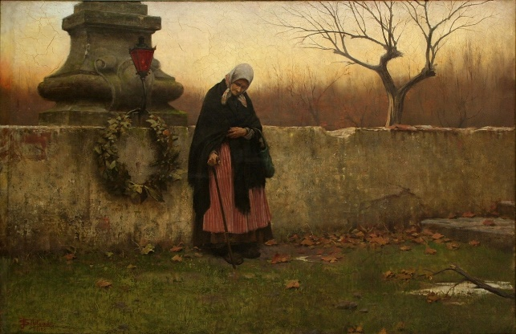
All Souls' Day, painting by Jakub Schikaneder, 1888
I would encourage you to have Holy Mass offered for all your deceased relatives during the month of November. Please also consider coming to Tenterden cemetery on the 7 November for the service and blessing of graves after the morning Mass and our service of prayer and remembrance on 21 November at 3pm.

Best wishes
Father Behr

Your Prayers are asked for:
Those recently deceased:
Those ill or infirm: Charlotte Elliot (daughter of Maureen Davidson), Joe Adams, Ellie Lawrence, Anne Bryant, Patricia Hook, Elena Peck (senior), Josie Payne, Pat Holland and all those self-isolating or suffering from COVID-19.
Those whose anniversaries of death occur at this time: Maureen Gilberto, John Dumbleton, Arthur Mollett, Lucy Mullins, Joseph Venables, Eric Ronald Booth and Norah Reed.

Congratulations to Lucie Burrows on making her First Holy Communion this Sunday!

This week’s services (30th October – 6th November),
Feasts and Mass intentions during the week.
Saturday 30th October  10am Mass  6pm Vigil Mass | The Blessed Virgin Mary  Father Gerrit Vervenne RIP  Private intention | Thursday 4th November  10am Mass | St Charles Borromeo, Bishop  Mass for Priests
Sunday 31st October  10am Mass  12 Midday Traditional Latin Mass | ALL SAINTS  People of the Parish | Friday 5th November  10am Mass | Feria  Private intention
Monday 1st November  10am Mass | Feria  Anne Nichols well-being | Saturday 6th November  10am Mass  6pm Vigil Mass | The Blessed Virgin Mary  People of the Parish
Tuesday 2nd November  10am Mass | THE COMMEMORATION OF ALL THE FAITHFUL DEPARTED  Holy Souls | Sunday 7th November  10am Mass  12 midday Traditional Latin Mass | Thirty-second Sunday (B)  John Dumbleton RIP
Wednesday 3rd November 10am Service of the Word and Holy Communion | St Martin de Porres
Flowers: For 7th November - Breeda

Synod
A two-year ‘synodal’ process is taking place in the Catholic Church from October 2021 that culminates in the final Synod Gathering of Bishops in Rome in October 2023. The overall theme is “For a Synodal Church: Communion, Participation, Mission”.
A synodal Church, in announcing the Gospel, ‘journeys together.’ How is this ‘journeying together’ happening today in your local Church? What steps does the Spirit invite us to take in order to grow in our ‘journeying together’?
Parish Meetings

Dates for Synod meetings at St Andrew’s between the Parish delegate Kathleen Bishop and parishioners:
Please try to attend one of these meetings and give your opinions and ideas. The meetings will last an hour and you only have to attend one!
In person:
Friday 5 November after 10am Mass
Sunday 21 November after 10am Mass
Online:
Monday 8 November 7.30pm Zoom Meeting

Thank you to everyone who offered to help with the Manger Trail but regretfully we have cancelled the Trail this year and will just concentrate on the Christmas Tree Festival.
A new networking group for clubs & groups!!!
Tenterden Community Action Network “CAN Do” is being formed to continue the positive, innovative and collaborative thinking that has seen us through the past eighteen months. We are stronger together!

Being part of a wider group will make us all stronger in the future and enable Tenterden to naturally develop more sustainable ideas.

Our first networking event is in St Mildred's Church on Monday 1 November 2021 at 5pm.

All community groups are welcome to come along and join in, meet other community groups. There's no need to tell us you're coming - just pop in!

See you there!

