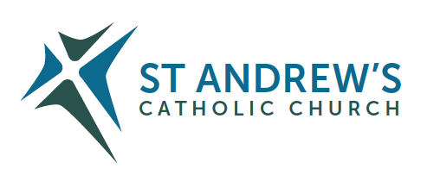
Parish Priest: Fr Behruz Rafat Telephone 01580 762785 Mobile: 07903 986646
Address: The Presbytery, 47 Ashford Road, Tenterden, Kent TN30 6LL.
Parish E-mail behruzrafat@rcaos.org.uk Parish Website: www.standrewstenterden.org
Deacon: Rev. Jolyon Vickers Telephone: 01580 766449 Email: jolyonvickers@rcaos.org.uk Hire of Parish Hall: Lesley McCarthy 07791 949652 E-mail: bookings.standrews@talktalk.net
Newsletter Editor: Patricia Sargent 01233 850963 E-mail: sargentpat51@gmail.com

Newsletter for the week commencing 7th November 2021
Thirty-second Sunday in Ordinary Time (B)
Entrance antiphon: Let my prayer come into your presence. Incline your ear to my cry for help, O Lord.
First Reading: First book of Kings 17: 10-15
Psalm 145 Response: My soul, give praise to the Lord.
Second Reading: Hebrews 9: 24-28
Acclamation: Alleluia, alleluia! Even if you have to die, says the Lord, keep faithful, and I will give you the crown of life. Alleluia!
Gospel: Mark 12: 38-44
Communion antiphon: The Lord is my shepherd; there is nothing I shall want. Fresh and green are the pastures where he gives me repose, near restful water he leads me.

November is the month of Holy Souls
Blessing of graves at Tenterden cemetery on Sunday 7 November at 11.30am.
Special sequence of music and scripture Friday 19 November at 10.30am
Remembrance service on Sunday 21 November at 3pm.
(Please note the change of date for the special sequence of music and scripture)

Father Behr writes:
Dear Parishioners
Blessing of Cemetery and Indulgences.
It is possible to gain a plenary indulgence for the souls in purgatory by visiting a cemetery. On Sunday we have a special service at Tenterden cemetery at 11.30am directly after Mass.
Here is an extract of the decree from the Apostolic Penitentiary
a.- the Plenary Indulgence for those who visit a cemetery and pray for the deceased, even if only mentally, normally established only on the individual days from 1 to 8 November, may be transferred to other days of the same month, until its end. These days, freely chosen by the individual believers, may also be separate from each other.

What do I have to gain this indulgence?
Visit a cemetery during November.
Go to confession (about 20 days before or after the visit) , receive holy Communion and pray for the intentions of the Holy Father.

For those who are housebound they may receive the indulgence for the holy souls by making a spiritual communion and praying for the Holy Father. I am also always happy to visit the housebound with Holy Communion and for Confession. Just send me an email or phone me to arrange a visit.

Best wishes
Father Behr

Your Prayers are asked for:
Those recently deceased:
Those ill or infirm: Charlotte Elliot (daughter of Maureen Davidson), Joe Adams, Ellie Lawrence, Anne Bryant, Patricia Hook, Elena Peck (senior), Josie Payne, Pat Holland and all those self-isolating or suffering from COVID-19.
Those whose anniversaries of death occur at this time: Joan D’Arts, Bernardette O’Malley, Yvonne Smith, Jo Babicz, Ross Smith, William Ovens, John Gray and Mary Pollock.

This week’s services (6th – 13th November 2021), Feasts and Mass intentions during the week.

Saturday 6th November  10am Mass  6pm Vigil Mass | The Blessed Virgin Mary  Little M  People of the Parish | Thursday 11th November  10am Mass | St Martin of Tours, Bishop  Michael Payne (90th Birthday)
Sunday 7th November  10am Mass  12 Midday Traditional Latin Mass | Thirty-second Sunday (B)  John Dumbleton (Anniversary)RIP | Friday 12th November  10 am No Mass - Service of the Word and Holy Communion | St Josaphat, Bishop & Martyr
Monday 8th November  10am Mass | St Willibrord, Bishop Br Thomas O’Johnson RIP | Saturday 13th November  10am Mass  6pm Vigil Mass | St Frances Xavier Cabrini, Religious  Father Robert Ellis RIP  Parents of Guy & Catrina RIP
Tuesday 9th November  10am Mass | The Dedication of the Lateran Basilica  Private Intention | Sunday 14th November  10am Mass  12 midday Traditional Latin Mass | Thirty-third Sunday (B)  People of the Parish
Wednesday 10th November 10am Service of the Word and Holy Communion | St Leo the Great, Pope
Flowers: For 14th November (Remembrance Sunday) - Frances
Second collection this weekend for the Archbishop’s Fund for Diocesan Administration, which helps to meet the cost of the central administration of the diocese.

On the weekend of 21st November there is a second collection for Catholic Youth Services.

Synod
A two-year ‘synodal’ process is taking place in the Catholic Church from October 2021 that culminates in the final Synod Gathering of Bishops in Rome in October 2023. The overall theme is “For a Synodal Church: Communion, Participation, Mission”.
A synodal Church, in announcing the Gospel, ‘journeys together.’ How is this ‘journeying together’ happening today in your local Church? What steps does the Spirit invite us to take in order to grow in our ‘journeying together’?
Parish Meetings

Dates for Synod meetings at St Andrew’s between the Parish delegate Kathleen Bishop and parishioners:
Please try to attend one of these meetings and give your opinions and ideas. The meetings will last an hour and you only have to attend one!
In person:
Sunday 21 November after 10am Mass
Online:
Monday 8 November 7.30pm Zoom Meeting

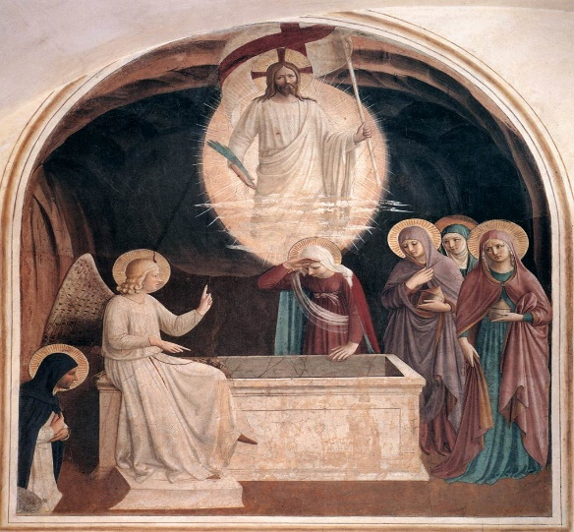
Women at the empty tomb, by Fra Angelico, 1437–1446

