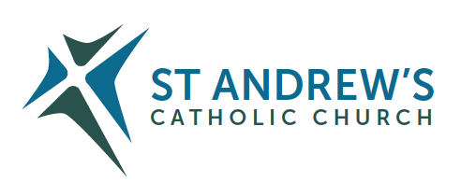
Parish Priest: Fr Behruz Rafat Telephone 01580 762785 Mobile: 07903 986646
Address: The Presbytery, 47 Ashford Road, Tenterden, Kent TN30 6LL.
Parish E-mail behruzrafat@rcaos.org.uk Parish Website: www.standrewstenterden.org
Deacon: Rev. Jolyon Vickers Telephone: 01580 766449 Email: jolyonvickers@rcaos.org.uk Hire of Parish Hall: Lesley McCarthy 07791 949652 E-mail: bookings.standrews@talktalk.net
Newsletter Editor: Patricia Sargent 01233 850963 E-mail: sargentpat51@gmail.com

Newsletter for the week commencing 28th November 2021
First Sunday of Advent (C)
Entrance antiphon: To you, I lift up my soul, O my God. In you, I have trusted; let me not be put to shame. Nor let my enemies exult over me; and let none who hope in you be put to shame.
First Reading: Jeremiah 33: 14-15
Psalm 24 Response: To you, O Lord, I lift up my soul.
Second Reading: First letter of St Paul to the Thessalonians 3: 12 – 4: 2
Acclamation: Alleluia, alleluia! Let us see, O Lord, your mercy and give us your saving help. Alleluia!
Gospel: Luke 21: 25-28; 34-36
Communion antiphon: The Lord will bestow his bounty, and our world shall yield its increase.

Father Behr writes:

Dear Parishioners

A few simple suggestions as we begin the joyful season of Advent.
Come to an extra Mass during the week. Weekday Mass is at 10am and takes about half an hour.
Fasting from meat or alcohol during the season is a wonderful way to prepare for the joy of Christmas. Children can be encouraged to give up sweets or chocolate.
Before Mass we will be praying the Angelus together during the season of Advent and Christmastide. You may wish to read this reflection on this painting of the Annunciation below.
https://www.christian.art/daily-gospel-reading/37

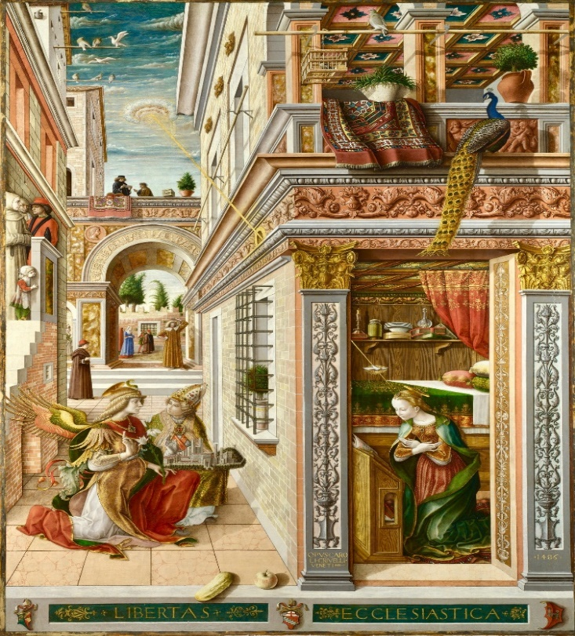
The Annunciation with St Emidius, Painted by Carlo Crivelli (1430-1495), Painted in 1486, Oil on canvas, Â© National Gallery, London

Bishops Statement on the Sunday Obligation

Honouring Sunday
As the Synodal Pathway of listening and discerning unfolds, we the bishops of England and Wales, are paying particular attention to the hopes and fears, the joys and anxieties of all who are sharing their thoughts and feelings with us.

Longing for our Lord
We are attentive to the experience of the last year or so, when we have lived our faith through the limitations of the pandemic. We have heard of the longing which some express as a “homesickness”. We want to be in the presence of the Blessed Sacrament. We yearn to celebrate the sacraments together, especially the Holy Sacrifice of the Mass. We desire to be nourished by our Lord in Holy Communion. The live streaming of the Mass and the remarkable response of our Catholic communities to those in need, have provided comfort, sustenance and resilience.

The Eucharist, source and summit
The Eucharist is the source and summit of our spiritual and pastoral life. Many people have said to us that they have appreciated the noble simplicity of the Mass at this time, which has allowed the mystery and majesty of our Lord’s sacrificial love to shine through.
The central appeal of the Mass, its beauty and its transcendence, raises our minds and hearts to God in an unambiguous and compelling manner. Our Lord Jesus invites us to receive anew the gift of Sunday as the preeminent day, the day of the Resurrection, when the Church gathers to celebrate the Eucharist. Here we stand together before our heavenly Father, offering our thanksgiving and prayer, through our Saviour in the Holy Spirit. Here we receive Christ in his Word. Here we are nourished by Christ in his precious Body and Blood. This is our primary joy, for which there is no substitute, and from which we draw our strength.

The Gift of the Sunday Eucharist
The Sunday Eucharist is a gift; as God’s holy people we are called to praise and thank God in the most sublime way possible. When the Church speaks of the Sunday obligation, it reminds us that attending Mass is a personal response to the selfless offering of Christ’s love.
At this time, we recognise that for some people there may be certain factors which hinder attendance at Sunday Mass. The pandemic is clearly not over. The risk of infection is still present. For some, there is legitimate fear in gathering together. As your bishops, we recognise that these prevailing circumstances suggest that not everyone is yet in the position to fulfil the absolute duty to attend freely Sunday Mass.

Responding to the Gift
We now encourage all Catholics to look again at the patterns which they have formed in recent months with regard to going to Mass on Sundays. This would include consideration and reflection about what we might do on Sundays, such as sports or shopping, or other leisure and social activities. This review, and the decisions which arise from it, fall to every Catholic and we trust this will be done with honesty, motivated by a real love for the Lord whom we encounter in the Mass.
The Sunday Mass is the very heartbeat of the Church and of our personal life of faith. We gather on the “first day of the week,” and devote ourselves to the apostles’ teaching and the fellowship, to the breaking of bread and the prayers (Acts 2:42). The Eucharist sustains us and spurs us on, renewing our gratitude and our hope. When we say “Amen” to Christ in receiving his Body and Blood, we express the love of God which is deep within us, and at the end of Mass, when we are sent forth, we express our love for our neighbour, especially those in need. These two dimensions reveal the full meaning of our faith. We are gathered together and sent out, we pray and are fed, we worship and we adore; these are intrinsic to our lives as those baptised into Christ.
Approved at the Plenary Assembly of Bishops in Leeds.
Thursday 18 November 2021
Best wishes
Father Behr

Your Prayers are asked for:
Those recently deceased:
Those ill or infirm: Marie Smith, Charlotte Elliot (daughter of Maureen Davidson), Joe Adams, Ellie Lawrence, Anne Bryant, Patricia Hook, Elena Peck (senior), Josie Payne, Pat Holland and all those self-isolating or suffering from COVID-19.
Those whose anniversaries of death occur at this time: Irene Balkham, Jimmy Hodson, Catherine Broughton, Theresa Maloney, John Leonard, David Daniels, Marie Witham, Ethel Curie, Rose Hewer- Hearst, Edith Margaret Corbett and Alex Mickle.

This week’s services (27th November – 4th December 2021),
Feasts and Mass intentions during the week.
Saturday 27th November  10am Mass  6pm Vigil Mass | The Blessed Virgin Mary  Allen Davis RIP  Father Kenneth McCarthy RIP | Thursday 2nd December  10am Mass | Feria  Holy Mass for Priests
Sunday 28th November  10am Mass  12 Midday Traditional Latin Mass | First Sunday of Advent (C)  People of the Parish | Friday 3rd December  10am Mass | St Francis Xavier, Priest  Kate Sarkis Intention
Monday 29th November  10am Mass  12 midday | Feria Holy Souls Funeral for Peter John Russell | Saturday 4th December  10am Mass  6pm Vigil Mass | St John Damascene, Priest & doctor of the Church  Bridget Bishop RIP  Fr Mario Sanderson RIP
Tuesday 30th November  10am Mass | St Andrew, Apostle Gertrude Barclay Foundation Mass | Sunday 5th December  10am Mass  12 midday # Traditional Latin Mass | Second Sunday of Advent (C)  People of the Parish
Wednesday 1st December 10am Service of the Word and Holy Communion | Feria
Flowers: For 29th Nov - Francien

Advent Confession
Next weekend, on Saturday 4 December and Sunday 5 December, Father Gabriel Diaz will be preaching at Mass and he will be available for Confession after holy Mass.
Have you bought your Christmas cards yet? Come to the Parish Centre after Mass (Saturday and Sunday) this weekend and check out our lovely selection of religious cards.
Proceeds will go to the “Catholic Children’s Society” and “Aid to the Church in need”.

A few reminders…
One of the jewels of the 2nd Vatican Council was the production of a new lectionary for use on Weekdays and Sundays and Holydays. This schematic reading of the Bible over a 3-year cycle for Sundays and a 2-year cycle for weekdays was then taken up by many of the “main-stream” Christian communities.
Thus, this Advent (starting Sunday 28th November) and for the next year, we will be all focussing on Saint Luke’s Gospel.
“Mapping Luke” is a unique way to explore the Gospel of Luke through 5 Bible study “maps”. Each “map” takes us on a reflective journey through a key episode of the Gospel with the help of art, poetry and music and invites our response.
No prior knowledge is required, yet even for those, who know the Gospel well, there is always something new to discover.
“Mapping Luke” will be online only on Wednesday evenings at 19:00 and thereafter on YouTube.

Thanks to our colleagues in the Church of England in Tenterden, tomorrow, we begin a new, online only series, entitled Mapping Luke.

Luke's Gospel presents Jesus as both the promised Saviour of Israel and as the Saviour of the whole human race.

Luke records that Jesus was called by the Spirit of the Lord to “bring good news to the poor”, and this Gospel is filled with a concern for people with all kinds of need.

The note of joy is also prominent in Luke, especially in the opening chapters that announce the coming of Jesus, and again at the conclusion, when Jesus ascends to heaven.

The story of the growth and spread of the Christian faith after the ascension of Jesus is told by the same writer in Acts.

There is much material that is found only in this gospel, such as:
the stories about the song of the angels,
and the shepherds' visit at the birth of Jesus,
Jesus in the Temple as a boy,
and the parables of the Good Samaritan and the Lost Son.
Throughout the gospel, great emphasis is placed on
prayer,
the Holy Spirit,
the role of women in the ministry of Jesus,
and God's forgiveness of sins.

Now you may know that the Catholic Church, the Church of England and other denominations follow a pattern of Sunday readings in a three-year cycle, each year focussing, in turn, on the gospels of Matthew, Mark and Luke (with bits from John appearing in all three years). We move from one year to the next at the beginning of Advent.

Over the next twelve months, the Sunday readings will be taken, for the most part, from Luke’s Gospel. To help us to appreciate more fully the gospel of Luke, we are going to use Advent to go on five reflective journeys, with the help of art, poetry and music and an interactive response. No prior knowledge is required, yet even for those who know Luke's Gospel well, there will be something new to discover.

Mapping Luke will be available from 6am tomorrow, and the following four Fridays. A link will be forwarded to you to use.
Deacon Jolyon
The Big Wrap – Saturday 4th December 2021
Last chance to help.
The Big Wrap supports families in Tenterden and the surrounding villages, who may be experiencing difficult times, by providing gifts, festive items and food vouchers.
We will be collecting donations of:
- brand-new items for children from baby to 16 years (suggested spend £10, but smaller items can be combined). Please avoid PC games, DVD’s, CD’s, weapon related toys and used/damaged items
- Gift cards
- Food and Hygiene items to include day to day food essentials such as
  - Flour, cereals, sugar, tea and coffee
  - Tins of fish, ham, spam, beans, pasta, soups, fruit, rice pudding etc
  - Toiletries, particularly feminine hygiene products
  - Jams
  - Pasta sauces
  - Long life Milk
  - Fruit Squash
  - Dry pasta and rice
  - Nappies, wet wipes and other baby care essentials
- Festive items, such as packets of mince pies, Christmas puddings, biscuits and confectionery
- Wrapping paper
Please bring these items to Saint Andrew’s by 9am Saturday December 4th. Boxes will be available for your donations
If you are able to help with the wrapping, please come to Saint Mildred’s Church by 13:00 on Saturday 4th December 2021
Many thanks in advance
Deacon Jolyon

And finally…
There will be tea and coffee after the 10 am Mass this Sunday.
Come and have a chat and some refreshments before you set off for home!

