T E N T E R D E N K E N T

**Parish Priest:** Fr Behruz Rafat **Telephone** 01580 762785 Mobile: 07903 986646

**Address:** The Presbytery, 47 Ashford Road, Tenterden, Kent TN30 6LL.

**Parish E-mail** [behruzrafat@rcaos.org.uk](mailto:behruzrafat@rcaos.org.uk) **Parish Website:** www.standrewstenterden.org

**Deacon:** Rev. Jolyon Vickers **Telephone:** 01580 766449 **Email:** jolyonvickers@rcaos.org.uk **Hire of Parish Hall:** Lesley McCarthy 07791 949652 **E-mail:** [bookings.standrews@talktalk.net](mailto:bookings.standrews@talktalk.net)

**Newsletter Editor:** Patricia Sargent 01233 850963 **E-mail:** sargentpat51@gmail.com

**Newsletter for the week commencing 24th January 2021**

**Third Sunday in Ordinary Time (B)**

**Entrance antiphon: O sing a new song to the Lord; sing to the Lord, all the earth. In his presence are majesty and splendour, strength and honour in his holy place.**

**First Reading: Jonah 3: 1-5, 10**

**Psalm 24 Response: Lord, make me know your ways.**

**Second Reading: First letter of St Paul to the Corinthians 7: 29-31**

**Acclamation: Alleluia, alleluia! The kingdom of God is close at hand: believe the Good News. Alleluia!**

**Gospel**: **Mark 1: 14-20**

**Communion antiphon: Look toward the Lord and be radiant; let your faces not be abashed.**

**Father Behr writes:**

This Sunday is the Sunday of the Word of God.  We are invited to deepen our appreciation and love for Sacred Scripture.

Pope Francis said, 'Devoting a specific Sunday of the liturgical year to the word of God can enable the Church to experience anew how the risen Lord opens up for us the treasury of his word and enables us to proclaim its unfathomable riches before the world.'    And 'the Third Sunday in Ordinary Time is to be devoted to the celebration, study and dissemination of the word of God.'  - (Aperuit illis)

There are so many excellent resources available for people who want to go deeper into the Bible.  You can always write to me and I will be happy to recommend things based on your interest and experience.

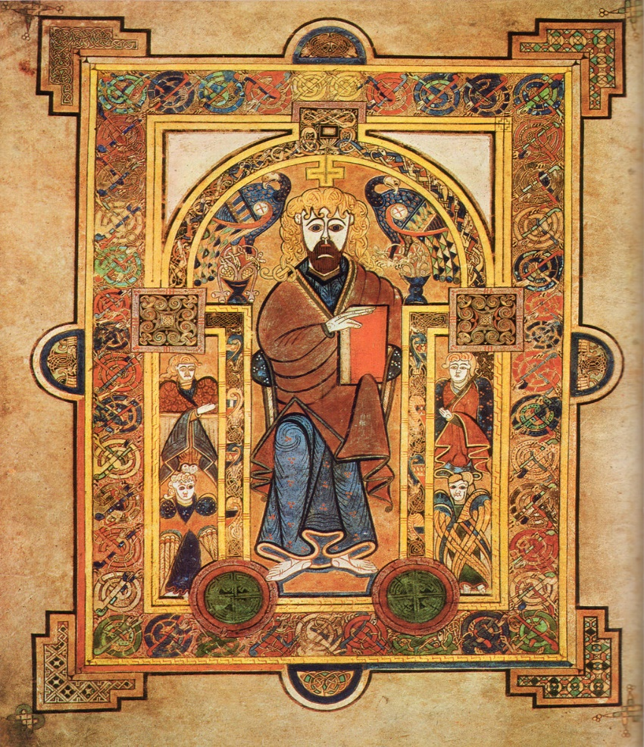

The image above is Christ Enthroned from the Book of Kells c800AD

We need to pray and ask for the grace to fall in love with Jesus, the Word of God, and the Bible which is the trustworthy revelation of God. It is an amazing library of inspired works, that can really help us to grow in our relationship with the Lord, but we need a framework to find a way in.  We need to understand the culture, history and literary genre of the books to really appreciate the truth that is revealed.

I will list a few free resources that you may like to explore.

<https://stpaulcenter.com/studies-tools/journey-through-scripture/parousia-the-bible-and-the-mass/>

<https://www.godwhospeaks.uk/the-god-who-speaks/bible-basics/>

[http://www.scotthahn.com](http://www.scotthahn.com/)

<https://www.universalis.com/mass.htm>

“This word is very near to you: it is in your mouth and in your heart for your observance” (*Dt* 30:14).

Fr Behr

**Your Prayers are asked for:**

**Those recently deceased**: Maggie Urquhart RIP, Trevor Leney RIP, Wilhelmina Franklin RIP, Alan Dorey RIP

**Those ill or infirm:** Charlotte Elliot (daughter of Maureen Davidson), Jennifer Jorden, Joe Adams, Ellie Lawrence, Anne Bryant,

Patricia Hook, Elena Peck (senior), Marjorie Dumbleton, Josie Payne, Pat Holland and all those self-isolating or suffering from COVID-19.

**Those whose anniversaries of death occur at this time:** Walter Wybourne,Patrick Byrne, Cyril Read, Canon Charles Walker and Ron Roberts.

**The funeral service for Alan Dorey** is on **Thursday, January 28th at 12:15** at **Charing Crematorium Chapel**.

**The funeral service for Wilhelmina Franklin** (of Woodchurch) will be on **Thursday, February 4th at 1pm (13:00)** at

**Wealden Crematorium Chapel, Horam.**

**This week’s services (24th – 30th January), Feasts and Mass intentions during the week.**

|  |  |  |  |
| --- | --- | --- | --- |
| **Sunday 24th Jan**  10 am Mass  **6 pm** | **Third Sunday of the Year**  **Ecumenical Celebration Service (via Zoom)** | **Thursday 28th Jan**  10 am Mass | St Thomas Aquinas, Priest & Doctor of the Church |
| **Monday 25th Jan**  10 am Mass | The Conversion of St Paul the Apostle  End of the Octave of Prayer for Christian Unity | **Friday 29th Jan**  10 am Mass | Feria |
| **Tuesday 26th Jan**  10 am Mass | Sts Timothy & Titus, Bishops | **Saturday 30th Jan**  10 am Mass | The Blessed Virgin Mary |
| **Wednesday 27th Jan**  10 am Service of the Word and Holy Communion | St Angela Merici, Virgin | **Sunday 31st Jan**  10 am Mass | **Fourth Sunday of the Year (B)**  **Racial Justice Day** |
| **Flowers for 31st Jan – Hilary Edwards** | | | |

Please try to join the Zoom service this Sunday evening. **Here is the link:**

**Topic: Churches Together Sunday 24 January 6pm   
Time: Jan 24, 2021 06:00 PM London**

**Join Zoom Meeting**[**https://us02web.zoom.us/j/88456488073?pwd=aFNOWG4rK3hMOEFhc1orQVByZjUzQT09**](https://us02web.zoom.us/j/88456488073?pwd=aFNOWG4rK3hMOEFhc1orQVByZjUzQT09)

A reminder of ways you can **support and participate in 40 Days of Prayer for Tenterden and our Nation**

There are several things we can do to support these 40 days of prayer.  
 Would you visit the My Tenterden website and look at the reflections and resources, which are being offered for each day?

[**https://www.mytenterden.co.uk/events/forty-days-of-prayer-churches-together-in-tenterden-listing-1357-82671.aspx#.X_cAGy3fXmp**](https://www.mytenterden.co.uk/events/forty-days-of-prayer-churches-together-in-tenterden-listing-1357-82671.aspx#.X_cAGy3fXmp)

You may like to fast on bread and water on Friday for the intention of the renewal of Christianity in our local area.  Alternatively, you could give up a main meal or give up television or something else you enjoy.

Say an extra Our Father in your family each day for the intention of the renewal of faith in Christ in our town and in our nation.

Look for opportunities to do something good for someone in need out of love for Jesus.  Perhaps there is someone you know who is lonely or afraid and who would appreciate a phone call or a card.

Almsgiving is a very powerful way of showing our love for God.  It is particularly powerful when we help those who can’t repay us in any way.

We all have sense of how much we need the Light of Christ in our lives and in our world. We have an amazing opportunity to share the good news that no matter how difficult the times get, with faith in Jesus, we always have hope and love.

The **Minutes of the recent St Andrew’s Parish Council Meeting** will be on the noticeboard in the porch for the next two weeks.

There will be a **second collection** next Sunday (31st January) for **Racial Justice**.

And finally, **a tribute for Maggie Urquhart:**

Maggie started married life in the Pacific Islands and from what she told me she had a very full and exciting life before she settled in Tenterden. Even then very late in her life she spent Christmas in the Cayman Islands with her son, travelling back all alone.

Maggie was quite a character. I will always remember her, half running the length of Tenterden with clean starched altar cloths or rushing to get the altar ready for daily Mass.  She was so upset one morning because she was late “Oh I’m so sorry Father “she said through her tears.  Father John comforted her.

It was not until the beginning of this awful virus that I really got to know her well by doing some shopping for her.  My goodness that tiny lady ate well. Every Monday morning, she rang with a list. “I want the strawberry jam, dear, with the red and white top, dear, remember the red and white top, brown bread, make sure it’s the thick cut and four bottles of ale.” And so, it went on.

She showed me round her sweet little house, her piano that she played so well. On her TV she had one red button so with one click she had her catholic services. I will always remember her as a well-travelled lady, her friendship with Liz Goodwin, both with their own packet of cigarettes, but more importantly for Maggie the red button on the TV.

Maureen Davidson