T E N T E R D E N K E N T

**Parish Priest:** Fr Behruz Rafat **Telephone** 01580 762785 Mobile: 07903 986646

**Address:** The Presbytery, 47 Ashford Road, Tenterden, Kent TN30 6LL.

**Parish E-mail** behruzrafat@rcaos.org.uk **Parish Website:** www.standrewstenterden.org

**Deacon:** Rev. Jolyon Vickers **Telephone:** 01580 766449 **Email:** jolyonvickers@rcaos.org.uk **Hire of Parish Hall:** Lesley McCarthy 07791 949652 **E-mail:** bookings.standrews@talktalk.net

**Newsletter Editor:** Patricia Sargent 01233 850963 **E-mail:** sargentpat51@gmail.com

**Newsletter for the week commencing 21st February 2021**

**First Sunday of Lent (B)**

**Entrance antiphon: When he calls to me, I will answer him; I will deliver him and give him glory, I will grant him length of days.**

**First Reading: Genesis 9: 8-15**

**Psalm 24 Response: Your ways, Lord, are faithfulness and love for those who keep your covenant,**

**Second Reading: St Peter 3: 18-22**

**Acclamation: Praise to you, O Christ, king of eternal glory! Man does not live on bread alone, but on every word that comes from the mouth of God. Praise to you, O Christ, king of eternal glory!**

**Gospel**: **Mark 1: 12-15**

**Communion antiphon: One does not live by bread alone, but by every word that comes forth from the mouth of God.**

**Father Behr writes:**

Dear Parishioners

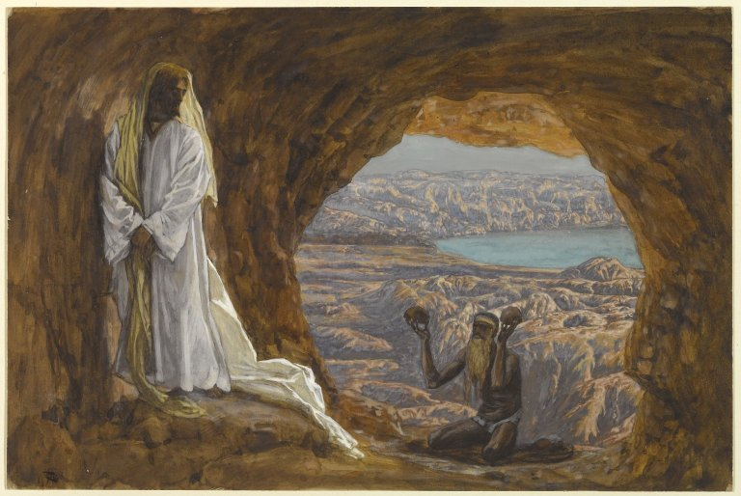

*Jesus Tempted in the Wilderness (Jésus tenté dans le désert)*, James Tissot, Brooklyn Museum (circa 1890)

‘Fasting of the body is food for the soul.’ St John Chrysostom

During this season of Lent we are called to deepen our spiritual lives using the ‘three pillars’ of

Prayer

Fasting

Almsgiving.

Today I want to focus on the value of fasting during Lent.

The Church does not oblige us to fast except on Ash Wednesday and Good Friday but as we learn to appreciate the value of fasting, we may wish to make this a regular spiritual practice.

First of all, those who want to fast from food should be in good health. If not, it may be better to practice another form of self-denial such as giving up things we enjoy or even more difficult, not insisting that we have the last word in every argument! We choose a particular day such as Fridays during Lent and try to stick with it.

Assuming a person is in good health and has decided to fast, it must always be accompanied by prayer. When I fast, I am going to encounter my own vulnerability and unless I am praying for grace, I could easily become discouraged, bad tempered or give in to other temptations.

I should start with a clear purpose by being clear about my intentions. For example, I am fasting from food on Fridays during Lent because I want to grow closer to God and as an offering for my prayer intentions.  Or, I am fasting from food during Lent to do penance for the sins I committed when I was young.  If I feel tempted to give up, I can remind myself of the reason why I am doing it and this will give me strength to continue.

Lots of helpful advice and encouragement is available online and you can always get in touch if you have any questions.

Online articles and guides to fasting:

https://spiritualdirection.com/2016/02/17/fasting-is-not-a-diet

https://www.catholic.org/lent/abfast.php

https://catholicgentleman.net/2014/04/spiritual-weapons-fasting/

Good general advice for Lent

https://catholicexchange.com/ten-ways-we-can-practice-fasting

Best wishes

Father Behr

**Your Prayers are asked for:**

**Those recently deceased: David Lloyd-Thomas RIP**

**Those ill or infirm:** David Green, Charlotte Elliot (daughter of Maureen Davidson), Jennifer Jorden, Joe Adams, Ellie Lawrence, Anne Bryant, Patricia Hook, Elena Peck (senior), Marjorie Dumbleton, Josie Payne, Pat Holland and all those self-isolating or suffering from COVID-19.

**Those whose anniversaries of death occur at this time:** Dennis Hobday, Frank O’Neill, Eileen Brandon, Raymond Carroll, Betty Manning, Maureen McGarry, Edmund Staples, Charles & Nellie Lawrence, Clifford Crofton, Marjorie Frain and Delia Pearson.

|  |  |  |  |
| --- | --- | --- | --- |
| **This week’s services (21st – 27th February), Feasts and Mass intentions during the week.** | | | |
| **Sunday 21st Feb**  10 am Mass  12 midday EF Mass (Latin) | **First Sunday of Lent (B)**  *People of the parish*  **Poor parishes** | **Thursday 25th Feb**  10 am Mass | Feria |
| **Monday 22nd Feb**  10 am Mass | The Chair of St Peter the Apostle | **Friday 26th Feb**  10 am Mass | Feria  *David Lloyd Thomas RIP* |
| T**uesday 23rd Feb**  10 am Mass | Feria  *Wilhelmina Franklin RIP* | **Saturday 27th Feb**  10 am Mass | Feria |
| **Wednesday 24th Feb**  10 am Service of the Word and Holy Communion | Feria | **Sunday 28th Feb**  10 am Mass | **Second Sunday of Lent (B)** |
| **No flowers during Lent** | | | |

**There will be a second collection this weekend for Poor Parishes.**

Archbishop John and the Diocesan Spirituality Commission are offering a **Retreat for Lent**, which you can follow in your own home.

Using the link below, you can watch a short video reflection each week, download prayer materials and other resources which can help you make the best use of whatever time and opportunity you may have during your week.

There are also additional materials for use by parish and other groups, either in person or via Zoom/Teams or similar.

**If you are looking for a way to deepen your life of prayer this Lent,** click on http://www.southwarkdsc.org.uk/followme where you can also sign up to receive materials directly to your email.

**And, for more suggestions…**

Churches Together in Tenterden

Suggested Lent Resources with Internet Links

Stations of the Cross: Lent 2021 | CAFOD

Your free devotional for Lent - Tearfund

Lent Page: Christian Publishing and Outreach (CPO)

Lent - Mission Together

Lent Resources (chpublishing.co.uk)

#LiveLent 2021 church resources: God’s Story, Our Story | The Church of England

The Baptist Union of Great Britain: Lent resources

Lent and Easter Resources (methodist.org.uk)

Diocesan Retreat 2021 — Archdiocese of Southwark Spirituality Commission (southwarkdsc.org.uk)

Lent (urc.org.uk)

FREE! resources for Lent 2021 (rootsontheweb.com)

The Resilient Disciple - Justine Allain Chapman - SPCK Publishing

**Hopefully, if you click on Hyperlink on your computer these links will open for you, if not there is sufficient information for you to Internet search**