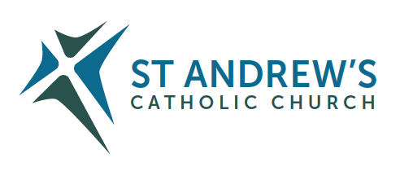
Parish Priest: Fr Behruz Rafat Telephone 01580 762785 Mobile: 07903 986646
Address: The Presbytery, 47 Ashford Road, Tenterden, Kent TN30 6LL.
Parish E-mail behruzrafat@rcaos.org.uk Parish Website: www.standrewstenterden.org
Deacon: Rev Jolyon Vickers Telephone: 01580 766449 Email: jolyonvickers@rcaos.org.uk Hire of Parish Hall: Lesley McCarthy 07791 949652 E-mail: tenterdenparishcentre@rcaos.org.uk
Newsletter Editor: Patricia Sargent 01233 850963 E-mail: sargentpat51@gmail.com

Double Issue Newsletter for the weeks commencing 17th April 2022 Sunday of the Resurrection
and 24th April 2022 Second Sunday of Easter (Divine Mercy)
Easter Sunday

Entrance antiphon: The Lord is truly risen, alleluia. To him be glory and power for all the ages of eternity, alleluia, alleluia!
First Reading: Acts of the Apostles 10: 34, 37-43
Psalm 117 Response: This day was made by the Lord; we rejoice and are glad.
Second Reading: The letter of St Paul to the Colossians 3: 1-4
Sequence: Christians, to the Pascal Victim offer sacrifice and praise
The sheep are ransomed by the Lamb;
And Christ, the undefiled,
Hath sinners to his Father reconciled.
Death with life contended: combat strangely ended!
Life’s own Champion, slain, yet lives to reign.
Tell us, Mary: say what thou didst see upon the way.
The tomb the Living did enclose;
I saw Christ’s glory as he rose!
The angels there attesting:
Shroud with grave-clothes resting.
Christ, my hope, has risen: he goes before you into Galilee.
That Christ is truly risen from the dead we know.
Victorious king, thy mercy show!
Amen.
Acclamation: Alleluia, alleluia! Christ, our Passover, has been sacrificed; let us celebrate the feast then, in the Lord. Alleluia!
Gospel: John 20: 1-9
Communion antiphon: Christ our Passover has been sacrificed, alleluia; therefore, let us keep the feast with the unleavened bread of purity and truth, alleluia, alleluia.

Father Behr writes:
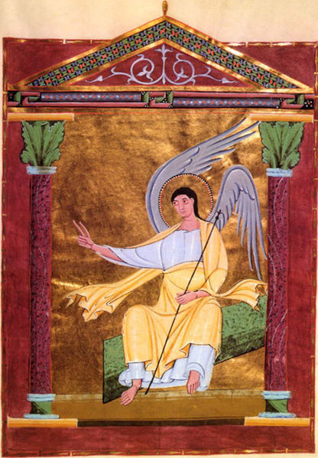

Pericopes of Henry II 11th century “Angel On Tomb”

Dear Parishioners
He is Risen. We celebrate the Resurrection of Our Lord Jesus with great joy this weekend.

Divine Mercy Novena
If you would like to pray the Divine Mercy Novena, which starts on Good Friday, you can see all the prayers by following this link
https://www.thedivinemercy.org/message/devotions/novena

Best wishes,
Fr Behr
Your Prayers are asked for:
Those recently deceased:
Those ill or infirm: Sylwia Dorosz, Joe Adams, Ellie Lawrence, Anne Bryant, Patricia Hook, Elena Peck (senior), Josie Payne, Pat Holland and all those who are unwell and in need of our prayers.
Those whose anniversaries of death occur at this time: Elizabeth Armstrong, Vera Ware, Ellen Marren, Joan Carey, Bozena Cloutier Wonska (Chris Lacki’s sister), Nellie Southcott, Elsie Brown, Deborah Burke, Bernard Grayner, John Stanley, Jack Holman and Eileen Rimmer.

This week’s services (17th – 23rd April 2022), Feasts and Mass intentions during the week.
Saturday 16th April: Holy Saturday
8pm: Easter Vigil Mass Thanksgiving Consecration of Russia and Ukraine
Sunday 17th April: Sunday of the Resurrection
10am: Easter Mass People of the Parish
12 midday Traditional Latin Mass
Monday 18th April (Easter Monday)
No Mass
Tuesday 19th April (Easter Tuesday)
No Mass
Wednesday 20th April (Easter Wednesday)
No Service of the Word and Communion
Thursday 21st April (Easter Thursday)
No Mass
Friday 22nd April (Easter Friday)
10am Mass: Margaret Banfield RIP
10.30am – 11.30am: Adoration:
Saturday 23rd April (Easter Saturday)
10am Mass: Morrison Family
10.30- 11am: Confession
6pm Mass: People of the Parish
Sunday 24th April: Second Sunday of Easter (Divine Mercy Sunday)
10am Mass: Burrows Family
12 midday Traditional Latin Mass:
Flowers for 24th April: Hilary + helpers to titivate/dismantle
Readers: for Saturday 23rd April – Charles/ Sunday 24th April – Kathleen

Your Easter Offering
Your Easter offering is your personal gift to your parish priest. Your priest relies on these offering for normal things like running a car, going on holiday and everyday items such as clothes and shoes

Next Sunday is Divine Mercy Sunday 24 April 3pm
Date for your diary!
We have special Holy Hour of adoration from 3pm. There will be a priest available for Confession. After Solemn Benediction around 4pm we will have a garden party with refreshments.
The afternoon will begin with a special blessing of our new Divine Mercy image in our car park.

APPRENTICE CHAPLAIN VACANCY
Are you interested in becoming a school chaplain? Would you like to learn more about what being a school chaplain involves? Know someone who would? St Simon Stock Catholic School has a really exciting opportunity to join our team as an Apprentice Chaplain, exploring your own call and ministry while sharing the good news with staff and students.

Application Deadline: 25th April 2022
Shortlisting: 29th April 2022
Interviews: w/c 3rd May 2022
For more information visit
https://www.ssscs.co.uk/support-posts/ Or Email irelandj@ssscs.co.uk

Wishing you all a Happy and Holy Easter!

Second Sunday of Easter C (Divine Mercy)

Entrance antiphon: Receive the joy of your glory, giving thanks to God, who has called you into the heavenly kingdom, alleluia!
First Reading: Acts of the Apostles 5: 12-16
Psalm 117 Response: Give thanks to the Lord for he is good, for his love has no end.
Second Reading: The book of the Apocalypse 1: 9-13, 17-19
Acclamation: Alleluia, alleluia! Jesus said: ‘You believe because you can see me. Happy are those who have not seen and yet believe.’ Alleluia!
Gospel: John 20: 19-31
Communion antiphon: Bring your hand and feel the place of the nails, and do not be unbelieving but believing, alleluia.

Your Prayers are asked for:
Those recently deceased:
Those ill or infirm: Sylwia Dorosz, Joe Adams, Ellie Lawrence, Anne Bryant, Patricia Hook, Elena Peck (senior), Josie Payne, Pat Holland and all those who are unwell and in need of our prayers.
Those whose anniversaries of death occur at this time: Margaret Toke-Nicholls, Florence (Flo) Primarolo, Karen Vidler, Gwen Terrett, Catherine Town, Patricia Walden, Catherine Dowding, Ellen Shanahan, Alfonsa Macapinlac Moodie, Bertha Parsons, John Parrock and Mary Hodges.

ANCIENT BYZANTINE ICONOGRAPHY COURSE
A full, 7-day immersion in the spirituality and discipline of writing an icon in the Byzantine style, led by Deacon Nikita Andreyev, of the Prosopon School of Iconography. Residential and non-residential options, with the course taking place from Saturday 25 June to Friday 1 July inclusive. Venue: Christian Heritage Centre, Stonyhurst. For more information and to book: https://christianheritagecentre.com/events/iconography-course/

This week’s services (23rd – 30th April 2022), Feasts and Mass intentions during the week.
Saturday 23rd April (Easter Saturday)
10am Mass: Morrison Family
10.30- 11am: Confession
6pm Mass: People of the Parish
Sunday 24th April: Second Sunday of Easter C (Divine Mercy)
10am Mass: Burrows Family
12 midday Traditional Latin Mass
Monday 25th April
10am Mass: St Mark, Evangelist Private Intention
Tuesday 26th April
10am Mass: St George, Patron saint of England Mark, Anna and Families
Wednesday 27th April
10am Service of the Word and Communion; Weekday of Easter
Thursday 28th April
9am – 10am: Adoration
10am Mass: St Peter Chanel, Priest, Martyr; St Louis Marie Grignion de Montfort, Priest Joan Carey RIP Foundation Mass
Friday 29th April
10am Mass: St Catherine of Siena, Virgin, Doctor of the Church Mick Prendergast RIP / Eddie Fahy RIP
10.30am – 11.30am: Adoration:
Saturday 30th April
10am Mass: St Pius V, Pope, Religious Ron Basher RIP
10.30- 11am: Confession
6pm Mass: Father Denis Paul RIP
Sunday 1st May: Third Sunday of Easter (C)
10am Mass: People of the Parish
12 midday Traditional Latin Mass:
Flowers for 1st May: Suzanne
Readers: for Saturday 30th April – Pat/ Sunday 1st May – Collette
Cleaners for 30th April/1st May: Brian & Frances

