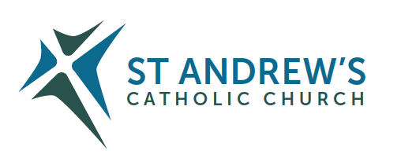
Parish Priest: Fr Behruz Rafat Telephone 01580 762785 Mobile: 07903 986646
Address: The Presbytery, 47 Ashford Road, Tenterden, Kent TN30 6LL.
Parish E-mail behruzrafat@rcaos.org.uk Parish Website: www.standrewstenterden.org
Deacon: Rev. Jolyon Vickers Telephone: 01580 766449 Email: jolyonvickers@rcaos.org.uk Hire of Parish Hall: Lesley McCarthy 07791 949652 E-mail: tenterdenparishcentre@rcaos.org.uk
Newsletter Editor: Patricia Sargent 01233 850963 E-mail: sargentpat51@gmail.com

Newsletter for the week commencing 1st May 2022
Third Sunday of Easter (C)
Entrance antiphon: Cry out with joy to God, all the earth; O sing to the glory of his name. O render him glorious praise, alleluia.
First Reading: Acts of the Apostles 5: 27-32; 40-41
Psalm 29 Response: I will praise you, Lord, you have rescued me.
Second Reading: Apocalypse 5: 11-14
Acclamation: Alleluia, alleluia! Christ has risen: he who crested all things, and has granted his mercy to men. Alleluia!
Gospel: John 21: 1-19
Communion antiphon: Jesus said to his disciples: Come and eat. And he took the bread and gave it to them, alleluia.

Father Behr writes:

Dear Parishioners
The month of May is dedicated to the Virgin Mary, the mother of Jesus. It is an excellent month to have a May procession and crowning of the statue of Our Lady.

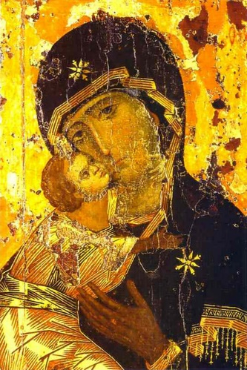

Vladimir icon of the Madonna with the Child Jesus

Annual Mass for Migrants
Monday, 2nd May 2022, at 2.30pm at Westminster Cathedral

The Dioceses and Ethnic Chaplaincies of Southwark, Westminster and Brentwood invite parishioners to a celebration of the annual Mass for Migrants. Banner procession starts at 2pm. The mass will be live streamed. The celebrant is Bishop Michael Campbell OSA. All are kindly invited to attend in person to celebrate the significant contribution made by migrants to the life of our Dioceses.

Mass in Celebration of the Sacrament of Marriage
Saturday July 9th at St George’s Cathedral 3pm

If you are celebrating your 1st/10th/25th/40th/50th/60th + wedding anniversary this year, please apply as soon as possible, and no later than May 31. Get in touch with us at mflkent@rcaos.org.uk so you can receive an invitation from the Archbishop. Spaces are limited. As the title of your email, please write your parish location e.g., Tenterden
and give us the following details: your names in the format John and Mary Smith, your home address, the anniversary you are celebrating. We look forward to seeing you in July!

Reading the Acts of the Apostles in Eastertide

Listen to the ‘Acts of the Apostles’ read throughout the season of Easter. Starting on Easter Monday, we begin Luke’s account of the early church after Christ’s Resurrection. The book of Acts records the spread of the Gospel from Jerusalem to Rome. You can listen to all 28 chapters, one-a-day from Monday to Saturday, taken from the English Standard Version of the Bible. https://www.cbcew.org.uk/series/reading-acts-in-easter/.

Congratulations to Rob and Isabella who are getting married at St Andrew on Saturday 21 May.

Best Wishes
Father Behruz Rafat

Your Prayers are asked for:

Those recently deceased:
Those ill or infirm: Mary Iglinski, Ailish Cantwell (Jones), Sylwia Dorosz, Joe Adams, Ellie Lawrence, Anne Bryant, Patricia Hook, Elena Peck (senior), Josie Payne, Pat Holland and all those who are unwell and in need of our prayers.
Those whose anniversaries of death occur at this time: Inez Wood, Alonzo Nugent, Fr John Hagreen (former Parish Priest), Ninette Purcell, John Moriarty, Sue Maxwell-Scott, Claire Claydon, Nigel Collins, Dr Mary Hoogewers, Ninette Newling and Winifred Price.

This week’s services (1st – 7th May), Feasts and Mass intentions during the week.
Saturday 30th April
10am Mass: St Pius V, Pope, Religious Ron Basher RIP
10.30- 11am: Confession
6pm Mass: People of the Parish Reader: Pat

Sunday 1st May: Third Sunday of Easter (C)
10am Mass: Sheelagh Horseman Wellbeing Reader: Collette
12 midday Traditional Latin Mass
Monday 2nd May
10am Mass: St Athanasius, Bishop, Doctor of the Church Margaret Banfield RIP

Tuesday 3rd May
10am Mass: Ss Philip and James, Apostles Private Intention

Wednesday 4th May
10am Service of the Word & Communion: The English Martyrs (E)

Thursday 5th May
9am-10am Adoration St Asaph, Bishop (W) Bernard Gallagher RIP
10am Mass:
Friday 6th May
10am Mass: Weekday of Easter Mary Iglinski Wellbeing (Ray Bell)
10.30am- 11.00am Adoration

Saturday 7th May
10am Mass: Weekday of Easter Father Denis Paul RIP
10.30am-11.00am Confession
6pm Mass: Maria Chainey Reader: Family readers

Sunday 8th May: Fourth Sunday of Easter ( C )
10am Mass: People of the Parish Reader: Brian
12 midday Traditional Latin Mass

Flowers for 8th May: Breeda

Readers: for Saturday 7th May – Family readers/ Sunday 8th May – Brian

Confession
Fr Behr is available for Confession every Saturday from 10.30am - 11am. He is also happy to visit those who are not able to come to church.
Canon John O’Toole
Just before Easter we were informed that Canon John is retiring from his role as Episcopal Vicar of Kent. We keep him in our prayers and ask for the guidance of the Holy Spirit on those who gather to select a new person for the role.

From Father Michael Woodgate
Dear Friends,
On Tuesday 3 May, I shall be celebrating my 25th Anniversary of Ordination to the Priesthood, which took place in Holy Family Church, Park Wood. I plan to say Mass at 9:30am in St. Thomas of Canterbury Church, Headcorn TN27 9SF on that day, and all are welcome.
On Saturday 7 May, Father Desmond, our P.P, has kindly invited me to celebrate a Mass of Thanksgiving in Holy Family Church ME15 9PS at 12 noon and arranged a light lunch in the church hall next door. There is limited parking at St. Thomas’s, rather more at Holy Family.
You are warmly invited to attend one or both of these events, but it would be helpful to have some idea of numbers, so if you could let me know before 1 May if you are coming, that would be very helpful for catering and seating arrangements.
Preferably contact this email address: kpentley@hotmail.co.uk to let us know you are coming. If you have no email then call this number 01622 891858

Saint Bernadette of Lourdes
The Friars at Aylesford will be hosting her relics from Monday 24 October to Friday 28 October 2022.
Monday - 7pm Welcome and Mass. Tuesday, Wednesday & Thursday - 12 noon Mass; 3.30pm Exposition & Benediction; 5pm Mass followed by Torchlight Procession.
Friday - 12 noon Mass & Farewell. Tel: 01622 717272 or reception@thefriars.org.uk

