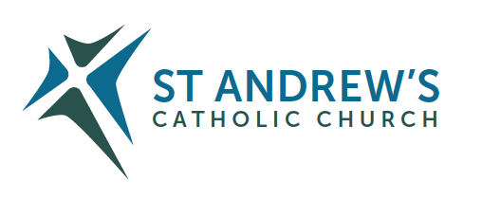
T E N T E R D E N K E N T

Parish Priest: The Rt. Rev. John Hine, (Emeritus Bishop)
Address: The Presbytery, 47 Ashford Road, Tenterden, Kent TN30 6LL.
Telephone: 01580 762785. Mobile: 07802 510847
Parish E-mail tenterden@rcaos.org.uk Parish Website: www.standrewstenterden.org
Deacon: Rev. Jolyon Vickers Telephone: 01580 766449 Email: j.vickers1@btinternet.com Hire of Parish Hall: Lesley McCarthy 07791 949652 E-mail: bookings.standrews@talktalk.net
Newsletter Editor: Patricia Sargent 01233 850963 E-mail: sargentpat51@gmail.com

Newsletter for the week commencing 20th/21st June 2020
Twelfth Sunday in Ordinary Time (A)

First Reading: Jeremiah 20: 10-13
Psalm 68 Response: In your great love, answer me, O God
Second Reading: St Paul’s letter to the Romans 5: 12-15
Gospel: Matthew 10: 26-33

Father John writes:
I am grateful to the group of volunteers for enabling us to have two hours of ‘private prayer’ in front of the Blessed Sacrament on Friday mornings 10am to 12 midday. I have now got all the requirements for ‘hand sanitising’, masks, and gloves etc. You are not expected to stay the whole time. The entry will be on the Turners Avenue side (the exit will be through the Fire door into the garden and out by that way to Turner’s Avenue.) Some explanation of the details will be given as you come in. There will be no service or led prayers – simply your prayer time in the Lord’s Sacramental presence.
Progress is being made in the refurbishment of the Church. By this weekend all the insulation on the ceiling should be completed. But there is still a lot more to be done, painting, the reordering of the sanctuary, electrical works etc.
Just a word on one of the individuals featured in the Scripture readings for this Sunday, namely the prophet Jeremiah. He is well known for prophesying doom and gloom! Right from the start he was the most reluctant of all the prophets and mad every excuse possible. He foresaw his message would not be welcomed, but he found he simply couldn’t keep silent about the Lord – it just burst out of him. And, sure enough, he was rejected by his listeners. He found himself in the stocks, being ridiculed and mocked. It was a bad time to be a prophet – they were experiencing the Babylonian Exile. And the temple which meant so much to them about God’s presence in their midst, had been ransacked. It was not an easy time to bring a message from God.
About fifty years ago, the Second Vatican Council told us: every baptised person is to be “priest, prophet and king.” This generation is also not the easiest time to be a prophet. The secular culture of our day is far from thirsting to know more about God. We need to ask Jeremiah to give us some of his strength. In the midst of his rejections, in our first reading today, he could say ‘ the Lord is at my side, a mighty hero’ ‘sing to the Lord, praise the Lord, for he has delivered the soul of the needy from the hands of evil men’.

Your Prayers are asked for:
Those recently deceased
Those ill or infirm: Joe Adams, Ellie Lawrence, Anne Bryant, Eric Booth, Patricia Hook, Elena Peck (senior), Marjorie Dumbleton, Josie Payne, Joe Venables and all those self-isolating or suffering from COVID-19
Those whose anniversaries of death occur at this time: Palas Blair-Drummond, Catherine Harre-Young, Stan Walczak, Lovemore Dzimati and Diana Wood.

This week
This Sunday is the Day of Prayer for Human Life.

Feast days
Wednesday 24th June | The Nativity of St john the Baptist
Sunday 28th June | St Peter and St Paul

Warning! Some parishioners have received emails supposedly from Fr John, asking the recipient to reply urgently as the sender needs a favour. The server should warn that it is a scam but be aware – the tone of the email is not quite Fr John! Also, the sender’s email address is NOT Fr John’s. If you are suspicious contact Fr John in a new email – DO NOT REPLY.

New Pilgrim Path Website of the Week Lectio Divina is the oldest method of Bible reading, systematised around the 5th century. It is a dialogue between the written biblical word and life experience. In the dialogue our experience throws light on the Bible word, bringing it to life for us so that we feel at home with it. The Bible word in turn throws light on our experience which is transformed from merely being an event into being a word of God spoken to us. Lectio Divina presupposes that every Bible text speaks to the imagination. It invites us to enter through our imagination into the movement. There are many excellent online resources for guided Lectio. One of these is provided by the Carmelite Brothers in Rome. You can access it at www.newpilgrimpath.ie
The refurb! You will be pleased to hear that everything is progressing well and up to the programme's schedule. The nave ceiling has been boarded in with insulated boards, the sanctuary flooring has been reinforced to allow the tabernacle to be moved and the infrastructure for the new lighting there is complete. In the coming week the contractor will begin to tackle the organ loft ceiling and work in the entrance lobby.
To keep right up to date with how the work is progressing, go to the website and click on “The Contractors are in!” on the front page.
Before…
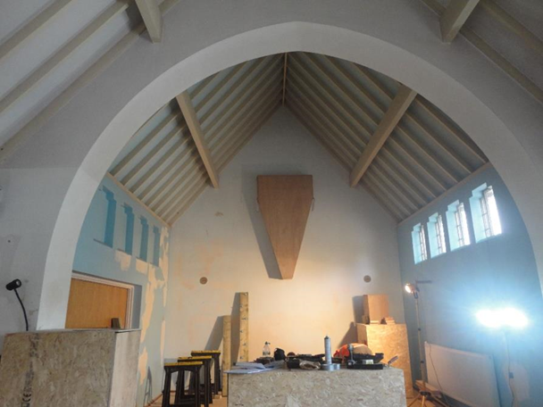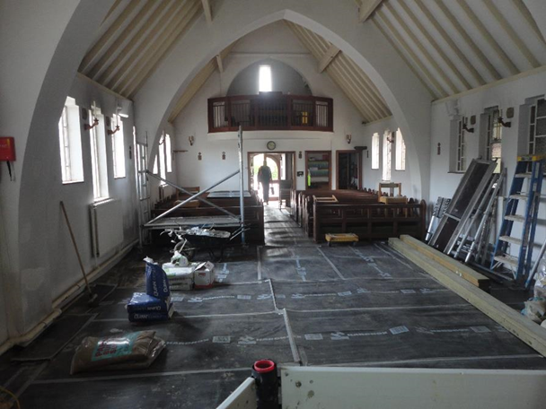

After…
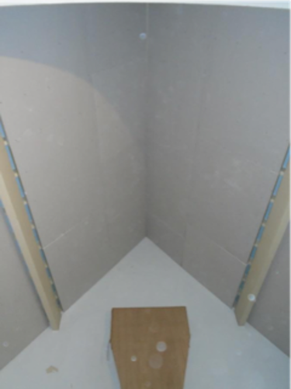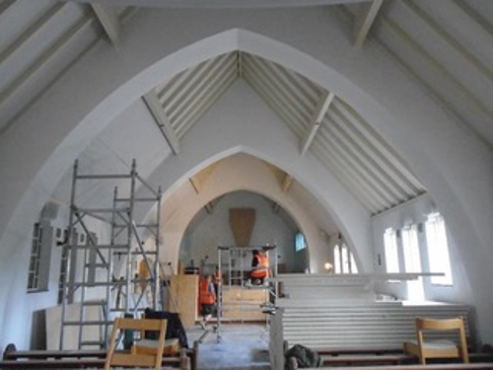
…so far!

