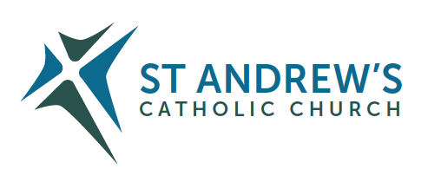
Parish Priest: Fr Behruz Rafat Telephone 01580 762785 Mobile: 07903 986646
Address: The Presbytery, 47 Ashford Road, Tenterden, Kent TN30 6LL.
Parish E-mail behruzrafat@rcaos.org.uk Parish Website: www.standrewstenterden.org
Deacon: Rev. Jolyon Vickers Telephone: 01580 766449 Email: jolyonvickers@rcaos.org.uk Hire of Parish Hall: Lesley McCarthy 07791 949652 E-mail: tenterdenparishcentre@rcaos.org.uk
Newsletter Editor: Patricia Sargent 01233 850963 E-mail: sargentpat51@gmail.com

Newsletter for the week commencing 29th May 2022
Seventh Sunday of Easter (C)
Entrance antiphon: O Lord, hear my voice, for I have called to you; of you my heart has spoken: seek his face; hide not your face from me, alleluia.
First Reading: Acts of the Apostles 7: 55-60
Psalm 96 Response: The Lord is king, most high above all the earth.
Second Reading: Apocalypse 22: 12-14, 16-17, 20
Acclamation: Alleluia, alleluia! I will not leave you orphans, says the Lord; I will come back to you, and your hearts will be full of joy. Alleluia!
Gospel: John 17: 20-26
Communion antiphon: Father, I pray that they may be one as we also are one, alleluia.

Father Behr writes:

Dear Parishioners,

Archbishop John has asked us to pray for the special intention of ‘Calling People Home and back to Sunday Mass.’
We are going to pray this prayer before Holy Mass in the build up to Pentecost.

Come Holy Spirit, fill the hearts of your faithful and kindle in them the fire of your love.
Send forth your Spirit and they shall be created.
and You shall renew the face of the earth.
O, God, who by the light of the Holy Spirit, did instruct the hearts of the faithful,
grant that by the same Holy Spirit we may be truly wise and ever enjoy His consolations,
Through Christ Our Lord, Amen.

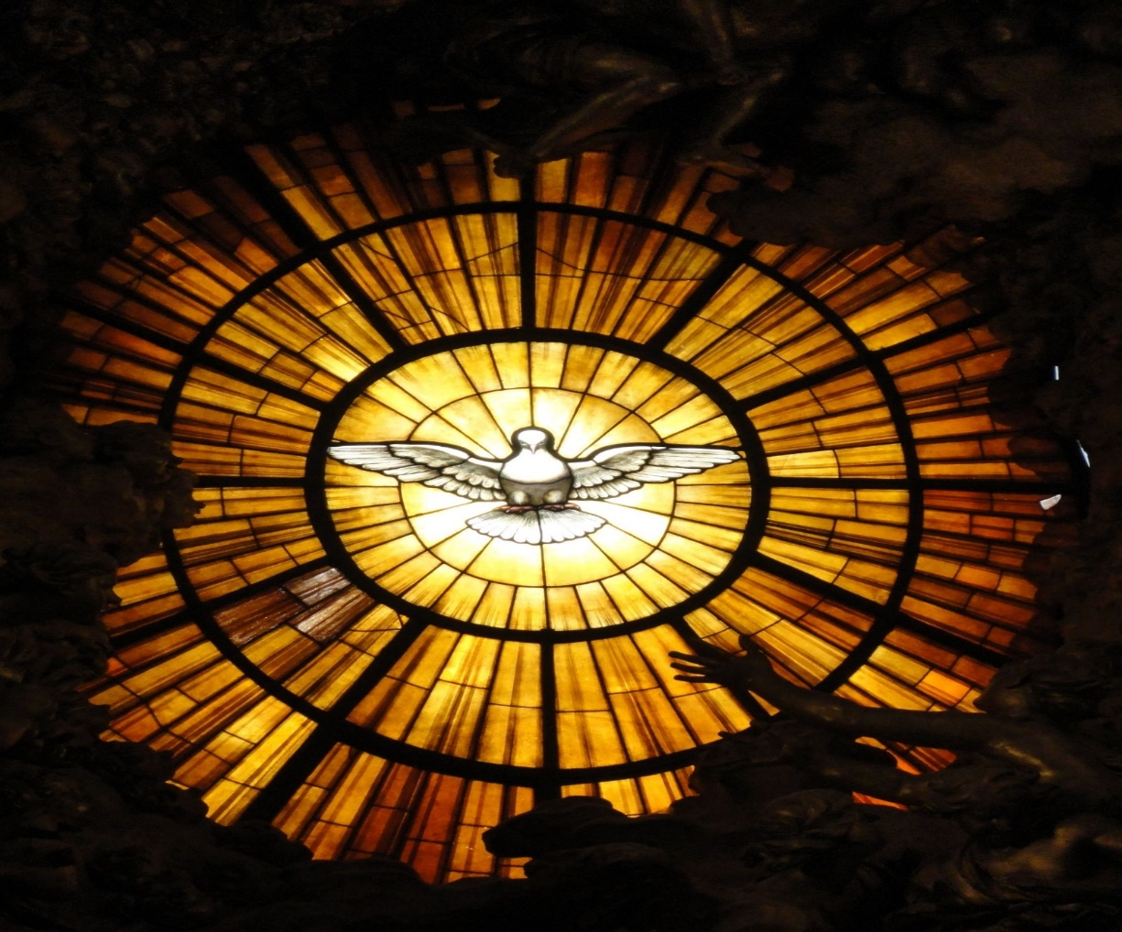

Archdiocese of Southwark 2022 Spring Assembly by the Justice and Peace Commission
on Saturday 25th June 2022 at St Paul Catholic Church, Dover, Kent CT16 1RU. Preceded by Mass at 10.00am at St Edmunds, Dover CT16 1BB. Registration 10.40am. Programme 11am to 4pm. Entitled: Caught in the Act: Tackling the injustice of the Nationality and Borders Act: removal to Rwanda and difficulties for Ukrainians in the UK. Everyone welcome. Entrance is free. Lunch provided. Donations suggested.
Email: jpiccontact@rcaos.org.uk or just turn up.

Congratulations
to Rob and Isabella who were married at St Andrew on Saturday 21 May. We wish them every blessing for their life together.
Bishops statement on the Sunday Obligation
The Bishops of England and Wales have written to all the faithful regarding the obligation to attend Mass on Sunday. From the 5 of June, Pentecost Sunday the faithful will be obliged to attend Sunday Mass.
In a statement the bishops of England and Wales said they believe “that the reasons which have prevented Catholics from attending Mass on Sundays and Holy Days of Obligation no longer apply”.
“Since the beginning of the Covid pandemic, until the present time, we have shared with you our judgment that the situation of the last two years has meant that the Sunday Obligation has been impeded and has needed to be fulfilled in other ways,” they said. “We thank God that this situation has now changed. The pressing challenges of the pandemic have lessened significantly. Most people have resumed the wide range of normal activities, no longer restricted by the previous Covid measures.” However, “there will still be some members of our congregations who, for reasons of health, do not feel safe enough to return to Mass”.

“It has always been the understanding of the Church that when the freedom of any Catholic to attend Mass in person is impeded for a serious reason, because of situations such as ill health, care for the sick or legitimate fear, this is not a breach of the Sunday Obligation,” they said in their statement.
The bishops also confirmed that “virtual viewing” of Mass did not fulfil the obligation to go to Mass on Sunday.
I hope that all those who have been away and are able will feel ready to return. A warm welcome awaits all those who have been away for whatever reason.

Best Wishes
Father Behruz Rafat

Your Prayers are asked for:
Those recently deceased: Mary Iglinski RIP (Her Funeral Mass is on Monday 13 June at 10.30am followed by burial at Northiam. Nora Mary McMahon RIP
Those ill or infirm: Ailish Cantwell (Jones), Sylwia Dorosz, Joe Adams, Ellie Lawrence, Anne Bryant, Patricia Hook, Elena Peck (senior), Josie Payne, Pat Holland and all those who are unwell and in need of our prayers.
Those whose anniversaries of death occur at this time: Elsie Hulse, Henry Balkham, Dorothy Stewart, Desmond Collins, Paul Lamonte, Annie Smith, Matthew Murphy and Colin Dolman.

News from the Catholic Bishop’s Conference of England and Wales

The Platinum Jubilee of Her Majesty Queen Elizabeth II
The Bishops’ Conference establishes that, at all Sunday Masses on 4–5 June 2022, each parish prays for Her Majesty the Queen to mark her Platinum Jubilee by including an intention in the Prayer of the Faithful and by reciting at the end of Mass (after the Prayer after Communion and before the Final Blessing) the Prayer for the Queen.
Parishes may also wish to sing the chant Domine, salvum fac and/or the National Anthem.

Jubilee Celebration
We have a very special Platinum Jubilee Cream Tea coming up on Thursday 2 June at 2.15pm. Please let us know by email or in person if you are coming so that we know how many people to cater for. This is an ideal opportunity to invite friends and family to come and enjoy the relaxed and welcoming atmosphere of our parish.

Prayer for the Queen
Following the Prayer after Communion
V. O Lord, save Elizabeth, our Queen. R. And hear us on the day we call upon you.
V. O Lord, hear my prayer. R. And let my cry come before you.
V. The Lord be with you. R. And with your spirit.

Almighty God, we pray, that your servant Elizabeth, our Queen, who, by your providence has received the governance of this realm, may continue to grow in every virtue, that, imbued with your heavenly grace, she may be preserved from all that is harmful and evil and, being blessed with your favour may, with the royal family, come at last into your presence, through Christ who is the way, the truth and the life and who lives and reigns with you in the unity of the Holy Spirit, one God, for ever and ever.
Amen
Confession
Fr Behr is available for Confession every Saturday from 10.30am - 11am. He is also happy to visit those who are not able to come to church.
This week’s services (28th May – 4th June),
Feasts and Mass intentions during the week.
Saturday 28th May Feria
10am Mass Anna Maria & Denise RIP
6pm Vigil Mass Father Terence Perkins RIP Reader: Charles
Sunday 29th May Seventh Sunday of Easter
10am Mass People of the Parish Reader: Rachel
12 midday Traditional Latin Mass
Monday 30th May Feria
10am Mass Mary Iglinski RIP
Tuesday 31st May the Visitation of the Blessed Virgin Mary
No Mass - Fr Behr is at a conference.
Wednesday 1st June St Justin, Martyr,
10 am Funeral Mass for Nora Mary McMahon RIP
Thursday 2nd June Ss Marcellinus and Peter, Martyrs
9am-10am Adoration
10am Mass Lindsay Nichols Wellbeing
Friday 3rd June Ss Charles Lwanga and Companions, Martyrs
10am Mass Sanctity of Human Life
10.30 – 11.30am Adoration
Saturday 4th June Feria
10am Mass Canon John O’Toole Wellbeing
6pm Vigil Mass Prendergast Family
Sunday 5th June Pentecost Sunday
10am Mass People of the Parish
12 midday Traditional Latin Mass
Flowers: For 5th June - Hilary
Readers: Saturday 4th June – Family readers/Sunday 5th June - Suzanne

The Bethlehem Nativity Group TBNG,
A missionary from Bethlehem, The Holy Land will visit us on the weekend 28th - 29th May to briefly talk about the Holy Land and sell religious articles made out of Olive Wood from the Holy Land to help and support the poor Christian families, any help you could give to them it will be highly appreciated. (When you help the poor, you help our Lord.)
Read the Bible in a Year
Check this website out as Fr Mike Schmitz guides you through the entire Bible. You won’t just read the Bible - you’ll finally understand how all the pieces fit together to tell an amazing story that continues in your life today! You’ll find it at www.ascensionpress.com
‘Building a Better Marriage’
Dear husband and wife!
During the restrictions due to the Covid pandemic, an online ‘Building a Better Marriage’ opportunity is being held from 9am - 1pm on Saturday JUNE 11th 2022.

The course offered means that you can attend the course from your own living room and there is no group sharing!

Recent Building a Better Marriage courses received the following comments from married couples who logged on …

‘The topics were chosen well and we could really relate to them. The personal stories you shared were very insightful and helped us to reflect on our own relationships more deeply… It was relaxed and you put us at ease, being friendly and personable...’

‘We thoroughly enjoyed attending the course and have certainly been practicing a few of the things we learnt already. It puts a smile on our faces when we do because we know that we are certainly richer from participating in the course.’

For further information contact: Carole - Tel: 07983524727 - email: mflkent@rcaos.org.uk

