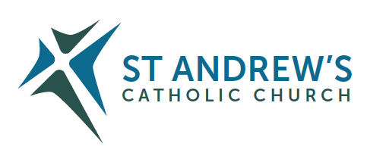
Parish Priest: Fr Behruz Rafat Telephone 01580 762785 Mobile: 07903 986646
Address: The Presbytery, 47 Ashford Road, Tenterden, Kent TN30 6LL.
Parish E-mail behruzrafat@rcaos.org.uk Parish Website: www.standrewstenterden.org
Deacon: Rev. Jolyon Vickers Telephone: 01580 766449 Email: jolyonvickers@rcaos.org.uk Hire of Parish Hall: Lesley McCarthy 07791 949652 E-mail: tenterdenparishcentre@rcaos.org.uk
Newsletter Editor: Patricia Sargent 01233 850963 E-mail: sargentpat51@gmail.com

Newsletter for the week commencing 5th June 2022
Pentecost Sunday (C)
Entrance antiphon:
(Vigil Mass) The love of God has been poured into our hearts through the Spirit of God dwelling within us, alleluia. (Mass during the Day) The Spirit of the Lord has filled the whole world and that which contains all things understands what is said, alleluia.
First Reading: Acts of the Apostles 2: 1-11
Psalm 103 Response: Send forth your spirit, O Lord, and renew the face of the earth.
Second Reading: First letter of St Paul to the Corinthians 12: 3-7, 12-13

Sequence
1.  Holy Spirit, Lord of light,  From the clear celestial light  Thy pure beaming radiance give. | 6.  If thou take thy grace away,  Nothing pure in man will stay;  All his good is turned to ill.
2.  Come, thou Father of the poor,  Come with treasures which endure;  Come, thou light of all that live! | 7.  Heal our wounds, our strength renew;  On our dryness pour thy dew;  Wash the stains of guilt away:
3.  Thou, of all consolers best,  Thou, the soul’s delightful guest,  Dost refreshing peace bestow, | 8.  Bend the stubborn heart and will;  Melt the frozen, warm the chill;  Guide the steps that go astray.
4.  Thou in toil art comfort sweet;  Pleasant coolness in the heat;  Solace in the midst of woe. | 9.  Thou, on us who evermore  Thee confess and thee adore,  With thy sevenfold gifts descend:
5.  Light immortal, light divine,  Visit thou these hearts of thine,  And our inmost being fill: | 10.  Give us comfort when we die;  Give us life with thee on high;  Give us joys that never end.

Acclamation:
Alleluia, alleluia! Come, Holy Spirit, fill the hearts of your faithful, and kindle in them the fire of your love. Alleluia!
Gospel: John 20: 19-23
Communion antiphon: They were all filled with the Holy Spirit and spoke of the marvels of God, alleluia.

Archbishop John has asked us to pray for the special intention of ‘Calling People Home and back to Sunday Mass.’

Come Holy Spirit, fill the hearts of your faithful and kindle in them the fire of your love.
Send forth your Spirit and they shall be created.
and You shall renew the face of the earth.
O, God, who by the light of the Holy Spirit, did instruct the hearts of the faithful,
grant that by the same Holy Spirit we may be truly wise and ever enjoy His consolations,
Through Christ Our Lord, Amen.

Father Behr writes:
Dear Parishioners,
June is the month of devotion to the Sacred Heart of Jesus. I encourage us all to pray the Litany of the Sacred Heart regularly throughout this period. If you would like to explore this devotion there are many excellent resources. Just Send me an email.

You can find the Litany online

https://www.ewtn.com/catholicism/teachings/litany-to-the-sacred-heart-of-jesus-270

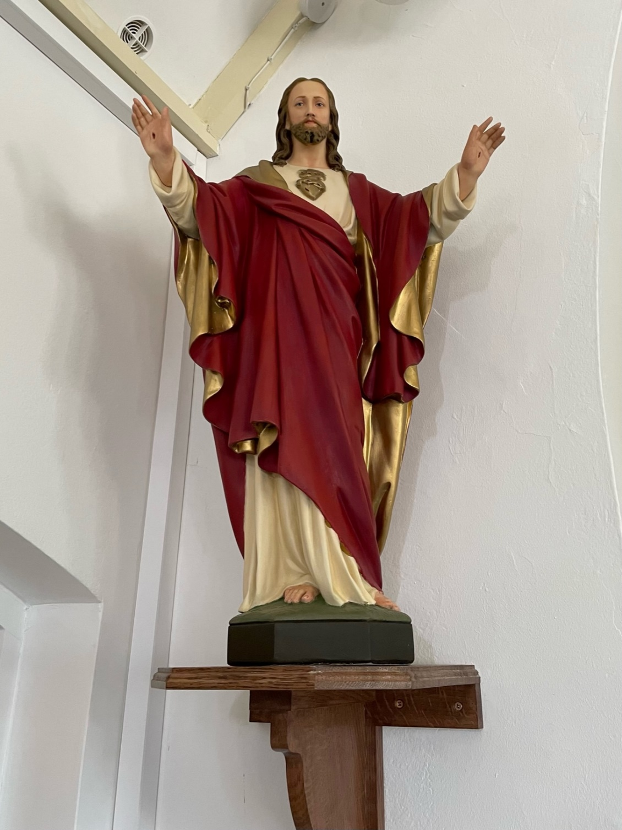

Best Wishes
Father Behruz Rafat

Your Prayers are asked for:
Those recently deceased: Mary Iglinska RIP. Her Funeral Mass is on Monday 13 June at 10.30am followed by burial at Northiam. The family request that there should be family flowers only. Any donations should be to the Hospice in the Weald - Fuggles are setting up a just giving page.
Those ill or infirm: Ailish Cantwell (Jones), Sylwia Dorosz, Joe Adams, Ellie Lawrence, Anne Bryant, Patricia Hook, Elena Peck, Josie Payne, Pat Holland and all those who are unwell and in need of our prayers.
Those whose anniversaries of death occur at this time: Agnes Cosens, Fanny Porter, Micheline Orde, Barbara O’Brien, Ron Basher, Richard Brignall, Joan Nicholson and Pauline Pratt.
This week’s services (4th – 5th June), Feasts and Mass intentions during the week.
Saturday 4th June Feria
10am Mass Canon John O’Toole Wellbeing Reader: Family readers
6pm Vigil Mass Pendergast Family
Sunday 5th June PENTECOST SUNDAY
10am Mass People of the Parish Reader: Suzanne
12 Midday Traditional Latin Mass
Monday 6th June Mary, Mother of the Church
10am Mass Mike Nichols
Tuesday 7th June Feria
10am Mass Donor’s Intentions
Wednesday 8th June Feria
10am Service of the Word and Holy Communion
Thursday 9th June Our Lord Jesus Christ, Eternal High Priest
No Mass or adoration today
Friday 10th June Feria
10am Mass Frank Brownhill
10.30 – 11.30am Adoration
Saturday 11th June St Barnabas, Apostle
10am Mass Patrick Michael Ledwidge RIP Reader: Pat
6pm Vigil Mass Caterina and Guy and Family
Sunday 12th June THE MOST HOLY TRINITY
10am Mass People of the Parish Reader: Kathleen
12 midday Traditional Latin Mass
Flowers: For 12th June – Suzanne
Readers: Saturday 11th June – Pat/Sunday 12th June – Kathleen
Cleaners: For 11th/ 12th June – Wendy and Christine

Confession
Fr Behr is available for Confession every Saturday from 10.30am - 11am. He is also happy to visit those who are not able to come to church.
Cream Tea
Thanks to all those who helped with our Cream Tea. We all had a really enjoyable afternoon.

Archdiocese of Southwark 2022 Spring Assembly by the Justice and Peace Commission on Saturday 25th June 2022 at St Paul Catholic Church, Dover, Kent CT16 1RU. Preceded by Mass at 10.00am at St Edmunds, Dover CT16 1BB. Registration 10.40am. Programme 11am to 4pm. Entitled: Caught in the Act: Tackling the injustice of the Nationality and Borders Act: removal to Rwanda and difficulties for Ukrainians in the UK. Everyone welcome. Entrance is free. Lunch provided. Donations suggested. Email: jpiccontact@rcaos.org.uk or just turn up.

‘Building a Better Marriage’
Dear husband and wife!
During the restrictions due to the Covid pandemic, an online ‘Building a Better Marriage’ opportunity is being held from 9am - 1pm on Saturday JUNE 11th, 2022.

The course offered means that you can attend the course from your own living room and there is no group sharing!
Recent Building a Better Marriage courses received the following comments from married couples who logged on …

‘The topics were chosen well and we could really relate to them. The personal stories you shared were very insightful and helped us to reflect on our own relationships more deeply… It was relaxed and you put us at ease, being friendly and personable...’

‘We thoroughly enjoyed attending the course and have certainly been practicing a few of the things we learnt already. It puts a smile on our faces when we do because we know that we are certainly richer from participating in the course.’

For further information contact: Carole - Tel: 07983524727 - email: mflkent@rcaos.org.uk

Read the Bible in a year
Check this website out as Fr Mike Schmitz guides you through the entire Bible. You won’t just read the Bible - you’ll finally understand how all the pieces fit together to tell an amazing story that continues in your life today! You’ll find it at
www.ascensionpress.com

A letter from Nicholas (Bethlehem Nativity Group, Holyland)
Dear Fr Behruz,
Christian greetings and the Peace of our Lord be with you always.
We would love to thank you by allowing our group to come to your church and sell religious articles, the result of which was very beneficial and rewarding for our needy Christian families.
Which raised £862.50
Your help is a great support for us, and for our Christian families in the Holy Land.
we don't have a word to thank you and your parishioners, but make sure that you are always in our prayers. If anyone has missed the carvings display, you can place an order online directly from them at www.tbng.co.uk
May our Lord Jesus Christ bless you and your work!
Thank You
Nicholas Khader

Lots of thanks are due
- The Christian Aid Big Breakfast in Saint Andrew's raised £317.71
- The Ukraine Appeal at the Methodist Church Tea and Organ recital raised £1053
- The Food Bank - Thanks so much to everyone, who is contributing, the worry is this week, the Ashford centre (from which we are served) ran out of food completely, due to a fall in donations
- The School Larder - thanks to everyone, who is supporting this local charity. We now have over 90 children supported with fresh food from this scheme, but regular monetary donations are desperately needed.
Please continue to support the Food Bank and the School Larder. Your donations are greatly needed in these tricky times.

Prayer for the Queen
(Following the Prayer after Communion)
V. O Lord, save Elizabeth, our Queen.
R. And hear us on the day we call upon you.
V. O Lord, hear my prayer.
R. And let my cry come before you.
V. The Lord be with you.
R. And with your spirit.

Almighty God, we pray, that your servant Elizabeth, our Queen, who, by your providence has received the governance of this realm, may continue to grow in every virtue, that, imbued with your heavenly grace, she may be preserved from all that is harmful and evil and, being blessed with your favour may, with the royal family, come at last into your presence, through Christ who is the way, the truth and the life and who lives and reigns with you in the unity of the Holy Spirit, one God, for ever and ever.
Amen

