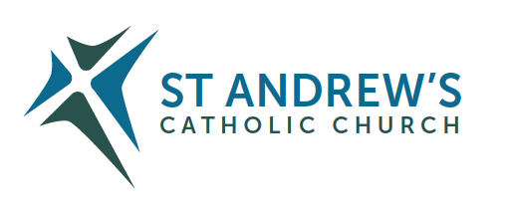
Parish Priest: Fr Behruz Rafat Telephone 01580 762785 Mobile: 07903 986646
Address: The Presbytery, 47 Ashford Road, Tenterden, Kent TN30 6LL.
Parish E-mail behruzrafat@rcaos.org.uk Parish Website: www.standrewstenterden.org
Deacon: Rev. Jolyon Vickers Telephone: 01580 766449 Email: jolyonvickers@rcaos.org.uk Hire of Parish Hall: Lesley McCarthy 07791 949652 E-mail: tenterdenparishcentre@rcaos.org.uk
Newsletter Editor: Patricia Sargent 01233 850963 E-mail: sargentpat51@gmail.com

Newsletter for the week commencing 10th July 2022
Fifteenth Sunday in Ordinary Time (C)
Entrance antiphon: As for me, in justice I shall behold your face; I shall be filled with the vision of your glory.
First Reading: Deuteronomy 30: 10-14
Psalm 68 Response: Seek the Lord, you who are poor, and your hearts will revive.
Second Reading: The letter of St Paul to the Corinthians 1: 15-20
Acclamation: Alleluia, alleluia! The sheep that belong to me listen to my voice, says the Lord, I know them and they follow me. Alleluia!
Gospel: Luke 10: 25-37
Communion antiphon: Whoever eats my flesh and drinks my blood remains in me and I in him, says the Lord.

Father Behr writes:

Dear Parishioners

Saturday 16 July is the feast of Our Lady of Mount Carmel. This devotion has a fascinating history.

At the time of the Crusades there were hermits living on Mt. Carmel in imitation of Elias. In their midst was a chapel dedicated to Our Lady. To the medieval members of the Order, Mary was the Gracious Lady who protected them from danger, who won for them the favour of Christ, her Son.
If we have any urgent needs, we can always bring them to Our Blessed Mother and she will surely help us.
We have Mass at the usual time of 10am.

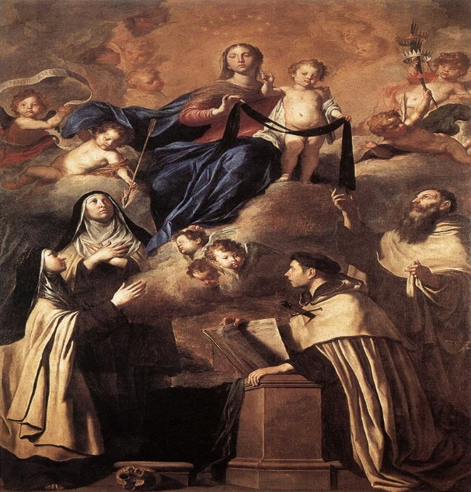

Our Lady of Mount Carmel by Pietro Novelli, 1641

Best Wishes
Father Behruz Rafat

Your Prayers are asked for:

Those recently deceased: David Donahue RIP Hetty Naish RIP (The funeral Mass is on Friday 22 July at 11am)
Those ill or infirm: Maureen Saunders, Ailish Cantwell (Jones), Sylwia Dorosz, Joe Adams, Ellie Lawrence, Anne Bryant, Patricia Hook, Elena Peck, Josie Payne, Pat Holland and all those who are unwell and in need of our prayers.
Those whose anniversaries of death occur at this time: Vincent Carty, Annie Wipp, Edward Duffy, John Lawrence, Hugh Broad, Alexander Porcherot, Gertrude Fisher, William Buck and Esther Tickner.

This week’s services (10th – 16th July), Feasts and Mass intentions during the week
Saturday 9th July Ss Augustine Zhao Rong, Priest and companions, Martyrs
10am Mass Mr BJ Vincent RIP
10.30 -11am Confession
6pm Vigil Mass John Dumbleton RIP Reader: Pat
Sunday 10th July Fifteenth Sunday in Ordinary Time
10am Mass People of the Parish Reader: Collette
12 midday Traditional Latin Mass
Monday 11th July St Benedict, abbot, patron of Europe
10am Mass Mary Boylan RIP
Tuesday 12th July St John Jones, Priest, Martyr
10am Mass Donor’s Intention
Wednesday 13th July St Henry
10am Service of the Word and Holy Communion
Thursday 14th July St Camillus de Lellis, Priest
9am-10am Adoration
10am Mass Violeta Odette Raymond
Friday 15th July St Bonaventure, Bishop, Doctor of the Church
10am Mass Mary Iglinski RIP (Sheila)
10.30 – 11.30am Adoration
Saturday 16th July Our Lady of Mount Carmel
10am Mass Edna O’Malley RIP
10.30 -11am Confession
6pm Vigil Mass Fr Anthony Hale RIP Reader: Kathy
Sunday 17th July Sixteenth Sunday in Ordinary Time
10am Mass People of the Parish Reader: Brian
12 midday Traditional Latin Mass
Flowers: for 16th July - Pat
Readers: for Saturday 16th July - Kathy / For Sunday 17th July - Brian

Confession
Fr Behr is available for Confession every Saturday from 10.30am - 11am. He is also happy to visit those who are not able to come to church.
This Sunday is Sea Sunday
Sea Sunday falls on 9th/10th July this year. This is the weekend when you are asked for prayer and financial contributions to support the work of Stella Maris (Apostleship of the Sea). This mandatory collection is vital for the future of Stella Maris and its important ministry to seafarers.

THE UNIVERSE CATHOLIC WEEKLY is thrilled to announce that we have launched our new online newspaper with the full support of our first subscriber none other than His Eminence Cardinal Vincent Nichols.
Order your Digital 4 weeks FREE trial supply by calling Michelle on 0743 661 7650 or email: michelle.jones@universecatholicweekly.co.uk

THE ORDINATION – to the Catholic Priesthood of Deacon Michael Etuka, Deacon Allan MacDonald, and Deacon Joseph Gulliford takes place at St George’s Cathedral on Saturday 16th July at 12.30pm. You are very welcome to attend. It is also available on the Southwark YouTube page at: https://www.youtube.com/c/RCSouthwark1

Our Summer Movie for July is Molokai.
Tuesday 19 July and Tuesday 26 July
10.30am refreshments
10.50am Movie
A fascinating biopic of Father Damian of Molokai. He is also known as the leper priest.

Sycamore course for engaged and married couples – Growing in Faith together.
A new exciting free ONLINE course, for engaged and married couples, has been developed in collaboration with the Southwark Marriage and Family Life team and Sycamore, a programme about the Christian faith by Fr Stephen Wang.
Growing in Faith Together (GIFT) consists of four hour-long sessions via Zoom and is a wonderful opportunity for:
- engaged couples who have completed their marriage preparation course and want to continue exploring their faith together
- married couples to enrich their friendship and love.
The Sycamore GIFT course runs on Tuesday evenings from 8 - 9pm beginning 6th September 2022and continuing on September 13th, 20th and 27th 2022.
To register click on the link below:
Growing in Faith Together — Agency for Evangelisation and Catechesis (rcaos.org.uk)

Pilgrimage of Reparation and Prayer for the Sanctity of Life to Walsingham –
Saturday 6th August 2022
The cause for life is continually under attack. This year has seen the so-called DIY abortions made permanent in England, Wales, Scotland and Eire, and the continued attempts by the British government to impose abortion on the province of Northern Ireland. In the Republic of Ireland there is concern that the provision of DIY abortions makes it harder to identify coercion and abuse, and GPs are paid more for abortion than for pregnancy care. The attempts to introduce euthanasia and assisted suicide are a continual threat, as are the attempts to further restrict the freedom to speak and witness to life.

World Day of Prayer for Grandparents and the Elderly – 24th July 2022
The Dicastery for Laity, Family and Life have sent a number of resources, including the Message of his Holiness Pope Francis, for this Sunday, and which are attached. More information and resources can be found on the website of the Catholic Grandparents’ Association in the UK, which can be found at:
https://www.catholicgrandparentsassociation.org/

A Bereavement Retreat
"Grief in Loss, Hope in Christ" weekend for those who are in mourning. Emotions out of control, feeling at a loss? Then this weekend is a time for you. A space for you. Aylesford Priory 7-9th October. For enquiries, please telephone Aylesford Priory 01622 717272

Building a Better Marriage
Dear husband and wife!
We’re offering you an opportunity to attend an online ‘Building a Better Marriage’ from 9am - 1pm on Saturday JULY 16th 2022.

The course offered means that you can attend from your own living room and there is no group sharing!

For further information contact: Carole - Tel: 07983524727 - email: mflkent@rcaos.org.uk

