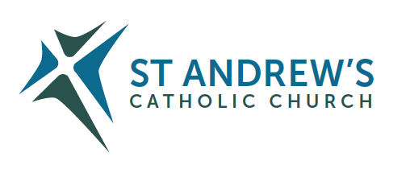
Parish Priest: Fr Behruz Rafat Telephone 01580 762785 Mobile: 07903 986646
Address: The Presbytery, 47 Ashford Road, Tenterden, Kent TN30 6LL.
Parish E-mail behruzrafat@rcaos.org.uk Parish Website: www.standrewstenterden.org
Deacon: Rev. Jolyon Vickers Telephone: 01580 766449 Email: jolyonvickers@rcaos.org.uk Hire of Parish Hall: Lesley McCarthy 07791 949652 E-mail: tenterdenparishcentre@rcaos.org.uk
Newsletter Editor: Patricia Sargent 01233 850963 E-mail: sargentpat51@gmail.com

Newsletter for the week commencing 17th July 2022
Sixteenth Sunday in Ordinary Time (C)
Entrance antiphon: See, I have God for my help. The Lord sustains my soul. I will sacrifice to you with willing heart, and praise your name, O Lord, for it is good.
First Reading: Genesis 18: 1-10
Psalm 14 Response: The just will live in the presence of the Lord.
Second Reading: The letter of St Paul to the Colossians 1: 24-28
Acclamation: Alleluia, alleluia! Open our heart, O Lord, to accept the words of your Son. Alleluia!
Gospel: Luke 10: 38-42
Communion antiphon: The Lord, the gracious, the merciful, has made a memorial of his wonders; he gives food to those who fear him.

Father Behr writes:

Dear Parishioners,

Charity Book Sale for the Old Schoolhouse Larder.
A number of parishioners have kindly donated books to our parish. Please have a look in the parish centre over the weekend before and after Mass and see if there is anything that would interest you. We have history, fiction and cookery plus many other areas of general interest.
All proceeds from the sale will be donated to the Old Schoolhouse Larder which provides food locally for those in need.
Summer is a great time for reading and I’m always keen to hear about your favourite books.

A book is a gift you can open again and again. —Garrison Keillor

“A lot of people ask me if I were shipwrecked and could only have one book, what would it be? I always say, “How to Build a Boat.” —Stephen Wright

Will you find a new favourite author at the charity book sale this weekend?

Youth reading, Persian miniature by Reza Abbasi(1625–6)

Best Wishes
Father Behruz Rafat

Your Prayers are asked for:

Those recently deceased:
- David Donahue RIP. Details of his funeral will be given once known.
- Hetty Naish RIP. Her Requiem Mass is on Friday 22 July at 11am
Those ill or infirm: Ailish Cantwell (Jones), Sylwia Dorosz, Joe Adams, Ellie Lawrence, Anne Bryant, Patricia Hook, Elena Peck, Josie Payne, Pat Holland and all those who are unwell and in need of our prayers.
Those whose anniversaries of death occur at this time: Ivor Corbett, Maisie Strivens, Mary Cowley, Denis Fain, Frank Edgeley, Allen Davis, Janet Chisholm, John Martin Hatherley and Charles Gregory Francis Munton.

Saturday 16th July  Our Lady of Mount Carmel | 10am Mass Edna O’Malley RIP  10.30 -11am Confession  6pm Vigil Mass Fr Anthony Hale RIP Reader: Kathy
Sunday 17th July  Sixteenth Sunday in Ordinary Time | 10am Mass People of the Parish Reader: Brian  12 midday Traditional Latin Mass
Monday 18th July  Feria | 10am Mass Dominic Tucker RIP
Tuesday 19th July  Feria | 10am Mass Donor’s Intention
Wednesday 20th July  St Apollinaris, Bishop & Martyr | 10am Service of the Word and Holy Communion
Thursday 21st July  St Lawrence of Brindisi, Priest, Doctor of the Church | 9am-10am Adoration  10am Mass Allen Davis RIP
Friday 22nd July  St Mary Magdalene | No Adoration due to the Requiem Mass at 11am for Hetty Naish RIP
Saturday 23rd July  St Bridget, Religious, patron of Europe (Eu);  Ss Philip Evans and John Lloyd, Priests and Martyrs | 10am Mass Angela Griffiths RIP  10.30 – 11.30am Adoration  10.30 -11am Confession  6pm Vigil Mass Colin Barrett RIP Reader: Charles
Sunday 24th July  Seventeenth Sunday in Ordinary Time | 10am Mass People of the Parish Reader: Frances  12 midday Traditional Latin Mass
Flowers: for 23rd July – Hilary
Readers: for Saturday 23rd July – Charles/for Sunday 24th July - Frances
Cleaners: for 23rd/24th July – Brian and Frances

Confession
Fr Behr is available for Confession every Saturday from 10.30am - 11am.
He is also happy to visit those who are not able to come to church.

Tales from the local Foodbanks
Most people look forward to the long summer holidays. A chance to enjoy a break from the work and school routines, long sunny days outside, cool drinks and ice-cream. For some, however the long days ahead spell dread. Hungry children at home all day circulating round the kitchen looking for things to eat, peering into empty fridges and cupboards and the family budget no longer able to meet the demand.

Every news bulletin brings a new story of food poverty, of adults going without meals to feed their children, of people having to choose whether to eat today or switch the power on for heat, light, hot water or cooking. This is not some far flung corner of the globe but happening in Tenterden, in Woodchurch and Wittersham, in Rolvenden and all villages in between.

To add to the seriousness of the situation, Fareshare and The Family Foodbank organisations have sent out a warning that donations have dropped and demand has risen at an almost unprecedented rate. This is leading to shortages at the very places people go to seek help.

Of course, all of us are being affected by the current grim financial situation in the country. The steep rises in fuel costs and inflation and knowing how to manage our own worries and still help those less fortunate is not easy. This perhaps is not the time for grand gestures (although if anyone DOES suddenly inherit and fortune, I will be pleased to hear from them!!) but PLEASE if you are reading this to the end, just put one tin of beans or tuna or carton of long-life milk into the collection points in Waitrose, St Michaels Post Office, St Mildred’s porch or Tesco when you are doing your shopping. Every single tin makes a difference and helps the Family Foodbank. You can also help The Old Schoolhouse Larder which more specifically helps children get a nutritious meal inside them every day. To do this requires you to simply to donate money. One off donations are welcome but better still is just a SMALL Standing Order so that there is a regular income to purchase the foods we need and prevent waste. There is no shame in donating even a very small amount. £2.50 a week, the cost of a coffee shop coffee makes a difference. You may be surprised to know that this sum will make a filling, nutritiously balanced meal for two children with the foods obtainable in the Larder.

Details to donate to the Old Schoolhouse Larder are here.

Please pay to: The Vicar of Tenterden Trust - Larder

Account No. 40963232

Sort Code: 20-02-62

Thank you. Emma Isworth , Town Foodbank Co-ordinator

National Synthesis Synod – a link from Kathleen Bishop, our Synod Leader
Well worth a read

https://www.cbcew.org.uk/wp-content/uploads/sites/3/2022/06/synod-national-synthesis-england-wales.pdf

Diocesan Lourdes Pilgrimage
The Southwark Diocesan Pilgrimage to Lourdes will take place between 19th and 26th August.
We are sad that, like most Lourdes pilgrimages this year, we have not been able to include pilgrims, who need medical support. At the same time, we are delighted to be returning to Lourdes after two years of absence.
Details are available at www.tangney-tours.com/pilgrimages/lourdes/catholic-association. Southwark contacts: Canon Ed Perera (edwardperera@rcaos.org.uk) and Bishop Paul Hendricks (paulhendricks@rcaos.org.uk).

The Universe Catholic Weekly
We are thrilled to announce that we have launched our new online newspaper with the full support of our first subscribe,r none other than His Eminence Cardinal Vincent Nichols.
Order your Digital 4 weeks FREE trial supply by calling Michelle on 0743 661 7650 or email: michelle.jones@universecatholicweekly.co.uk

Our Summer Movie

“Molokai”
Tuesday 19 July and Tuesday 26 July
10.30am refreshments
10.50am Movie
A fascinating biopic of Father Damian of Molokai. He is also known as the leper priest. We will be serving ice cream to beat the heat wave!

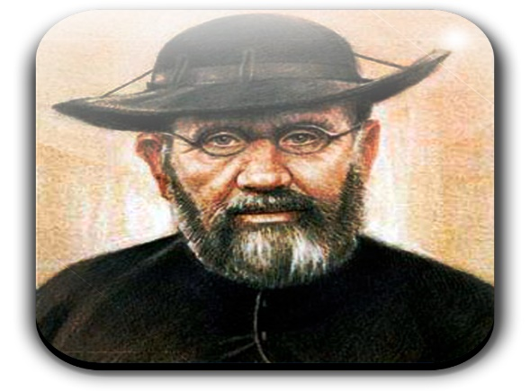

SycamOre course
for engaged and married couples – Growing in Faith together.
A new exciting free ONLINE course, for engaged and married couples, has been developed in collaboration with the Southwark Marriage and Family Life team and Sycamore, a programme about the Christian faith by Fr Stephen Wang.

Growing in Faith Together (GIFT) consists of four hour-long sessions via Zoom and is a wonderful opportunity for:
- engaged couples who have completed their marriage preparation course and want to continue exploring their faith together
- married couples to enrich their friendship and love.

The Sycamore GIFT course runs on Tuesday evenings from 8 - 9pm beginning 6th September 2022and continuing on September 13th, 20th and 27th 2022.
To register click on the link below:
Growing in Faith Together — Agency for Evangelisation and Catechesis (rcaos.org.uk)

Pilgrimage of Reparation and Prayer for the Sanctity of Life to Walsingham – Saturday 6th August 2022
The cause for life is continually under attack. This year has seen the so-called DIY abortions made permanent in England, Wales, Scotland and Eire, and the continued attempts by the British government to impose abortion on the province of Northern Ireland. In the Republic of Ireland there is concern that the provision of DIY abortions makes it harder to identify coercion and abuse, and GPs are paid more for abortion than for pregnancy care. The attempts to introduce euthanasia and assisted suicide are a continual threat, as are the attempts to further restrict the freedom to speak and witness to life.

World Day of Prayer for Grandparents and the Elderly – 24th July 2022
The Dicastery for Laity, Family and Life have sent a number of resources, including the Message of his Holiness Pope Francis, for this Sunday, and which are attached. More information and resources can be found on the website of the Catholic Grandparents’ Association in the UK, which can be found at:
https://www.catholicgrandparentsassociation.org/

A Bereavement Retreat
"Grief in Loss, Hope in Christ" weekend for those who are in mourning. Emotions out of control, feeling at a loss? Then this weekend is a time for you. A space for you. Aylesford Priory 7-9th October. For enquiries please telephone Aylesford Priory 01622 717272

Building a Better Marriage
Dear husband and wife!
We’re offering you an opportunity to attend an online ‘Building a Better Marriage’ from 9am - 1pm on Saturday JULY 16th 2022.

The course offered means that you can attend from your own living room and there is no group sharing!

For further information contact: Carole - Tel: 07983524727 - email: mflkent@rcaos.org.uk

