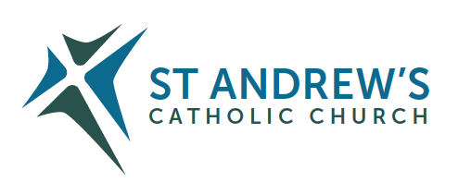
Parish Priest: Fr Behruz Rafat Telephone 01580 762785 Mobile: 07903 986646
Address: The Presbytery, 47 Ashford Road, Tenterden, Kent TN30 6LL.
Parish E-mail behruzrafat@rcaos.org.uk Parish Website: www.standrewstenterden.org
Deacon: Rev. Jolyon Vickers Telephone: 01580 766449 Email: jolyonvickers@rcaos.org.uk Hire of Parish Hall: Lesley McCarthy 07791 949652 E-mail: tenterdenparishcentre@rcaos.org.uk
Newsletter Editor: Patricia Sargent 01233 850963 E-mail: sargentpat51@gmail.com

Newsletter for the week commencing 24th July 2022
Seventeenth Sunday in Ordinary Time (C)
Entrance antiphon: God is in his holy place, God who unites those who dwell in his house; he himself gives might and strength to his people.
First Reading: Genesis 18: 20-32
Psalm 137 Response: On the day I called, you answered me, O Lord.
Second Reading: The letter of St Paul to the Colossians 2: 12-14
Acclamation: Alleluia, alleluia! The Word was made flesh and lived among us; to all who did accept him he gave power to become children of God. Alleluia!
Gospel: Luke 11: 1-13
Communion antiphon: Bless the Lord, O my soul, and never forget all his benefits.

Father Behr writes:

Dear Parishioners

Appointment Of Auxiliary Bishop for Kent
Bishop Paul Hendricks has been appointed Bishop for the Kent area. Bishop Paul has very kindly agreed to move from the Southwest Area of the diocese, at the Archbishop’s request, to Kent. He will take up his post during September. Please remember Bishop Paul in your prayers at this time of change and for his future pastoral responsibilities.

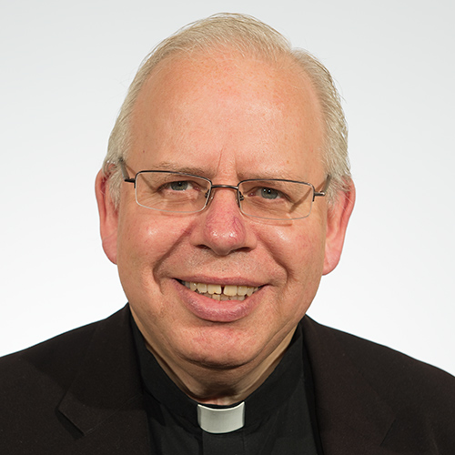

Bishop Paul Hendricks
Best Wishes
Father Behruz Rafat

Your Prayers are asked for:
Those recently deceased: David Donahue RIP. Details of his funeral will be given once known.
Those ill or infirm: Ailish Cantwell (Jones), Sylwia Dorosz, Joe Adams, Ellie Lawrence, Anne Bryant, Patricia Hook, Elena Peck, Josie Payne, Pat Holland and all those who are unwell and in need of our prayers.
Those whose anniversaries of death occur at this time: Gilbert Rahr, Derek Carpenter, Susan Rahr, Michael McDermott, Bessie King and Lilliana Mortimer.
.

Saturday 23rd July  St Bridget, Religious, patron of Europe (Eu);  Ss Philip Evans and John Lloyd, Priests and Martyrs | 10am Mass Angela Griffiths RIP  10.30 – 11.30am Adoration  10.30 -11am Confession  6pm Vigil Mass Colin Barrett RIP Reader: Charles
Sunday 24th July  Seventeenth Sunday in Ordinary Time | 10am Mass People of the Parish Reader: Frances  12 midday Traditional Latin Mass
Monday 25th July  St James, Apostle | 8.30am Mass Anne Nichols
Tuesday 26th July  Ss Joachim and Ann, Parents of the Blessed Virgin Mary | 10am Mass Donor’s Intention
Wednesday 27th July  Feria | 10am Mass Martin Cummings Well-being
Thursday 28th July  Feria | 9am-10am Adoration  10am Mass Roger Humphrey RIP
Friday 29th July  St Martha, Mary & Lazarus | 10am Mass Mary Iglinski RIP (Ray)  10.30 – 11.30am Adoration
Saturday 30th July  St Peter Chrysologus, Bishop, Doctor of the Church; | 10am Mass Elena Peck Wellbeing  10.30 – 11.30am Adoration  10.30 -11am Confession  6pm Vigil Mass Fr Vincent Flanagan RIP Reader: James
Sunday 31st July  Eighteenth Sunday in Ordinary Time | 10am Mass People of the Parish Reader: Peter  12 midday Traditional Latin Mass
Flowers: for 30th July - Suzanne
Readers: for Saturday 30th July – James/for Sunday 31st July - Peter

Please note the change in services on Monday and Wednesday.

Confession
Fr Behr is available for Confession every Saturday from 10.30am - 11am. He is also happy to visit those who are not able to come to church.
World Day of Prayer for Grandparents and the Elderly – this Sunday, 24th July 2022
The Dicastery for Laity, Family and Life have sent a number of resources, including the Message of his Holiness Pope Francis, for this Sunday, and which are attached. More information and resources can be found on the website of the Catholic Grandparents’ Association in the UK, which can be found at:
https://www.catholicgrandparentsassociation.org/

Our Summer Movie for July is Molokai.
Final Part this Tuesday 26 July
10.30am refreshments and ice cream
10.50am Movie
A fascinating biopic of Father Damian of Molokai. He is also known as the leper priest. We will be serving ice cream to beat the heat wave!

SycamOre course for engaged and married couples – Growing in Faith together.
A new exciting free ONLINE course, for engaged and married couples, has been developed in collaboration with the Southwark Marriage and Family Life team and Sycamore, a programme about the Christian faith by Fr Stephen Wang.
Growing in Faith Together (GIFT) consists of four hour-long sessions via Zoom and is a wonderful opportunity for:
- engaged couples who have completed their marriage preparation course and want to continue exploring their faith together
- married couples to enrich their friendship and love.
The Sycamore GIFT course runs on Tuesday evenings from 8 - 9pm beginning 6th September 2022and continuing on September 13th, 20th and 27th 2022.
To register click on the link below:
Growing in Faith Together — Agency for Evangelisation and Catechesis (rcaos.org.uk)

Pilgrimage of Reparation and Prayer for the Sanctity of Life to Walsingham –
Saturday 6th August 2022
The cause for life is continually under attack. This year has seen the so-called DIY abortions made permanent in England, Wales, Scotland and Eire, and the continued attempts by the British government to impose abortion on the province of Northern Ireland. In the Republic of Ireland there is concern that the provision of DIY abortions makes it harder to identify coercion and abuse, and GPs are paid more for abortion than for pregnancy care. The attempts to introduce euthanasia and assisted suicide are a continual threat, as are the attempts to further restrict the freedom to speak and witness to life.

