**Parish Priest:** Fr Behruz Rafat **Telephone** 01580 762785 Mobile: 07903 986646

**Address:** The Presbytery, 47 Ashford Road, Tenterden, Kent TN30 6LL.

**Parish E-mail** [behruzrafat@rcaos.org.uk](mailto:behruzrafat@rcaos.org.uk) **Parish Website:** www.standrewstenterden.org

**Deacon:** Rev. Jolyon Vickers **Telephone:** 01580 766449 Email**:** jolyonvickers@rcaos.org.uk **Hire of Parish Hall:** Lesley McCarthy 07791 949652 **E-mail:** tenterdenparishcentre@rcaos.org.uk

**Newsletter Editor:** Patricia Sargent 01233 850963 **E-mail:** [sargentpat51@gmail.co](mailto:sargentpat51@gmail.co)m

**Newsletter for the week commencing 28th August 2022**

**Twenty second Sunday in Ordinary Time (C)**

**Entrance antiphon: Have mercy on me, O Lord, for I cry to you all the day long. O Lord, you are good and forgiving, full of mercy to all who call to you.**

**First Reading: Ecclesiasticus 3: 17-20, 28-29**

**Psalm 67 Response: In your goodness, O God, you prepared a home for the poor.**

**Second Reading: Letter to the Hebrews 12: 18-19, 22-24**

**Acclamation: Alleluia, alleluia! If anyone loves me, he will keep my word, and my Father will love him, and we shall come to him. Alleluia!**

**Gospel: Luke 14: 1-7, 14**

**Communion antiphon: How great is the goodness, Lord, that you keep for those who fear you.**

**Father Behr writes:**

**Dear Parishioners**

Please pray for the repose of the soul of Monsignor Ted Hill former parish priest of St Andrew.

Monsignor Hill served in many parishes during his 54 years of priesthood and his last appointment before his retirement in 2014 was as Parish Priest of St Andrew’s, Tenterden.  He recently celebrated his 79th birthday.

Monsignor Edward Hill died on the evening of Friday 12th August in the Conquest Hospital, St Leonard’s on Sea, where he was recovering from surgery.

Eternal rest grant unto him, O Lord, and let perpetual light shine upon him.   
May his soul and the souls of all the faithful departed, through the mercy of God, rest in peace. Amen

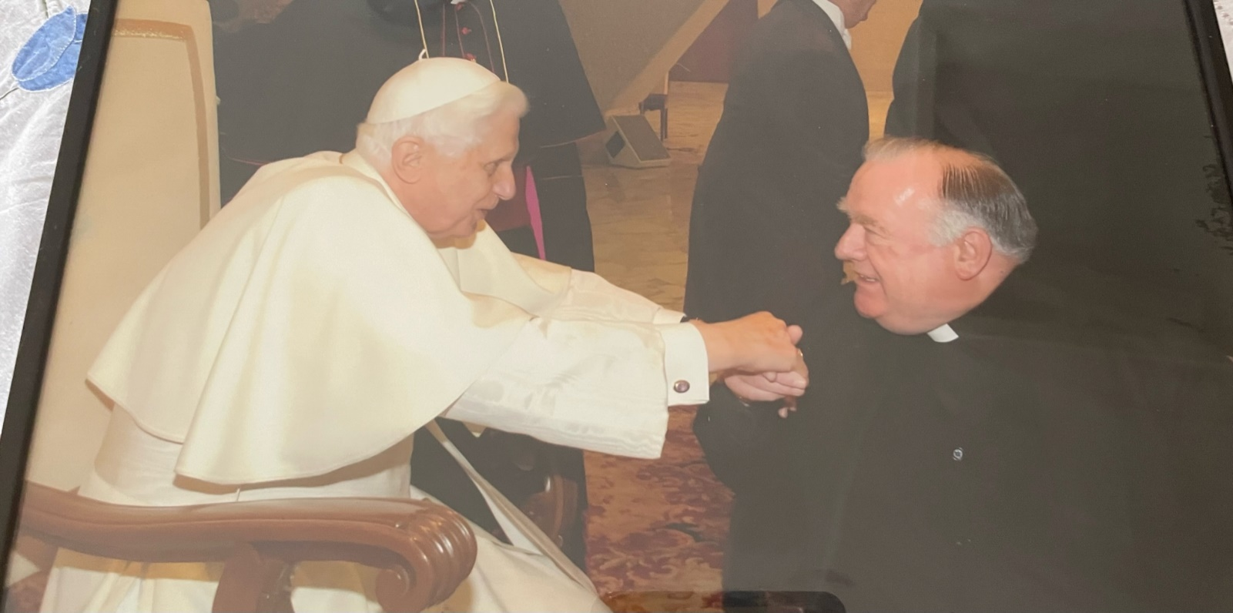

Monsignor Ted with Pope Benedict XVI

Details of the Funeral Liturgy for Monsignor Edward (Ted) Hill RIP are as follows: Funeral Mass:

Thursday 15th September at 12.30pm at The Church of St. Cecilia, North Cheam (Stonecot Hill, North Cheam SM3 9HN) Followed by Internment at Sutton and Merton Cemetery. Purple vestments

May he rest in peace and rise in glory

Best Wishes

Father Behruz Rafat

**Your Prayers are asked for:**

**Those recently deceased: Monsignor Edward Peter Hill RIP**

**Those ill or infirm:** Ailish Cantwell (Jones), Sylwia Dorosz, Joe Adams, Ellie Lawrence, Anne Bryant, Patricia Hook, Elena Peck, Josie Payne, Pat Holland and all those who are unwell and in need of our prayers.

**Those whose anniversaries of death occur at this time:** Rosalie Robertson, Donald Hayesmore, Audrey Clark, Hester Rositer, Kevin Thornton, Dorothy Taylor, Violet Bruce-Norton, Mary Bly, Brian Leo Barrett, Moya Crofton, Anthony Whately, Joseph Davis and Martin Vickers.

|  |  |
| --- | --- |
| **This week’s services (28th August – 3rd September), Feasts and Mass intentions during the week.** | |
| **Saturday 27th August**  St Monica | 10am Mass  10.30 -11am Confession  6pm Vigil Mass *Mary Iglinski RIP (Doreen)*  **Reader: Pat** |
| **Sunday 28th August**  **Twenty second Sunday** | 10am Mass *People of the Parish* **Reader: Rachel**  12 Midday Traditional Latin Mass |
| **Monday 29th August**  The Passion of St John the Baptist | 10am Mass *Maureen Saunders Wellbeing* |
| **Tuesday 30th August**  Ss Margaret Clitherow, Anne Line and Margaret Ward, Martyrs | 10am Mass *Donor’s Intention* |
| **Wednesday 31st August**  St Aidan, Bishop, and Saints of Lindisfarne | 10am Service of the Word and Holy Communion |
| **Thursday 1st September**  Feria | 9am-10am Adoration  10am Mass *Sr Clare 50th Anniversary* |
| **Friday 2nd September**  Feria | 10am Mass *People in Hospital (Saunders)*  10.30 – 11.30am Adoration |
| **Saturday 3rd September**  St Gregory the Great, Pope, Doctor of the Church | 10am Mass *March For Life*  10.30 -11am Confession  6pm Vigil Mass *Marjorie Dumbleton RIP*  **Readers: Wendy & Melody** |
| **Sunday 4th September**  **Twenty third Sunday** | 10am Mass *People of the Parish*  **Reader: Brian**  12 Midday Traditional Latin Mass |
| **Flowers: for 3rd/4th September - Hilary** | |
| **Readers: for Saturday 3rd September – Family readers/Sunday 4th September - Brian** | |
| **Cleaners: for 3rd/4th September – Christine & Wendy** | |

**A Bereavement Retreat**

"Grief in Loss, Hope in Christ" weekend for those who are in mourning.  Emotions out of control, feeling at a loss? Then this weekend is a time for you. A space for you. Aylesford Priory **7-9th October**. For enquiries, please telephone Aylesford Priory 01622 717272

**BISHOPS’ REFLECTION ON THE SYNOD SYNTHESIS –**The Bishops of England and Wales have produced a document which offers their initial reflections on the Synod. It can be found on the Diocesan website – [www.rcsouthwark.co.uk](http://www.rcsouthwark.co.uk/)

**Ride & Stride (Friends of Kent Churches): Saturday 10th September 2022, 10am - 6pm**

It's that Ride & Stride time of year again! By taking part in the annual Ride & Stride you can:

* keep fit;
* visit some of Tenterden's and Kent's beautiful churches on foot or by bicycle;
* Support St. Andrew’s: the money you raise is divided equally between the church of your choice and the Friends of Kent Churches

You can ride and stride alone, or plan a route with friends and family. You can cover the churches of a single town, like Tenterden, or go further afield. You can walk or ride for an hour or devote a day to it. Every little counts!

Sponsorship forms and list of participating churches are available for download at the Friends of Kent Churches website at <https://www.kentrideandstride.co.uk/downloads>

We also need kind volunteers to greet riders and striders and sign their forms. There are only a few slots still to be covered so,

if you can spare just one an hour next Saturday,

**please** sign the form at the back of the church

(and don’t forget to include your contact number).

**Refugees from Ukraine**

**These items are urgently needed:**

1. Single beds with mattresses - have you any to dispose of to a good home?
2. Duvets, single, double - have you any to dispose of to a good home?
3. Accommodation for rental for under the market rate

**NO** other bedding is currently required.

The beds and duvets will be delivered to the Ashford Borough property being used to house refugee families.

Please contact Deacon Jolyon if you can help with any of these. Thank you.

**FOOD BANK**

**Regrettably the need for food bank donations continues to grow - any contributions will be gratefully received. Thank you.**

***Catholic Certificate in Religious Studies***

*The CCRS is a knowledge-based, internationally recognised qualification that provides participants with an understanding of the teachings of the Catholic faith.  It enhances the understanding that education within the Church is a life-long process which leads to greater intimacy with Jesus Christ.  This course presents the basic foundational teachings of the Catholic Church in a manner that is captivating, inspiring, and applicable.  The CCRS is designed and intended to support the Archbishop’s vision of missionary parishes and schools by cultivating an evangelistic spirit.  Participants will be equipped to make an informed and practical contributions to their chosen field of ministry within the Church. Please visit aec.rcaos.org.uk/ccrs for further information.  Modules begin 13 September.*

**EVANGELII GAUDIEM SUNDAY –**The third Sunday in September, formerly called Home Mission Sunday, is now Evangelii Gaudium Sunday. Named after Pope Francis’ first (solo) Apostolic Exhortation on the Joy of the Gospel, the day offers the catholic community in England and Wales the opportunity to celebrate the beauty of our faith and our commitment to witness to the fullness of life in Christ.



**Retrouvaille: A Programme for Couples Struggling in their Marriages**

**Help Your Marriage –**Do you feel alone? Are you frustrated or angry with each other? Do you argue … or have you just stopped talking to each other? Does talking about it only make it worse? Retrouvaille is a programme to support couples who have difficulties in their marriage. It brings a positive focus, new hope and helps nourish and grow your marriage. Tens of thousands of couples headed for divorce have successfully saved their marriages by attending and using the tools provided. The programme helps spouses uncover or re-awaken the love, trust and commitment that originally brought them together. It helps them through difficult times whether they are disillusioned or in deep misery. There is no group therapy or group work. For confidential information about ‘Retrouvaille’ or to register for the next programme commencing with a Virtual weekend on 13 - 16 October 2022 or a Face to Face weekend in Welwyn Garden City on 24 - 26 February 2023, call or text 07887 296983 or 07973 380443 or email [retrouvailleukinfo@gmail.com](mailto:retrouvailleukinfo@gmail.com) - or visit [www.retrouvaille.org.uk](http://www.retrouvaille.org.uk/)

**March For Life** on Saturday 3 September more details <https://www.marchforlife.co.uk/2022-annual-event-page/?mc_cid=e115021745&mc_eid=6034781bf7>