Parish Priest: Fr Behruz Rafat Telephone 01580 762785 Mobile: 07903 986646
Address: The Presbytery, 47 Ashford Road, Tenterden, Kent TN30 6LL.
Parish E-mail behruzrafat@rcaos.org.uk Parish Website: www.standrewstenterden.org
Deacon: Rev. Jolyon Vickers Telephone: 01580 766449 Email: jolyonvickers@rcaos.org.uk Hire of Parish Hall: Lesley McCarthy 07791 949652 E-mail: tenterdenparishcentre@rcaos.org.uk
Newsletter Editor: Patricia Sargent 01233 850963 E-mail: sargentpat51@gmail.com

Newsletter for the week commencing 18th September 2022
Twenty fifth Sunday in Ordinary Time (C)
Entrance antiphon: I am the salvation of the people, says the Lord. Should they cry to me in any distress, I will hear them, and I will be their Lord for ever.
First Reading: Amos 8: 4-7
Psalm 112 Response: Praise the Lord, who raises the poor.
Second Reading: First letter of St Paul to Timothy 2: 1-8
Acclamation: Alleluia, alleluia! Open our heart, O Lord, to accept the words of your Son. Alleluia!
Gospel: Luke 16: 1-13
Communion antiphon: I am the Good Shepherd, says the Lord; I know my sheep, and mine know me.

Father Behr writes:

Dear Parishioners,
This Sunday is Evangelii Gaudium Sunday, named after Pope Francis’ first (solo) Apostolic Exhortation on the Joy of the Gospel.

The Centre for Evangelisation has produced a marvellous resource for us to encourage friends and family to experience the joy of the gospel.

Special prayers will be given out during Mass and we are invited to pray a novena for three people, who we care about and who are close to us.

Prayer is powerful and praying for nine consecutive days for someone we love, is extremely efficacious.

This resource has an accessible summary of Pope Francis’s document.

A Summary of Evangelii Gaudium (Joy of the Gospel): Pope Francis' First Apostolic Exhortation - FOCUS (focusequip.org)

Type – Evangelli Gaudium focus – into your browser

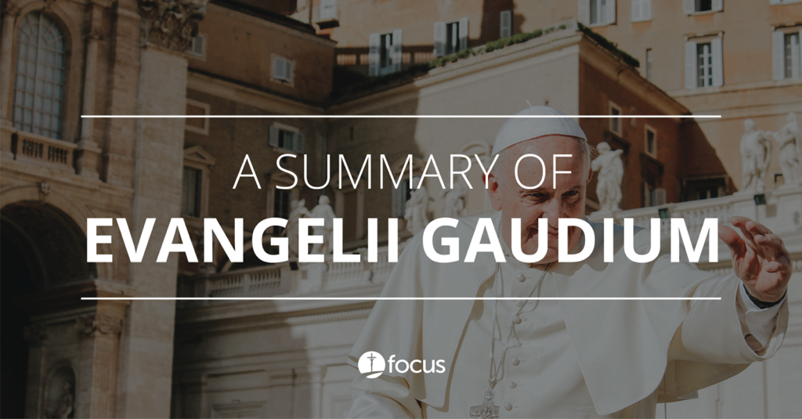

A Summary of Evangelii Gaudium (Joy of the Gospel): Pope Francis' First Apostolic Exhortation - FOCUS
focusequip.org
Best Wishes
Father Behruz Rafat

Your Prayers are asked for:
Those recently deceased:
Queen Elizabeth II RIP;
Monsignor Ted Hills RIP, (We will be having a memorial Mass on Friday 30 September at 7.30pm to pray for Fr Ted and to give thanks to God for his time as parish priest of St Andrew. After Mass, refreshments will be available in the parish centre, which was Fr Ted’s legacy to our parish. Please use the sign-up sheet in the porch, so we have an idea of how many people to cater for.

Sir Frank McWilliams GBE RIP (Requiem Mass here on Thursday 29th September at 11:30am)
Those ill or infirm: Cora Hazle, Ailish Cantwell (Jones), Sylwia Dorosz, Joe Adams, Ellie Lawrence, Anne Bryant, Patricia Hook, Elena Peck, Josie Payne, Pat Holland and all those who are unwell and in need of our prayers.
Those whose anniversaries of death occur at this time: Joan Carey, Josie Parsons, Sheila Allen, John Cregan, Hugh Blake, Dorothy Whiting, Juliet O’Hea and Christine Carney.

This week’s services (17th – 24th September), Feasts and Mass intentions during the week.
Saturday 17th September | No Mass  10.30 -11am Confession  6pm Vigil Nadia Ghawi RIP Reader: Pat
Sunday 18th September | 10am Mass People of the Parish Reader: Collette  12 Midday Traditional Latin Mass
Monday 19th September  St Januarius, Bishop, Martyr;  St Theodore of Canterbury, Bishop | 10am Mass Doreen’s Intentions
Tuesday 20th September  Ss Andrew Kim Tae-gun, Priest, Paul Chŏng Ha-sang, and Companions, Martyrs | 10am Mass Donor’s Intentions
Wednesday 21st September  St Matthew, Apostle, Evangelist | 10am Service of the Word and Holy Communion
Thursday 22nd September  Feria | 9am-10am Adoration  10am Mass Mary Iglinski RIP
Friday 23rd September  St Pio of Pietrelcina | 10am Mass Charlie & Caroline - Wedding  10.30 – 11.30am Adoration
Saturday 24th September  Our Lady of Walsingham | 10am Mass Our Lady Queen of Peace  10.30 -11am Confession  6pm Vigil Charlwood Family Reader: Kathy
Sunday 25th September  Twenty sixth Sunday (C) | 10am Mass People of the Parish Reader: Rachel  12 Midday Traditional Latin Mass
Flowers: for 25th September - Frances
Readers: for Saturday 24th - Kathy/Sunday 25th - Rachel
Cleaners: for 24th/25th September – Martin & Rachel

Confession
Fr Behr is available for Confession every Saturday from 10.30am - 11am. He is also happy to visit those who are not able to come to church.
Relics of Saint Bernadette
We ask the Lord’s blessing on this pilgrimage and hope that the physical presence of the Saint’s relics in our land will inspire not only a deeper love of Our Lord and Our Lady, but an increase of faith in all our people. "I shall do everything for Heaven, my true home. There I shall find my Mother in all the splendour of her glory. I shall delight with her in the joy of Jesus Himself” St Bernadette

St Bernadette Relic Tour
The relics of St Bernadette will be at The Friars, Aylesford (ME20 7BX) between 7:00pm on 24th October and 1:00pm on 28th October. You need to book to visit the relics: go to Registration.

What are relics and why do we venerate them? Here is an interesting explanation.
https://stbernadette.org.uk/what-are-relics/

World Day for Migrants and Refugees 25th September 2022
This international day of prayer will be celebrated on 25 September 2022.

Pact (Prison Advice & Care Trust)
invites you to join them at an online JustPeople Workshop taking place on Saturday 24th September 9.30am – 3pm, via Zoom.
Free to attend, it offers an opportunity to reflect upon Scripture, Church Teaching and Catholic Social Teaching through the lens of people affected by imprisonment.
Register here: JustPeople Workshops | Prison Advice and Care Trust
For more information about our workshops or volunteering opportunities with Pact, contact Marie on marie.norbury@prisonadvice.org.uk or call 07581 194907

Messages from Brian Lawrence:
Choir practice next Wednesday at 6.15pm – 7pm. If you would like to help, come along - we would be very grateful. Please contact Brian Lawrence on 01233 732657 (b.lawrence999@btinternet.com).

Carmen Antaki, who was a parishioner for many years before moving to Loughton, Essex, has recently died. She was a great benefactor to St. Andrew's, especially the new Parish Centre. May she rest in peace.

Fr. Oswald Mallya, known to many of us in his missionary work, has spent the last 7 years teaching in a seminary in Uganda. He is now in Dublin studying for an M.A. in Applied Spirituality and sends his best wishes to all at St. Andrew's. He will have a long break over Christmas and hopes to visit Tenterden.

