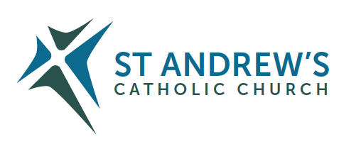
Parish Priest: Fr Behruz Rafat Telephone 01580 762785 Mobile: 07903 986646
Address: The Presbytery, 47 Ashford Road, Tenterden, Kent TN30 6LL.
Parish E-mail behruzrafat@rcaos.org.uk Parish Website: www.standrewstenterden.org
Deacon: Rev. Jolyon Vickers Telephone: 01580 766449 Email: jolyonvickers@rcaos.org.uk Hire of Parish Hall: Lesley McCarthy 07791 949652 E-mail: tenterdenparishcentre@rcaos.org.uk
Newsletter Editor: Patricia Sargent 01233 850963 E-mail: sargentpat51@gmail.com

Newsletter for the week commencing 25th September 2022
Twenty sixth Sunday in Ordinary Time ( C )
Entrance antiphon: All that you have done to us, O Lord, you have done with true judgement, for we have sinned against you and not obeyed your commandments. But give glory to your name and deal with us according to the bounty of your mercy.
First Reading: Amos 6: 1, 4-7
Psalm 145 Response: My soul, give praise to the Lord.
Second Reading: First letter of St Paul to Timothy 6: 11-16
Acclamation: Alleluia, alleluia! The sheep that belong to me listen to my voice, says the Lord. I know them and they follow me. Alleluia!
Gospel: Luke 16: 19-31
Communion antiphon: Remember your word to your servant, O Lord, by which you have given me hope. This is my comfort when I am brought low.

Father Behr writes:
Dear Parishioners
The Rosary
In 1917, Servant of God Sr Lucia of Fatima (1907 – 2005) was chosen by Our Lady to give a very important message to the world.

At the heart of the message was a plea by the blessed Mother for all of us to pray the Rosary every day.
Sr Lucia said
“The Most Holy Virgin in these last times in which we live has given a new efficacy to the recitation of the Rosary to such an extent that there is no problem, no matter how difficult it is, whether temporal or above all spiritual, in the personal life of each one of us, of our families… that cannot be solved by the Rosary. There is no problem, I tell you, no matter how difficult it is, that we cannot resolve by the prayer of the Holy Rosary.”

“Since we all need to pray, God asks of us, as a kind of daily instalment, a prayer which is within our reach: the Rosary, which can be recited either in common or in private, either in church in the presence of the Blessed Sacrament or at home, either with the rest of the family or alone, either when traveling or while walking quietly in the fields. A mother of a family can say the Rosary while she rocks her baby’s cradle or does the housework. Our day has 24 hours in it. It is not asking a great deal to set aside a quarter of an hour for the spiritual life, for our intimate and familiar converse with God.”
Quotes from https://aleteia.org/2017/02/16/7-powerful-quotes-from-fatima-visionary-sister-lucia/

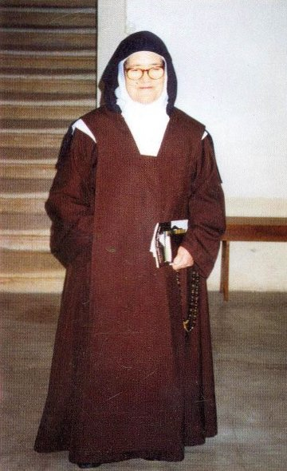
Sister Lúcia at the Discalced Carmelite Monastery of Coimbra, circa 1998
We will pray the Rosary in our church during October on Friday morning during Adoration at 10.30am and on Saturday evening at 5.30pm before the 6pm Mass.

Best Wishes
Father Behruz Rafat

Your Prayers are asked for:
Those recently deceased: Queen Elizabeth II RIP; Monsignor Ted Hills RIP, Sir Frank McWilliams GBE RIP
Those ill or infirm: Cora Hazle, Ailish Cantwell (Jones), Sylwia Dorosz, Joe Adams, Ellie Lawrence, Anne Bryant, Patricia Hook, Elena Peck, Josie Payne, Pat Holland and all those who are unwell and in need of our prayers.
Those whose anniversaries of death occur at this time: Terence Price, Tony Russell, Angela Drummond-Brady, Stanislaw Iglinski, Andrew O’Brien, John Feetenby, Dorothea Banyard, Archbishop Peter Amigo and Kathleen Nolan

Please pray for the repose of the soul of Sir Frank McWilliams GBE and for the comfort of his family. The funeral Mass is on Thursday 29 September 11.30am and all parishioners are welcome to attend.

This week’s services (25th September – 1st October), Feasts and Mass intentions during the week.
Saturday 24th September  Our Lady of Walsingham | 10am Mass Our Lady Queen of Peace  10.30 -11am Confession  6pm Vigil Charlwood Family Reader: Kathy
Sunday 25th September  Twenty sixth Sunday ( C ) | 10am Mass People of the Parish Reader: Rachel  12 Midday Traditional Latin Mass
Monday 26th September Ss Cosmas and Damian, Martyrs | No Mass
Tuesday 27th September  St Vincent de Paul, Priest | No Mass
Wednesday 28th September  St Wenceslaus, Martyr; Ss Lawrence Ruiz, and Companions, Martyrs | 10am Service of the Word and Holy Communion
Thursday 29th September  Ss Michael, Gabriel, and Raphael, Archangels | 11.30am Funeral Mass for Sir Francis McWilliams GBE. RIP
Friday 30th September  St Jerome, Priest, Doctor of the Church | No Mass or Adoration  7.30pm Mass for Monsignor Ted RIP (Doreen)
Saturday 1st October  St Therese of the Child Jesus, Virgin, Doctor of the Church | 10am Mass Pat Hook & Family  10.30 -11am Confession  6pm Vigil People of the Parish Reader: Christine & Lucie (Family readers)  Adoration and Benediction after Mass
Sunday 2nd October  Twenty seventh Sunday ( C ) | 10am Mass Stanislaw Iglinski RIP (Anniversary) Reader: Kathleen  12 Midday Traditional Latin Mass
Flowers: for 2nd October - Kathy
Readers: for Saturday 1st October – Christine & Lucie/Sunday 2nd October - Kathleen

Confession
Fr Behr is available for Confession every Saturday from 10.30am - 11am. He is also happy to visit those who are not able to come to church.
WORLD DAY FOR MIGRANTS AND REFUGEES, 25 SEPTEMBER 2022
This international day of prayer will be celebrated this weekend.

Memorial Mass for Monsignor Ted Hill RIP
We will be having a memorial Mass on Friday 30 September at 7.30pm to pray for Fr Ted and to give thanks to God for his time as parish priest of St Andrew.
After Mass refreshments will be available in the parish centre which was Fr Ted’s legacy to our parish.
Please let me or Jolyon know if you are coming so we have an idea of how many people to cater for.

RELICS OF ST BERNADETTE
We ask the Lord’s blessing on this pilgrimage and hope that the physical presence of the Saint’s relics in our land will inspire not only a deeper love of Our Lord and Our Lady, but an increase of faith in all our people. "I shall do everything for Heaven, my true home. There I shall find my Mother in all the splendour of her glory. I shall delight with her in the joy of Jesus Himself” St Bernadette

What are relics and why do we venerate them? Here is an interesting explanation.
https://stbernadette.org.uk/what-are-relics/

St Bernadette Relic Tour - the relics are due to visit St George’s Cathedral from the morning of Wednesday 19 October until the morning of Friday 21 October; they will also visit Aylesford from Monday 24 October until Friday 28 October. Please consult the website of each venue for further details.

KENT POLICE MALE VOICE CHOIR – Autumn Concert – Saturday 1st October at 7.30pm – All Saints Church, Biddenden

Invitation to webinar: Thank you for your recent generous support for seafarers and fishers on Sea Sunday. As a follow up, Catholic charity Stella Maris (formerly called Apostleship of the Sea) invites you to join a webinar on Tuesday 27th September from 7.30pm to 9pm GMT to learn more about the issue of seafarer abandonment, and how donations like yours on Sea Sunday are supporting those in crisis. If you would like to attend, please register in advance at www.stellamaris.org.uk/abandonment

DAY OF RENEWAL – At Aylesford Priory on Saturday 1st October, organised by your local prayer group. The day starts with Rosary at 9.30 am, followed by Prayer and Praise at 10am. The Guest speaker is Derek Williams a much-respected evangelist. Prayer & Praise, Healing and Mass at 3.45pmto end the day. Come and refresh your spiritual life! Please, put the date in your diary.

Escorted Pilgrimage to Knock Shrine, 17th October 2022. £699.00 per person sharing. Price includes 4 nights’ in Knock House Hotel with full board. All entertainment and excursions included. Day trips to Westport, Ballintubber Abbey, Croagh Patrick, Fr. Peyton Centre & National Museum. Single supplement £100.00. Contact Patricia on 01268 762 278 or 07740 175557 or email knockpilgrimages@gmail.com

