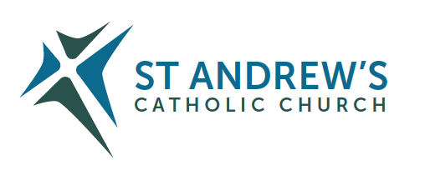
Parish Priest: Fr Behruz Rafat Telephone 01580 762785 Mobile: 07903 986646
Address: The Presbytery, 47 Ashford Road, Tenterden, Kent TN30 6LL.
Parish E-mail behruzrafat@rcaos.org.uk Parish Website: www.standrewstenterden.org
Deacon: Rev. Jolyon Vickers Telephone: 01580 766449 Email: jolyonvickers@rcaos.org.uk Hire of Parish Hall: Lesley McCarthy 07791 949652 E-mail: tenterdenparishcentre@rcaos.org.uk
Newsletter Editor: Patricia Sargent 01233 850963 E-mail: sargentpat51@gmail.com

Newsletter for the week commencing 2nd October 2022
Twenty Seventh Sunday in Ordinary Time (C)
Entrance antiphon: Within your will, O Lord, all things are established, and there is none that can resist your will. For you have made all things, the heaven and the earth, and all that is held within the circle of heaven; you are the Lord of all.
First Reading: the prophet Habakkuk 1: 2-3; 2: 2-4
Psalm 94 Response: O that today you would listen to his voice! Harden not your hearts.
Second Reading: Second letter of St Paul to Timothy 1: 6-8. 13-14
Acclamation: Alleluia, alleluia! Speak, Lord, your servant is listening: you have the message of eternal life. Alleluia!
Gospel: Luke 17: 5-10
Communion antiphon: The Lord is good to those who hope in him, to the soul that seeks him.

Father Behr writes:
Dear Parishioners
On Friday we celebrate the memorial feast of Our Lady of the Rosary.

The Battle of Lepanto (October 7, 1571) is one of the most decisive naval battles in history.
To commemorate this important event St Pius V gave the Church the feast we know today as Our Lady of the Rosary.

Historian Paul K Davis wrote
“More than a military victory, Lepanto was a moral one. For decades, the Ottoman Turks had terrified Europe, and the victories of Suleiman the Magnificent caused Christian Europe serious concern. The defeat at Lepanto further exemplified the rapid deterioration of Ottoman might under Selim II, and Christians rejoiced at this setback for the Ottomans. The mystique of Ottoman power was tarnished significantly by this battle, and Christian Europe was heartened.” Quote from https://en.m.wikipedia.org/wiki/Battle_of_Lepanto

If you would like to find out more about this battle and the part the Rosary played, please visit this article.

https://catholicism.org/battle-of-lepanto.html

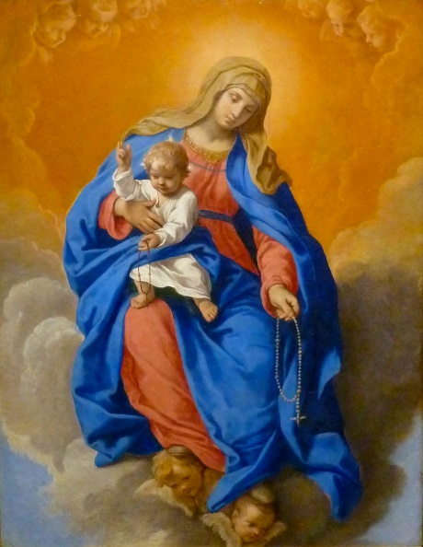
Our Lady of the Rosary Simone Cantarini • Public domain
On Friday We have Mass at 10am followed by Adoration and Rosary.

Why not make a special effort to pray the Rosary during October.

Best Wishes
Father Behruz Rafat

Your Prayers are asked for:
Those recently deceased: Anne Bryant RIP – Requiem Mass followed by Burial – Thursday 20th October at 11am
Those ill or infirm: Cora Hazle, Ailish Cantwell (Jones), Sylwia Dorosz, Joe Adams, Ellie Lawrence, Anne Bryant, Patricia Hook, Elena Peck, Josie Payne, Pat Holland and all those who are unwell and in need of our prayers.
Those whose anniversaries of death occur at this time: Sheila Fielding, Catherine Young, Honora Scanlan, David Strivens, Agnes Mary Nolan, Mary McHugh, Anne Wickham, Arthur McMullen, John Lorimar, Kenneth Stacey and Freddie Ryan.

This week’s services (1st – 8th October), Feasts and Mass intentions during the week.
Saturday 1st October  St Therese of the Child Jesus, Virgin, Doctor of the Church | 10am Mass Pat Hook & Family  10.30 -11am Confession  6pm Vigil People of the Parish Reader: Christine & Lucie (Family readers)  Adoration and Benediction after Mass
Sunday 2nd October  Twenty seventh Sunday (C) | 10am Mass Stanislaw Iglinski RIP (Anniversary) Reader: Kathleen  12 Midday Traditional Latin Mass
Monday 3rd October  Feria | 10am Mass Anne Hunt (Wellbeing)
Tuesday 4th October  St Francis of Assisi | 10am Mass Donor’s Intention
Wednesday 5th October  St Faustina Kowalska, Virgin | No Service
Thursday 6th October  St Bruno, Priest | 9am-10am Adoration  10am Mass Martin Cummings RIP
Friday 7th October  Our Lady of the Rosary | 10am Mass Our Lady Queen of Peace  10.30 – 11.30am Adoration
Saturday 8th October  Feria | 10am Mass Fr Paul Gibbons RIP  10.30 -11am Confession  6pm Vigil Robert Barrett RIP Reader: James
Sunday 9th October  Twenty Eighth Sunday (C) | 10am Mass People of the Parish Reader: Collette  12 Midday Traditional Latin Mass
Flowers: for 9th October – Pat
Readers: for Saturday 8th October - James/Sunday 9th October – Collette

Confession
Fr Behr is available for Confession every Saturday from 10.30am - 11am. He is also happy to visit those who are not able to come to church.
Rosary in October
We will pray the Rosary in our church during October on Friday morning during Adoration
at 10.30am and on Saturday evening at 5.30pm before the 6pm Mass.

Sr Lucia of Fatima said:
“The Most Holy Virgin in these last times in which we live has given a new efficacy to the recitation of the Rosary to such an extent that there is no problem, no matter how difficult it is, whether temporal or above all spiritual, in the personal life of each one of us, of our families… that cannot be solved by the Rosary. There is no problem, I tell you, no matter how difficult it is, that we cannot resolve by the prayer of the Holy Rosary.”

St Simon Stock Catholic School
Open events for entry in September 2023
Open Evening Thursday 6 October - 5pm to 7.30pm / Principal talks at 5.15pm, 6pm & 6.45pm
Open Mornings Tuesday 11 October & Thursday 13 October - 9am to 10.30am (Tours commence at 9am)
Sixth Form Open Evening Thursday 3 November - 6pm to 8pm / Talk by Leader of the Sixth Form at 6pm
Please visit www.ssscs.co.uk for advance booking and further information
St Simon Stock Catholic School, Oakwood Park, Maidstone ME16 0JP Tel: 01622 754551

St Bernadette Relic Tour - the relics are due to visit St George’s Cathedral from the morning of Wednesday 19 October until the morning of Friday 21 October; they will also visit Aylesford from Monday 24 October until Friday 28 October. Please consult the website of each venue for further details.

CAFOD Family Fast Day – World Food Crisis Appeal
Millions of families are facing a food crisis that could be the worst in living memory. As each day goes by, the situation worsens. As people of faith, we must act. Your donations can help CAFOD’s local experts to provide emergency food supplies to families in the worst affected countries in East Africa and support communities around the world working hard to put food on the table. Please give today or start a monthly gift to CAFOD. Use the envelope for our parish collection or go to cafod.org.uk/fast day.

MARRIAGE PREPARATION PRESENTERS – RC ARCHDIOCESE OF SOUTHWARK
A married couple, both being practising Catholics, to present 6 courses a year in various locations in South London and Kent, plus cover in case of colleagues’ illness.
Salary: £30,000 pro rata (£7,000) for the couple. Mileage paid in addition. All training given.
For full job description and further details, please contact liamgallagher@rcaos.org.uk
Applications by October 14th.

HELP YOUR MARRIAGE – Do you feel alone? Are you frustrated or angry with each other? Do you argue ... or have you just stopped talking to each other? Does talking about it only make it worse? Retrouvaille is a programme to support couples who have difficulties in their marriage. It brings a positive focus, new hope and helps nourish and grow your marriage. Tens of thousands of couples headed for divorce have successfully saved their marriages by attending and using the tools provided. The programme helps spouses uncover or re-awaken the love, trust and commitment that originally brought them together. It helps them through difficult times whether they are disillusioned or in deep misery. There is no group therapy or group work. For confidential information about ‘Retrouvaille’ or to register for the next programme commencing with a Virtual weekend on 13 - 16 October 2022 or a Face-to-Face weekend in Welwyn Garden City on 24 - 26 February 2023, call or text 07887 296983 or 07973 380443 or email retrouvailleukinfo@gmail.com - or visit www.retrouvaille.org.uk

Escorted Pilgrimage to Knock Shrine, 17th October 2022. £699.00 per person sharing. Price includes 4 nights in Knock House Hotel with full board. All entertainment and excursions included. Day trips to Westport, Ballintubber Abbey, Croagh Patrick, Fr. Peyton Centre & National Museum. Single supplement £100.00. Contact Patricia on 01268 762 278 or 07740 175557 or email knockpilgrimages@gmail.com

Ride & Stride
A belated (but still grateful!) thanks to all who took part in and/or supported the Friends of Kent Churches Ride and Stride in different ways this year. The team of welcomers greeted 21 visitors to St Andrew's during the course of the day. This was a little down on the 25 visitors last year, but unsurprising given the circumstances, and visitors were pleased as always to be welcomed in person. Also, if any parishioners from St. Andrews rode and strode around Kent's churches, please could you now collect your sponsorship money and either pay direct by BACS (details on R&S website) or give this as a cheque, along with your sponsorship forms, to Rachel Heinrichsmeier by 24th October. Please make any cheques payable to: Friends of Kent Churches Ride & Stride.

