Parish Priest: Fr Behruz Rafat Telephone 01580 762785 Mobile: 07903 986646
Address: The Presbytery, 47 Ashford Road, Tenterden, Kent TN30 6LL.
Parish E-mail behruzrafat@rcaos.org.uk Parish Website: www.standrewstenterden.org
Deacon: Rev. Jolyon Vickers Telephone: 01580 766449 Email: jolyonvickers@rcaos.org.uk Hire of Parish Hall: Lesley McCarthy 07791 949652 E-mail: bookings.standrews@talktalk.net
Newsletter Editor: Patricia Sargent 01233 850963 E-mail: sargentpat51@gmail.com

Newsletter for the week commencing 9th January 2022
The Baptism of the Lord
Entrance antiphon: After the Lord was baptised, the heavens were opened, and the Spirit descended upon him like a dove, and the voice of the Father thundered: This is my beloved Son, with whom I am well pleased.
First Reading: Isaiah 42: 1-4, 6-7
Psalm 28 Response: The Lord will bless his people with peace.
Second Reading: Acts of the Apostles 10: 34-38
Acclamation: Alleluia, alleluia! The heavens opened and the Father’s voice resounded: “This is my Son, the Beloved. Listen to him.” Alleluia!
Gospel: Luke 3: 15-16, 21-22
Communion antiphon: Behold the One of whom John said: I have seen and testified that this is the Son of God.

Father Behr writes:
Dear Parishioners,

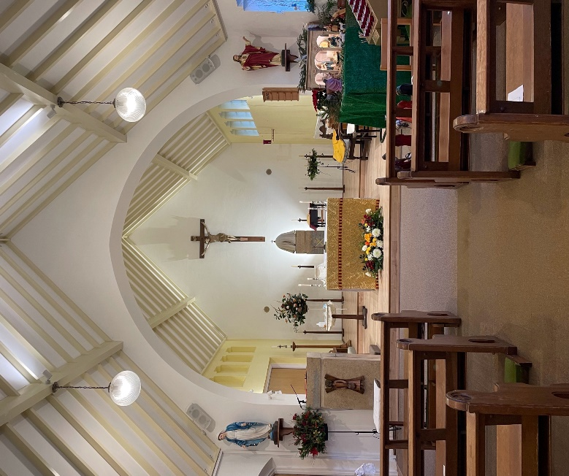

Adoration of Jesus, Truly Present in the Blessed Sacrament
We are going to start having Adoration from Friday 14 January every week for one hour after the 10am Mass.

There are great benefits to Adoration for each person and for those we love. Our Lord Jesus is truly present in the Blessed Sacrament and he loves you with a very great love. Adoration is a very deep and personal experience of that love. If you haven’t spent time in Adoration why not start with half an hour.

There will also be prayer books and other resources available to help us during our time of prayer.

Some quotations to inspire us to spend time in Adoration

“Nowhere on earth are we more welcomed or loved than by Jesus in Eucharist.” Mother Teresa

“Once you feel the attraction to remain in the silence of adoration in God’s presence, you must give yourself entirely to the Holy Spirit and remain there in pure faith. If God gives you no feeling, no sentiment, no distinct thought, just be there before Him in silent love. During such moments He operates insensibly in the soul and does more for her perfection than she could in a lifetime by her own thoughts. Blessed Columba Marmiom. “

Best wishes
Father Behr

Your Prayers are asked for:
Those recently deceased:
Those ill or infirm: Charlotte Elliot (daughter of Maureen Davidson), Joe Adams, Ellie Lawrence, Anne Bryant, Patricia Hook, Elena Peck (senior), Josie Payne, Pat Holland and all those self-isolating or suffering from COVID-19.
Those whose anniversaries of death occur at this time: Howard Wickham, Dorothy Marie Newell, Margaret Salmon, Joyce Thomas, Christine Wood (Anne Bryant’s sister), Julie Elliott, Clemens Heinrichsmeier, Catherine Mellor, Norman Styles, Jan Czarski and Josephine Harrington.

This week’s services (8th – 15th January),
Feasts and Mass intentions during the week.
Saturday 8th January  10am Mass  10.30 -11am Confession  6pm Vigil Mass | Weekday after the Epiphany  Frederick Bishop RIP  Little M | Thursday 13th January  10am Mass | St Hilary, Bishop & Doctor of the Church  Holy Mass for Priests
Sunday 9th January  10am Mass  12 Midday Traditional Latin Mass | The Baptism of the Lord  People of the Parish | Friday 14th January  10am Mass  10.30 – 11.30am Adoration | Feria  In Thanksgiving (Lawrence)
Monday 10th January  10am Mass | Feria Iglinski Family | Saturday 15th January  10am Mass  6pm Vigil Mass | Feria  Frances Hirst Intentions  Catherine Lista RIP
Tuesday 11th January  10am Mass | Feria  Brian Bishop RIP | Sunday 16th January  10am Mass  12 midday Traditional Latin Mass | Second Sunday in Ordinary Time  People of the Parish
Wednesday 12th January  10am Service of the Word and Holy Communion | St Aelred of Rievaulx
Flowers: For 16th January – Breeda

Confession
Fr Behr is available for Confession every Saturday from 10.30am - 11am. He is also happy to visit those who are not able to come to church.
A message from Frances…
Grateful thanks to all those who brought such lovely vases and arrangements for the windowsills. What talents you have. Please let me know what reimbursements you need (01233 732657/f.lawrence999@btinternet.com)
Frances

