Parish Priest: Fr Behruz Rafat Telephone 01580 762785 Mobile: 07903 986646
Address: The Presbytery, 47 Ashford Road, Tenterden, Kent TN30 6LL.
Parish E-mail behruzrafat@rcaos.org.uk Parish Website: www.standrewstenterden.org
Deacon: Rev. Jolyon Vickers Telephone: 01580 766449 Email: jolyonvickers@rcaos.org.uk Hire of Parish Hall: Lesley McCarthy 07791 949652 E-mail: bookings.standrews@talktalk.net
Newsletter Editor: Patricia Sargent 01233 850963 E-mail: sargentpat51@gmail.com

Newsletter for the week commencing 30th January 2022
Fourth Sunday in Ordinary Time ( C )
Entrance antiphon: Save us, O Lord our God! And gather us from the nations, to give thanks to your holy name, and make it our glory to praise you.
First Reading: Jeremiah 1: 4-5; 17-19
Psalm 70 Response: My lips will tell of your help.
Second Reading: First letter of St Paul to the Corinthians 12: 31-13: 13
Acclamation: Alleluia, alleluia! I am the Way, the Truth and the life, says the Lord; no one can come to the Father except through me. Alleluia!
Gospel: Luke 4: 21-30
Communion antiphon: Let your face shine on your servant. Save me in your merciful love. O Lord, let me never be put to shame, for I call on you.

Father Behr writes:
Dear Parishioners,

Candlemas
Wednesday is the feast of the Presentation and we have Mass at 10am.
We will have a special service of blessing of candles at the start of Holy Mass. Do bring your candles to be blessed.

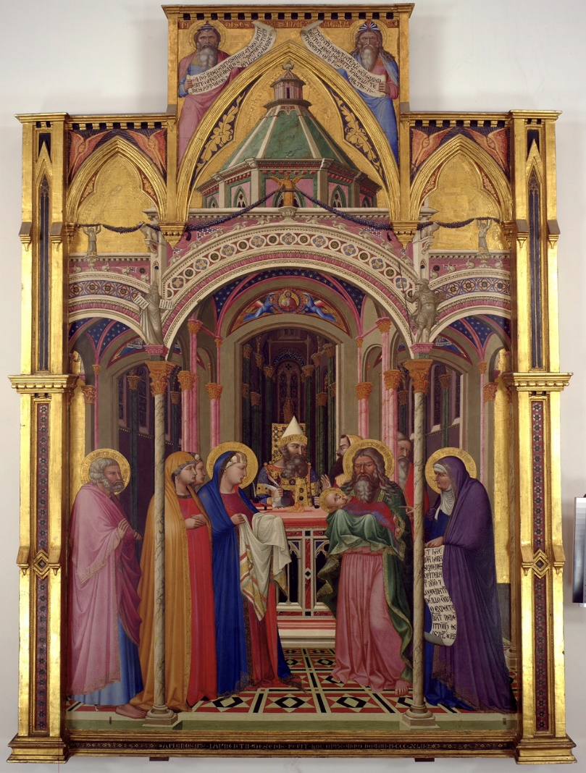

Presentation at the Temple by Ambrogio Lorenzetti, 1342 (Galleria degli Uffizi, Florence)

We have received up-to-date guidance from the diocese.

No social distancing is needed. We no longer need to book for Mass.
The wearing of masks is now optional. Please be careful and respect the needs of others.
If you have any questions please speak to me or Jolyon.
As always if you have a cough or a fever it is better to stay home.
We will continue to make the parish centre available.

Statue of the Sacred Heart
I am grateful to Liz and Wayne for their kind donation to pay for the refurbishment of our Sacred Heart statue. Liz wanted to do this in memory of her late mum and dad, John and Marjorie Dumbleton. We will have a special votive Mass of the Sacred Heart on Friday February 4 at the usual time of 10am which will be offered for John and Marjorie.

Best wishes
Father Behr

Your Prayers are asked for:
Those recently deceased: Colin Morrison RIP
Those ill or infirm: Charlotte Elliot (daughter of Maureen Davidson), Joe Adams, Ellie Lawrence, Anne Bryant, Patricia Hook, Elena Peck (senior), Josie Payne, Pat Holland and all those self-isolating or suffering from COVID-19.
Those whose anniversaries of death occur at this time: Philip Charles Dennis Wilkinson, Charles Priggy, Leslie & Edith Cave, Billy Benies, Kenneth Francis, Edwin Stephen Knott, Joan Freeman, Kathleen Lewis, Lady Sheila Bates, John McDonald and Dorothy Castle.

Please pray for the for the repose of the soul of Colin Morrison RIP who died recently. Colin’s Funeral will be on Thursday 24 February at 11am

This week’s services (30th January – 5th February),
Feasts and Mass intentions during the week.
Saturday 29th Jan  10am Mass  10.30 -11am Confession  6pm Vigil Mass | Feria  Little M  John Fahy RIP | Thursday 3rd Feb  10am Mass | St Blaise, Bishop, Martyr; St Ansgar, Bishop  Oscar Wells
Sunday 30th Jan  10am Mass  12 Midday Traditional Latin Mass | Fourth Sunday in Ordinary Time  People of the Parish | Friday 4th Feb  10am Mass  10.30 – 11.30am Adoration | Feria  John & Marjorie Dumbleton RIP
Monday 31st Jan  10am Mass | St John Bosco, Priest Dunhill Family Wellbeing | Saturday 5th Feb  10am Mass  6pm Vigil Mass | St Agatha, Virgin & Martyr  David Burford Intentions  Eileen Fahy
Tuesday 1st Feb  10am Mass | Feria  The Meagher Family | Sunday 6th Feb  10am Mass  12 midday Traditional Latin Mass | Fifth Sunday in Ordinary Time  People of the Parish
Wednesday 2nd Feb  10am Mass  12 Midday Traditional Latin Mass | The Presentation of the Lord  Jose Carrizales RIP and Family (Lawrence)
Flowers: For 6th February - Pat
Confession
Fr Behr is available for Confession every Saturday from 10.30am - 11am. He is also happy to visit those who are not able to come to church.
Coffee, tea and conversation… From next Sunday (6th February) there will be refreshments after the 10am Mass every week. Come and have a cuppa and a chat – get to know your fellow parishioners.

