Views of the Church in the hands of the Contractor after Four Days

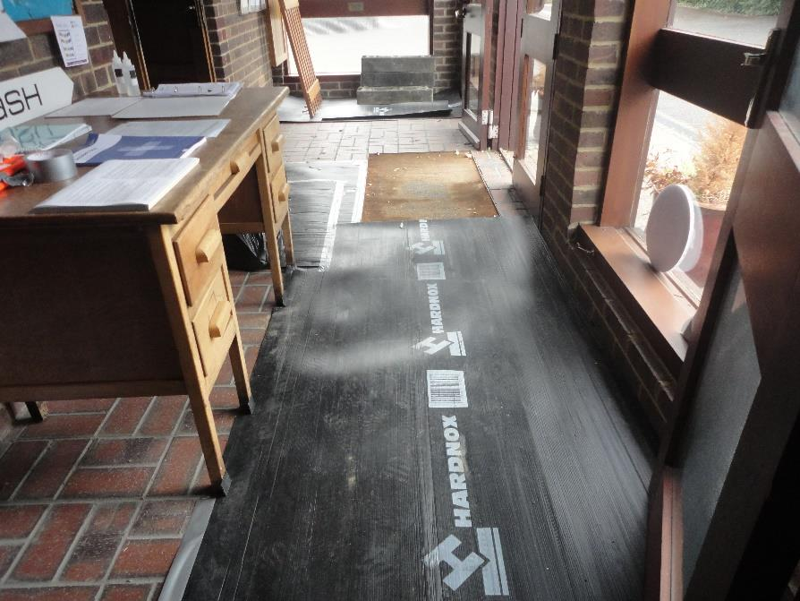
The entrance lobby

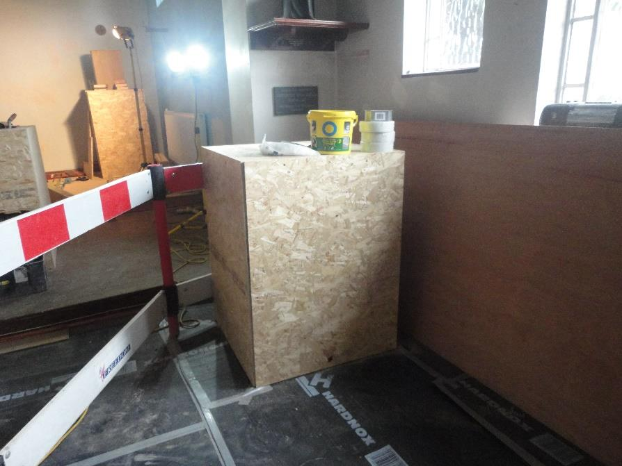

The font is being protected
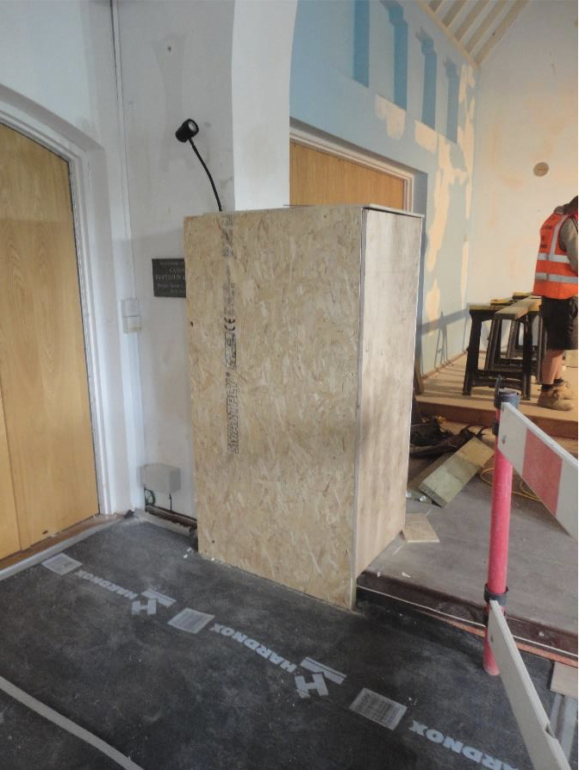
The ambo under protection

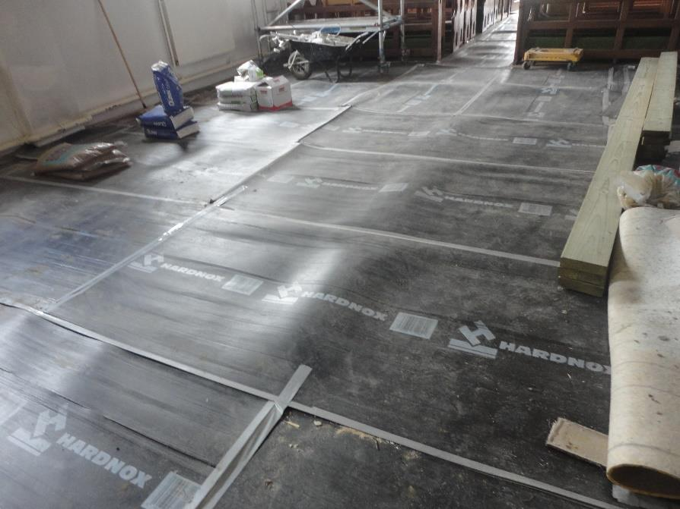

The floor of the nave
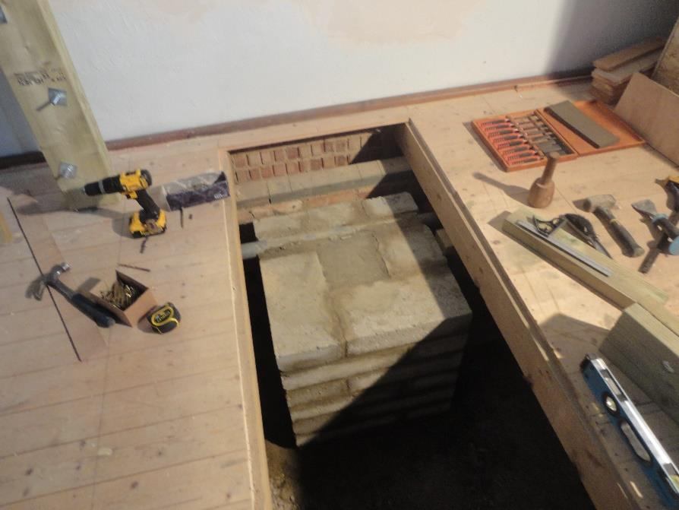
The new location for the tabernacle is reinforced….

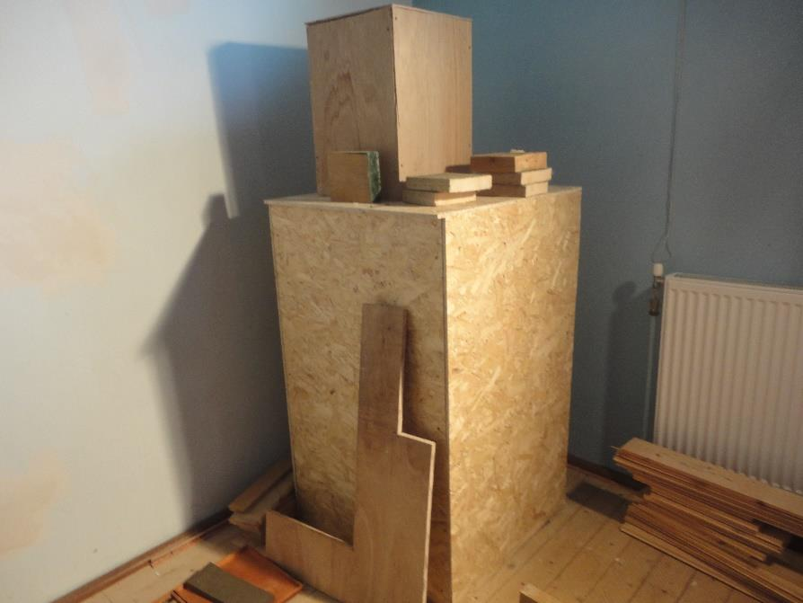
….in the meantime, it is protected

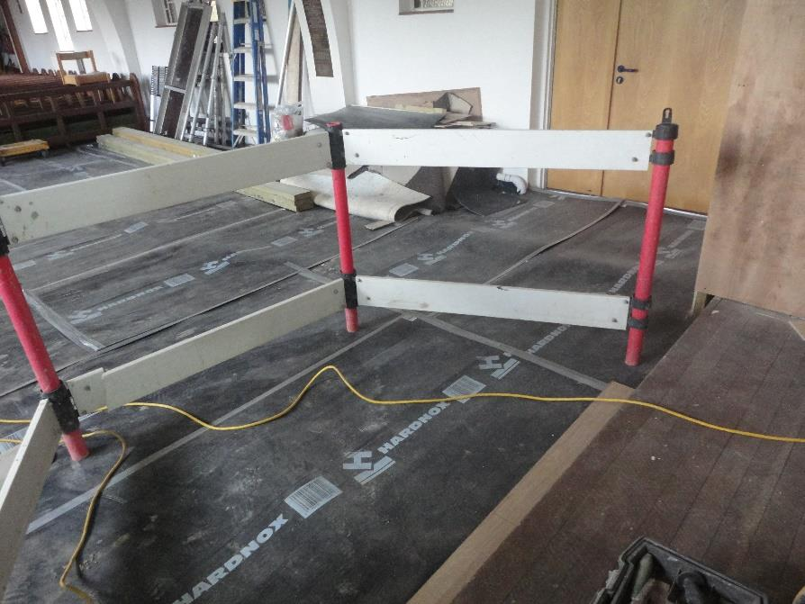
The sanctuary carpet reveals the wooden floor

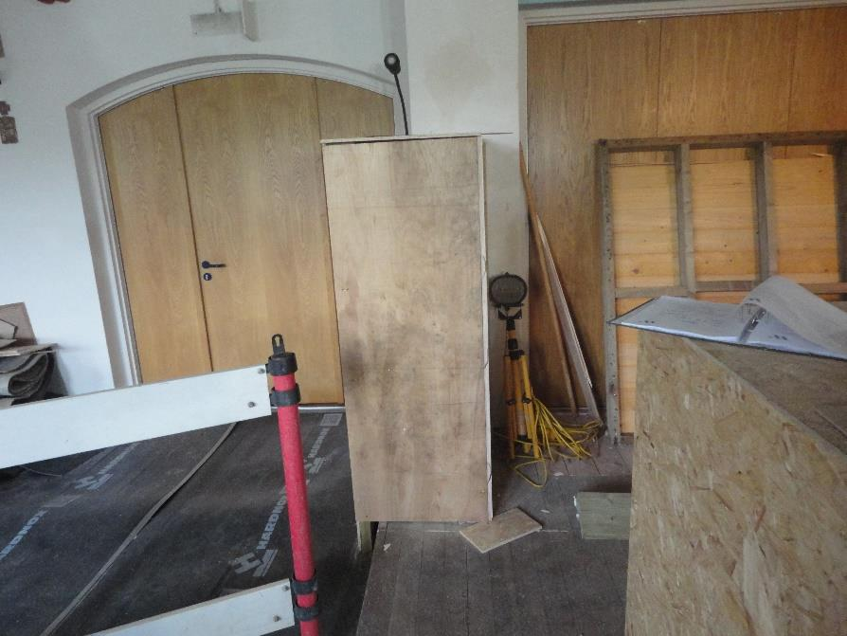
Work in the sanctuary

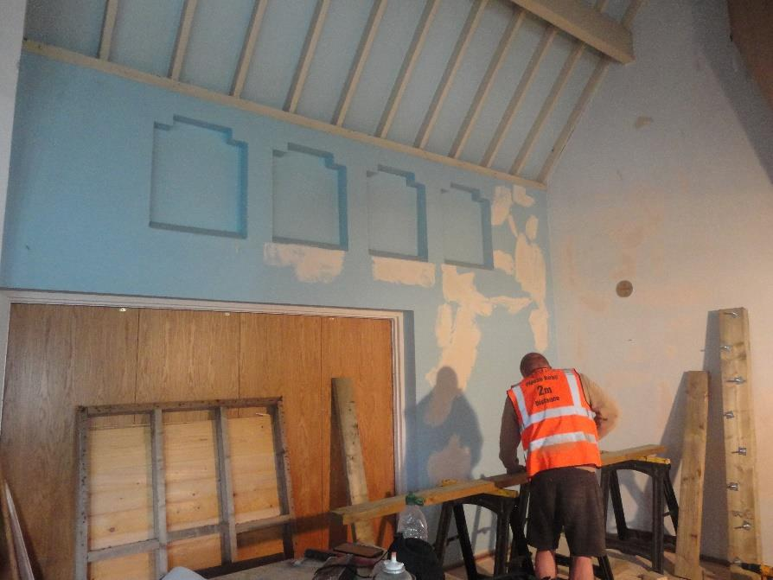
The doors into the Parish Centre are covered while work goes on

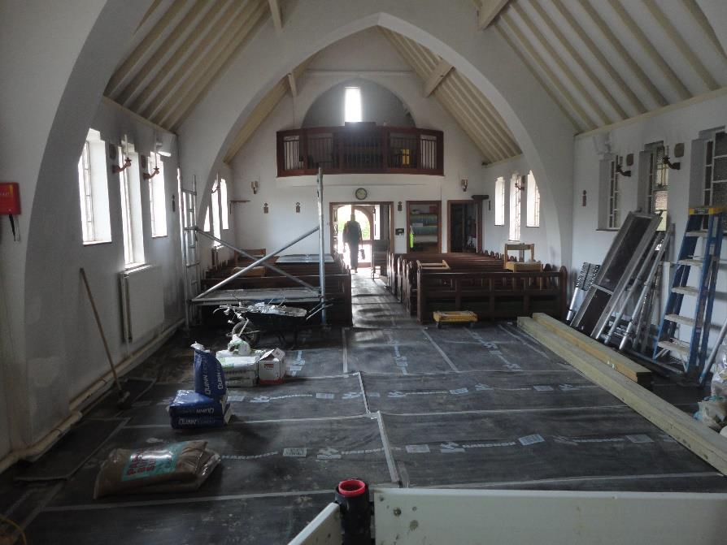

Looking from the sanctuary into the nave
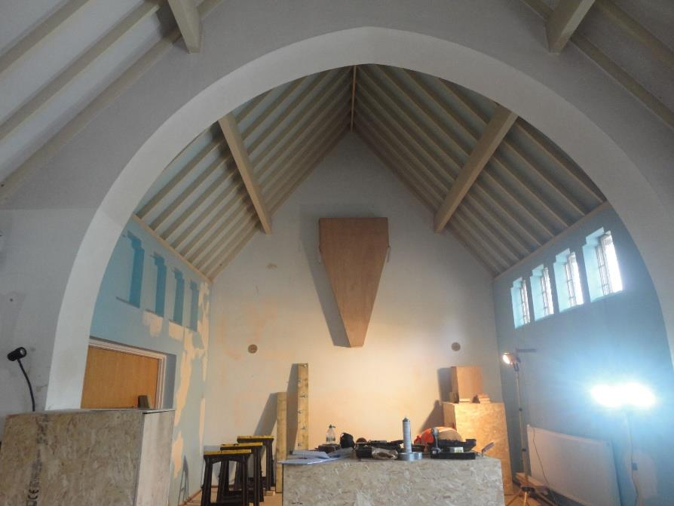
Looking from the nave into the sanctuary; the crucifix is also protected

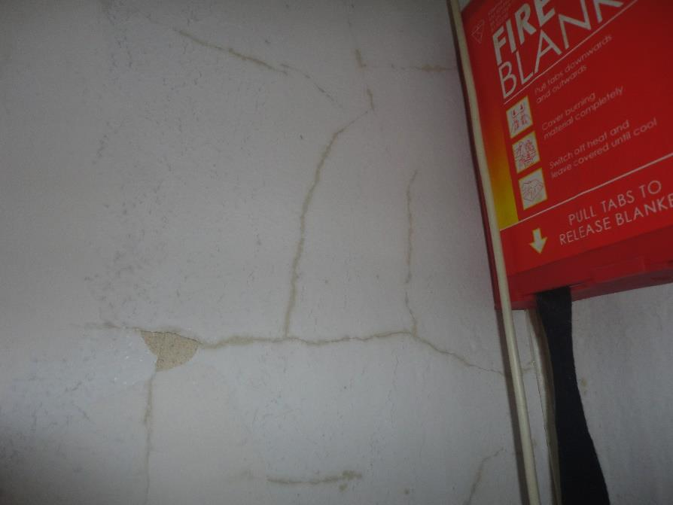

Some of the damage to the plaster on the walls

