T E N T E R D E N K E N T

**Parish Priest:** Fr Behruz Rafat **Telephone** 01580 762785 Mobile: 07903 986646

**Address:** The Presbytery, 47 Ashford Road, Tenterden, Kent TN30 6LL.

**Parish E-mail** [behruzrafat@rcaos.org.uk](mailto:behruzrafat@rcaos.org.uk) **Parish Website:** www.standrewstenterden.org

**Deacon:** Rev. Jolyon Vickers **Telephone:** 01580 766449 **Email:** jolyonvickers@rcaos.org.uk **Hire of Parish Hall:** Lesley McCarthy 07791 949652 **E-mail:** [bookings.standrews@talktalk.net](mailto:bookings.standrews@talktalk.net)

**Newsletter Editor:** Patricia Sargent 01233 850963 **E-mail:** sargentpat51@gmail.com

**Newsletter for the week commencing 31st January 2021**

**Fourth Sunday in Ordinary Time (B)**

**Entrance antiphon: Save us, O Lord our God! And gather us from the nations, to give thanks to your holy name, and make it our glory to praise you.**

**First Reading: Deuteronomy 18: 15-20**

**Psalm 94 Response: O that today you would listen to his voice! Harden not your hearts.**

**Second Reading: First letter of St Paul to the Corinthians 7: 32-35**

**Acclamation: Alleluia, alleluia! Blessed are you, Father, Lord of heaven and earth, for revealing the mysteries of the kingdom to mere children. Alleluia!**

**Gospel**: **Mark 1: 21-28**

**Communion antiphon: Let your face shine on your servant. Save me in your merciful love. O Lord, let me never be put to shame, for I call on you.**

**Father Behr writes:**

Dear Parishioners

In Sunday’s Gospel Jesus encounters an unclean spirit and by his own authority casts it out.

 ‘But Jesus said sharply, ‘Be quiet! Come out of him!’ And the unclean spirit threw the man into convulsions and with a loud cry went out of him.’ (Mark 1)

 As uncomfortable as it may be, the truth of our Catholic faith reveals the existence of fallen Angels we call demons; chief among them Satan.  They rebelled against God and are now permitted to tempt humans and ‘to seek the ruin of souls’.

We don’t have to be afraid of demons or obsessed with them but we do have to have a mature approach based on Faith.  We need the graces that come through our Catholic faith and use all the means the church places at our disposal, particularly prayer and the sacraments to protect ourselves and those we love.

The church has given us many powerful prayers, one very effective prayer is to ask the assistance of St Michael the Archangel.  I would strongly recommend that we pray this prayer every day.

St. Michael the Archangel,

defend us in battle.

Be our defence against the wickedness and snares of the Devil.

May God rebuke him, we humbly pray,

and do thou,

O Prince of the heavenly hosts,

by the power of God,

thrust into hell Satan,

and all the evil spirits,

who prowl about the world

seeking the ruin of souls. Amen.

**10th-century gold and enamel Byzantine**[**icon**](https://en.wikipedia.org/wiki/Icon)**of**[**St Michael**](https://en.wikipedia.org/wiki/St_Michael)

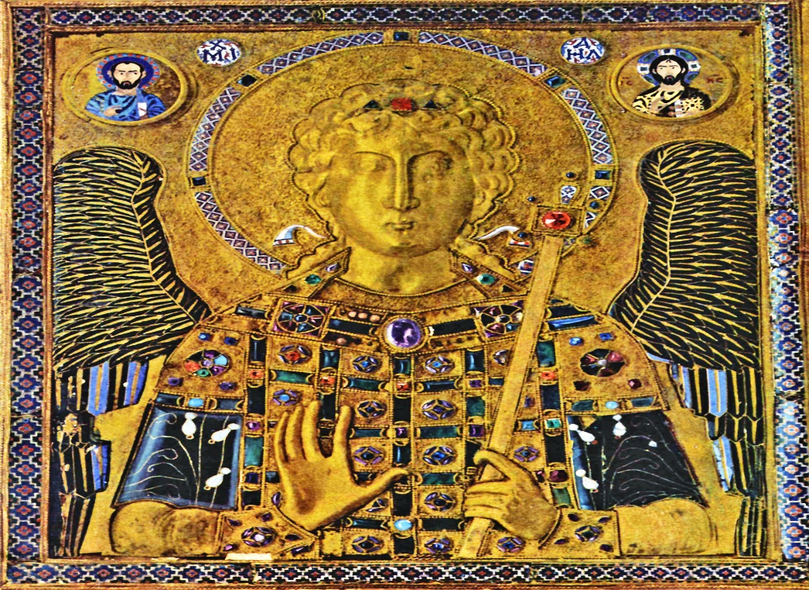

Best wishes

Father Behruz Rafat

**Your Prayers are asked for:**

**Those recently deceased**: Wilhelmina Franklin RIP, Alan Dorey RIP

**Those ill or infirm:** Charlotte Elliot (daughter of Maureen Davidson), Jennifer Jorden, Joe Adams, Ellie Lawrence, Anne Bryant, Patricia Hook, Elena Peck (senior), Marjorie Dumbleton, Josie Payne, Pat Holland and all those self-isolating or suffering from COVID-19.

**Those whose anniversaries of death occur at this time:** Philip Charles Wilkinson, Charles Priggy, Leslie & Edith Cave, Billy Benies, Kenneth Francis, Edwin Stephen Knott, Joan Freeman, Kathleen Lewis, Lady Sheila Bates, John McDonald, Dorothy Castle, Adele Sherston and Patrick O’Keeffe.

**The funeral service for Wilhelmina Franklin** (of Woodchurch) will be on **Thursday, February 4th at 1pm (13:00)** at **Wealden Crematorium Chapel, Horam.**

**There is a second collection this weekend for the Catholic Association for Racial Justice.**

|  |  |  |  |
| --- | --- | --- | --- |
| **This week’s services (31st January – 6th February), Feasts and Mass intentions during the week.** | | | |
| **Sunday 31st Jan**  10 am Mass  **6 pm** | **Fourth Sunday of the Year**  **Racial Justice Day**  *For the people of the parish* | **Thursday 4th Feb**  10 am Mass | Feria |
| **Monday 1st Feb**  10 am Mass | Feria | **Friday 5th Feb**  10 am Mass | St Agatha, Virgin & Martyr |
| **Tuesday 2nd Feb**  10 am Mass | **THE PRESENTATION OF THE LORD** | **Saturday 6th Feb**  10 am Mass | St Paul Miki & Companions, Martyrs |
| **Wednesday 3rd Feb**  10 am Service of the Word and Holy Communion | St Lawrence of Canterbury, Bishop | **Sunday 7th Feb**  10 am Mass  12 midday EF Latin Mass | **Fifth Sunday of the Year (B)** |
| **Flowers for 7th Feb – Suzanne Vickers** | | | |