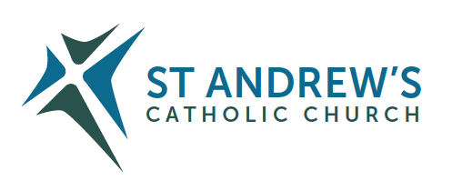
Parish Priest: Fr Behruz Rafat Telephone 01580 762785 Mobile: 07903 986646
Address: The Presbytery, 47 Ashford Road, Tenterden, Kent TN30 6LL.
Parish E-mail behruzrafat@rcaos.org.uk Parish Website: www.standrewstenterden.org
Deacon: Rev. Jolyon Vickers Telephone: 01580 766449 Email: jolyonvickers@rcaos.org.uk Hire of Parish Hall: Lesley McCarthy 07791 949652 E-mail: bookings.standrews@talktalk.net
Newsletter Editor: Patricia Sargent 01233 850963 E-mail: sargentpat51@gmail.com

Newsletter for the week commencing 15th -21st August 2021
The Assumption of the Blessed Virgin Mary
Entrance antiphon: A great sign appeared in heaven; a woman clothed with the sun, and the moon beneath her feet, and on her head a crown of twelve stars.
First Reading: Apocalypse 11: 19; 12: 1-6, 10
Psalm 44 Response: On your right stands the queen, in garments of gold.
Second Reading: First letter of St Paul to the Corinthians 15: 20-25
Acclamation: Alleluia, alleluia! Mary has been taken up into heaven; all the choirs of angels are rejoicing. Alleluia!
Gospel: Luke 1: 39-56
Communion antiphon: All generations will call me blessed, for he who is mighty has done great things for me.

Father Behr writes:

Dear Parishioners
This Sunday is the Solemnity of the Assumption of the Blessed Virgin Mary.
The dogma was infallibly proclaimed by Pope Pius XII in 1950 in the historical context of a world which had seen so much suffering as a result of the Second World War.

The dogma reminds us of the hope of Heaven for all who die in Christ. We turn to the Blessed Virgin and ask her prayers for our troubled and broken world.

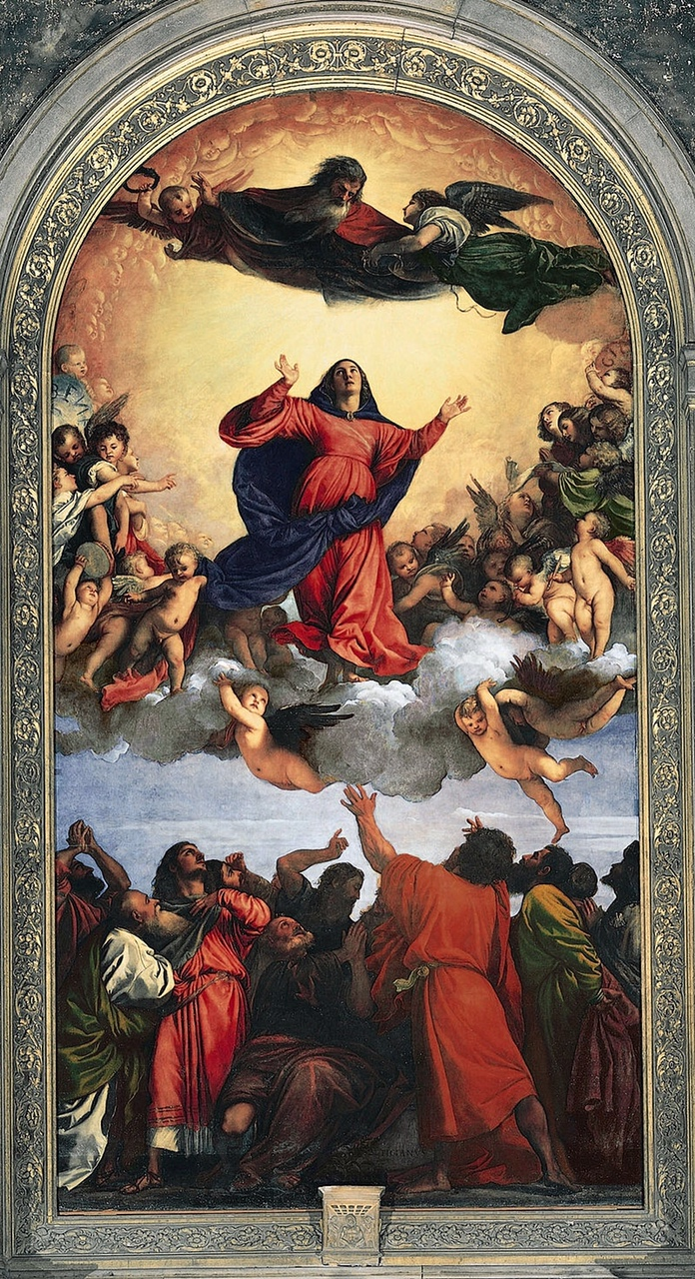
Assumption by Titian, painted in 1515–1518
From the Collect for the Solemnity of the Assumption.

O God, who, looking on the lowliness of the Blessed Virgin Mary, raised her to this grace, that your Only Begotten Son was born of her according to the flesh and that she was crowned this day with surpassing glory, grant through her prayers, that, saved by the mystery of your redemption, we may merit to be exalted by you on high.
Through our Lord Jesus Christ, your Son, who lives and reigns with you in the unity of the Holy Spirit, God, for ever and ever.

For a YouTube talk by Scott Hahn on the feast visit
https://www.youtube.com/watch?v=momjlXorYo4

For newsreel from 1950 visit
https://www.youtube.com/watch?v=PJcSyaRU0kc

Best wishes
Father Behr

Your Prayers are asked for:
Those recently deceased:
Those ill or infirm: David Green, Charlotte Elliot (daughter of Maureen Davidson), Joe Adams, Ellie Lawrence, Anne Bryant, Patricia Hook, Elena Peck (senior), Josie Payne, Pat Holland and all those self-isolating or suffering from COVID-19.
Those whose anniversaries of death occur at this time: Leonard Holley, George Foster, Mary Cherry and Ian Currie.

This week’s services ( 15th – 21st August 2021 ), Feasts and Mass intentions during the week.

Saturday 14th August  10 am Mass  6 pm Vigil Mass | St Maximillian Mary Kolbe, Priest & Martyr  Kay Ockenden RIP (Milton) | Thursday 19th August  10 am Mass | St john Eudes, Priest  Holy Souls
Sunday 15th August  10 am Mass  12 Midday Traditional Latin Mass | THE ASSUMPTION OF THE BLESSED VIRGIN MARY  People of the Parish | Friday 20th August  10 am Mass | St Bernard, Abbot & Doctor of the Church  Fox Family
Monday 16th August 10 am Mass | St Stephen of Hungary Anna Campbell & Family | Saturday 21st August  10 am Mass  6 pm Vigil Mass | St Pius X, Pope  Thanksgiving (Milton)
Tuesday 17th August  10 am Mass | Feria  Allen Davis RIP | Sunday 22nd August  10 am Mass  12 midday Traditional Latin Mass | Twenty-First Sunday (B)  People of the Parish
Wednesday 18th August 10 am Service of the Word and Holy Communion | Feria
Flowers: For 22nd August - Pat

