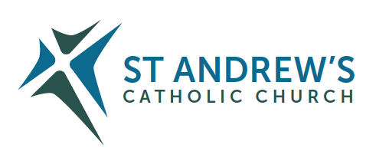
Parish Priest: Fr Behruz Rafat Telephone 01580 762785 Mobile: 07903 986646
Address: The Presbytery, 47 Ashford Road, Tenterden, Kent TN30 6LL.
Parish E-mail behruzrafat@rcaos.org.uk Parish Website: www.standrewstenterden.org
Deacon: Rev. Jolyon Vickers Telephone: 01580 766449 Email: jolyonvickers@rcaos.org.uk Hire of Parish Hall: Lesley McCarthy 07791 949652 E-mail: bookings.standrews@talktalk.net
Newsletter Editor: Patricia Sargent 01233 850963 E-mail: sargentpat51@gmail.com

Newsletter for the week commencing 12th September 2021
Twenty-fourth Sunday in Ordinary Time (B)
Entrance antiphon: Give peace, Lord, to those who wait for you, that your prophets be found true. Hear the prayers of your servant, and of your people Israel.
First Reading: Isaiah 50: 5-9
Psalm 114 Response: I will walk in the presence of the Lord in the land of the living.
Second Reading: St James 2: 14-18
Acclamation: Alleluia, alleluia! I am the Way, the Truth and the Life, says the Lord; no one can come to the Father except through me. Alleluia!
Gospel: Mark 8: 27-35
Communion antiphon: How precious is your mercy, O God! The children of men seek shelter in the shadow of your wings.

Father Behr writes:
Dear Parishioners,
We should glory in the Cross of our Lord Jesus Christ,
in whom is our salvation, life and resurrection,
through whom we are saved and delivered. (Entrance Antiphon from the feast. )

The Feast of the Exaltation of the Holy Cross on Tuesday 14 September reminds us of what great things Our Lord Jesus has done for us. How can we ever thank the Lord enough for laying down his life for us on the cross of Calvary? How could we possibly repay such an enormous debt of love?

One response is to try to attend one extra Mass during the week as a very good spiritual habit. It’s not easy when people have busy and demanding working lives but should be manageable for retired people. That kind of faith will always be greatly blessed by Our Lord and will also help to renew our parish.

Ecce Crucem Domini,
Fugite, partes adversae,
Vicit Leo de Tribu Juda,
Radix David, alleluia.
English version:
Behold the Cross of the Lord!
Flee ye adversaries!
The Lion of the Tribe of Juda,
The Root of David has conquered, alleluia!
(St Anthony’s Brief)
Best wishes
Father Behr

Your Prayers are asked for:
Those recently deceased: Those ill or infirm: Wayne (Liz Dumbleton’s husband), Charlotte Elliot (daughter of Maureen), Joe Adams, Ellie Lawrence, Anne Bryant, Patricia Hook, Elena Peck (senior), Josie Payne, Pat Holland and all those self-isolating or suffering from COVID-19.
Those whose anniversaries of death occur at this time: Jocelyn Stevenson, Philomena Curtin, Doreen Richardson, John (Christian) Gray, Sidonia Munn and James O’Leary

Please pray for our four First Holy Communion children who are nearing the end of their preparation and will be receiving the sacrament in just a few weeks.
This week’s services (12th – 18th September 2021 B ), Feasts and Mass intentions during the week.

Saturday 11th September  No Mass  6 pm Vigil Mass | Frank Stryzyk RIP | Thursday 16th September  10 am Mass | St Cornelius, Popo & St Cyprian, Bishop  Holy souls
Sunday 12th September  10 am Mass  12 Midday Traditional Latin Mass | Twenty-fourth Sunday (B)  People of the Parish | Friday 17th September  10 am Mass | St Robert Bellarmine, Bishop & Doctor of the Church  Patricia White RIP
Monday 13th September  10 am Mass | St John Chrysostom, Bishop & Doctor Irene RIP | Saturday 18th September  10 am Mass  6 pm Vigil Mass | St Edith of Kemsing
Tuesday 14th September  10 am Mass | The Exaltation of the Holy Cross  Private Intention | Sunday 19th September  10 am Mass  12 midday Sung Traditional Latin Mass | Twenty-fifth Sunday (B)  People of the Parish
Wednesday 15th September 10 am Service of the Word and Holy Communion | Our Lady of Sorrows
Flowers: For 19th September - Breeda

Rediscover Your Marriage – Retrouvaille (pronounced retro-vi with a long i) simply means 'rediscovery'. The programme offers the chance to rediscover yourself, your spouse, and a loving relationship in your marriage. 10s of 1000s headed for divorce have successfully saved their marriages by attending and using the tools provided. There is no group therapy or group work
For confidential information about ‘Retrouvaille’ or to register for the programme commencing with a ‘Virtual’ weekend on… 21st –24th October 2021… Call or text +44 788 7296983 or+44 797 3380443 – or Email retrouvailleukinfo@gmail.com - or visit www.retrouvaille.org.uk

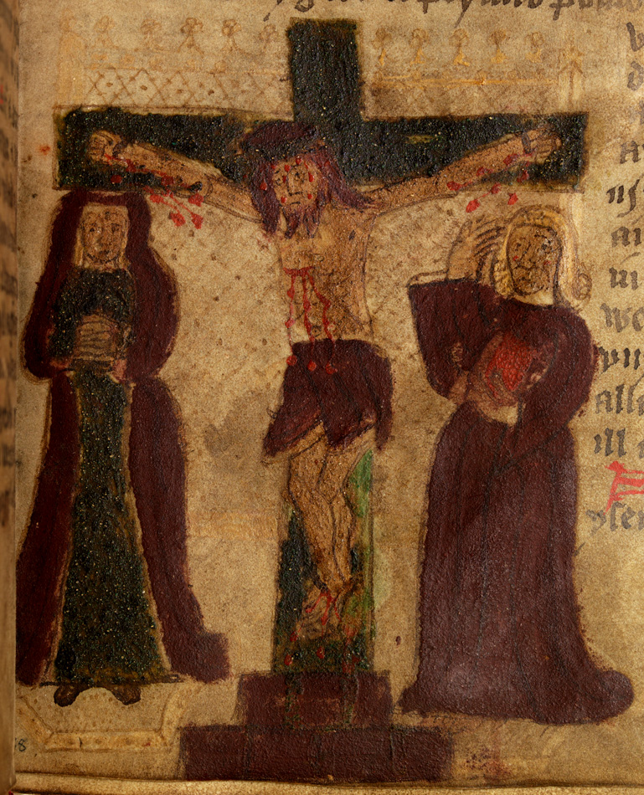
From a 14 – 15 Century Welsh manuscript

