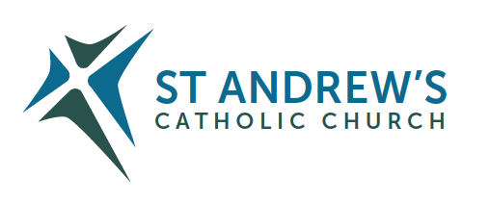
Parish Priest: Fr Behruz Rafat Telephone 01580 762785 Mobile: 07903 986646
Address: The Presbytery, 47 Ashford Road, Tenterden, Kent TN30 6LL.
Parish E-mail behruzrafat@rcaos.org.uk Parish Website: www.standrewstenterden.org
Deacon: Rev. Jolyon Vickers Telephone: 01580 766449 Email: jolyonvickers@rcaos.org.uk Hire of Parish Hall: Lesley McCarthy 07791 949652 E-mail: bookings.standrews@talktalk.net
Newsletter Editor: Patricia Sargent 01233 850963 E-mail: sargentpat51@gmail.com

Newsletter for the week commencing 19th September 2021
Twenty-fifth Sunday in Ordinary Time (B)
Entrance antiphon: I am the salvation of the people, says the Lord. Should they cry to me in any distress, I will hear them, and I will be their Lord forever.
First Reading: Wisdom 2: 12, 17-20
Psalm 53 Response: The Lord upholds my life.
Second Reading: St James 3: 16-4: 3
Acclamation: Alleluia, alleluia! I am the light of the world, says the Lord, anyone who follows me will have the light of life. Alleluia!
Gospel: Mark 9: 30-37
Communion antiphon: You have laid down your precepts to be carefully kept; may my ways be firm in keeping your statutes.

Father Behr writes:
Dear Parishioners
The Bishops of England and Wales have urged all Catholics and all people of good will to oppose Baroness Meacher’s ‘Assisted Dying Bill 2021’.
Bishop John Sherrington has written an open letter outlining the dangers of this legislation. You can read the letter in full here.

https://www.cbcew.org.uk/bishop-sherrington-letter-on-assisted-dying-bill-2021/

A time has come when all people of good will need to speak up. The Assisted Dying bill will cause grave harm to our nation and to vulnerable people.

As a parish we can consider the following responses.
On the 24 September feast of Our Lady of Walsingham please come and pray for England.

We will pray the Holy Rosary at 9.30am with Mass at the usual time of 10am. The Mass will be offered for the sanctity of life and the defeat of the Meacher Bill. After Mass we will have refreshments in the parish centre.

As well as prayer we can also write to our MP’s and members of the House of Lords. We are particularly encouraged to write if we have experience of palliative care and are, or have been, health care professionals.

A number of excellent pro life organisations are working flat out and we need to support them financially as those involved in promoting assisted suicide have access to unlimited funds and the support of large corporations and the mainstream media.

Care Not Killing is a great organisation.

https://www.carenotkilling.org.uk/events-reports/experts-outline-assisted-suicide-risks-to-mps/

Right To Life are hugely effective.
Share Your experience of palliative care.
https://righttolife.org.uk/mystory

I recommend that we pray this prayer every day until the bill is defeated.

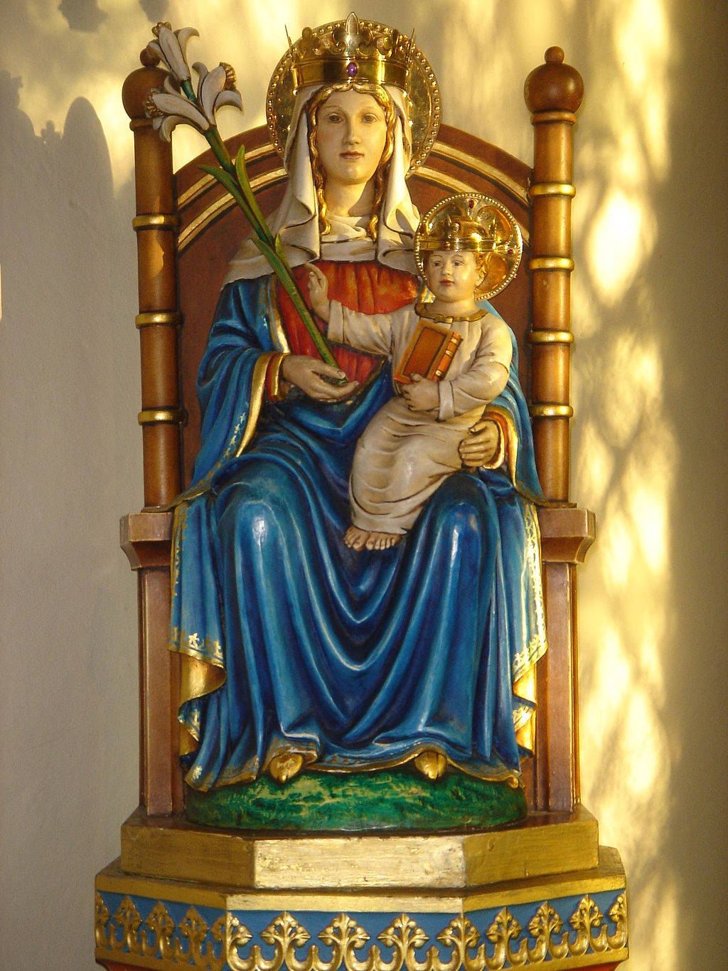

Prayer for England
O blessed Virgin Mary, Mother of God and our most gentle Queen and Mother, look down in mercy upon England thy "Dowry" and upon us all who greatly hope and trust in thee. By thee it was that Jesus our Saviour and our hope was given unto the world; and He has given thee to us that we might hope still more. Plead for us thy children, whom thou didst receive and accept at the foot of the Cross, O sorrowful Mother. Intercede for our separated brethren, that with us in the one true fold they may be united to the supreme Shepherd, the Vicar of thy Son. Pray for us all, dear Mother, that by faith fruitful in good works we may all deserve to see and praise God, together with thee, in our heavenly home.
Amen.

Best wishes
Father Behr

Your Prayers are asked for:
Those recently deceased:
Those ill or infirm: Wayne (Liz Dumbleton’s husband), Charlotte Elliot (daughter of Maureen), Joe Adams, Ellie Lawrence, Anne Bryant, Patricia Hook, Elena Peck (senior), Josie Payne, Pat Holland and all those self-isolating or suffering from COVID-19.
Those whose anniversaries of death occur at this time: Joan Carey, Josie Parsons, Sheila Allen, John Cregan, Hugh Blake, Dorothy Whiting, Juliet O’Hea, Christine Carney and Terence Price.

Please continue to pray for our First Communicants.

This week’s services (19th – 26th September 2021), Feasts and Mass intentions during the week.

Saturday 18th September  10 am Mass  6 pm Vigil Mass | St Edith of Kemsing  Fr Chris O’Brien RIP | Thursday 23rd September  10 am Mass | St Pius of Pietrelcina  Mass for Priests
Sunday 19th September  10 am Mass  12 Midday Traditional sung Latin Mass | Twenty-fifth Sunday (B)  People of the Parish | Friday 24th September  10 am Mass | Our Lady of Walsingham  Sanctity of Human Life/Defeat of Meacher Bill
Monday 20th September  10 am Mass | St Andrew Kim Tae-gon, Priest & Paul Chong Ha-sang & Companions, Martyrs Catherine O’Driscoll RIP | Saturday 25th September  10 am Mass  6 pm Vigil Mass | The Blessed Virgin Mary  Denise Boddington RIP  Big M
Tuesday 21st September  10 am Mass | St Matthew, Apostle & Evangelist  Max & Flo (Wedding) | Sunday 26th September  10 am Mass  12 midday Traditional Latin Mass | Twenty-sixth Sunday (B)  People of the Parish
Wednesday 22nd September  10 am Service of the Word and Holy Communion | Feria
Flowers: For 26th September - Frances
Columban Mission Appeal
I received a letter of thanks from Father Tom Ryan of the Columban Missionaries. He is so grateful for the cheque we sent for £267.65 following the mission appeal. Fr Behr

Plumbing in the Presbytery
I recently spent over a £1500 on the plumbing in the presbytery. The boiler is very old, probably installed when the house was built in the 80’s. It was making terrible banging noises during the night which have now stopped. Also I needed to make sure that the shower in the guest bathroom would work so that when priests and others come to stay they have a working shower.
Ride & Stride
Very many thanks to all who took part in and/or supported the Friends of Kent Churches Ride and Stride in different ways this year. The team of welcomers greeted 25 visitors to St Andrew's during the course of the day (just 15 people visited last year). Some parishioners generously made individual donations, and a few intrepid parishioners from St. Andrews rode and strode around Kent's churches too. Please could the latter now collect their sponsorship money and give this (preferably as a single cheque rather than cash) and their sponsorship forms (these are very important) to Rachel Heinrichsmeier by 24th October. Please make cheques payable to: Friends of Kent Churches.

