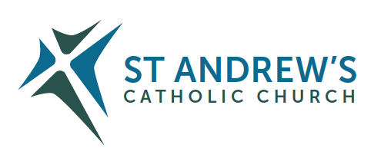
Parish Priest: Fr Behruz Rafat Telephone 01580 762785 Mobile: 07903 986646
Address: The Presbytery, 47 Ashford Road, Tenterden, Kent TN30 6LL.
Parish E-mail behruzrafat@rcaos.org.uk Parish Website: www.standrewstenterden.org
Deacon: Rev. Jolyon Vickers Telephone: 01580 766449 Email: jolyonvickers@rcaos.org.uk Hire of Parish Hall: Lesley McCarthy 07791 949652 E-mail: bookings.standrews@talktalk.net
Newsletter Editor: Patricia Sargent 01233 850963 E-mail: sargentpat51@gmail.com

Newsletter for the week commencing 26th September 2021
Twenty-sixth Sunday in Ordinary Time (B)
Entrance antiphon: All that you have done to us, O Lord, you have done with true judgement, for we have sinned against you and not obeyed your commandments. But give glory to your name and deal with us according to the bounty of your mercy.
First Reading: Numbers 11: 25-29
Psalm 18 Response: The precepts of the Lord gladden the heart.
Second Reading: St James 5: 1-6
Acclamation: Alleluia, alleluia! Your word is truth, O Lord, consecrate us in the truth. Alleluia!
Gospel: Mark 9: 38-43, 45, 47-48
Communion antiphon: Remember your word to your servant, O Lord, by which you have given me hope. This is my comfort when I am brought low.

Prayer for England
O blessed Virgin Mary, Mother of God and our most gentle Queen and Mother, look down in mercy upon England thy "Dowry" and upon us all who greatly hope and trust in thee. By thee it was that Jesus our Saviour and our hope was given unto the world; and He has given thee to us that we might hope still more. Plead for us thy children, whom thou didst receive and accept at the foot of the Cross, O sorrowful Mother. Intercede for our separated brethren, that with us in the one true fold they may be united to the supreme Shepherd, the Vicar of thy Son. Pray for us all, dear Mother, that by faith fruitful in good works we may all deserve to see and praise God, together with thee, in our heavenly home.
Amen.

Father Behr writes:

Dear Parishioners

“ Beside each believer stands an angel as a protector and shepherd leading him to life.” (Saint Basil the Great)

Saturday 2 October is the feast of the Holy Guardian Angels.

God is the creator of everything. The universe is vast and yet scientists now inform us that only 5% of it is made of visible matter. The rest is dark matter 27% and dark energy 68%. And yet all that may be classed as the material stuff related to material things and not spiritual things. The invisible spiritual realm is vaster than anything we can conceive.

Among the spiritual things created by God, we believe that God created the angels and among the nine types of angels there are guardian angels. Each soul when created is assigned a guardian angel. They guide each of us through life and help us avoid dangers physical and spiritual – their goal is to make sure we reach heaven and accumulate as little dirt (sin) as possible before we get there.

Your guardian angel is there to enable God’s love to flourish in you and in all your actions towards the people around you. Let us turn in prayer to these amazing beings. God, who loves us so much, has gifted to each of us a guardian angel to help us in our daily struggles.

From the Compendium of the Catechism
60. Who are the angels?
The angels are purely spiritual creatures, incorporeal, invisible, immortal, and personal beings endowed with intelligence and will. They ceaselessly contemplate God face-to-face and they glorify him. They serve him and are his messengers in the accomplishment of his saving mission to all.

61. In what way are angels present in the life of the Church?
The Church joins with the angels in adoring God, invokes their assistance and commemorates some in her liturgy.

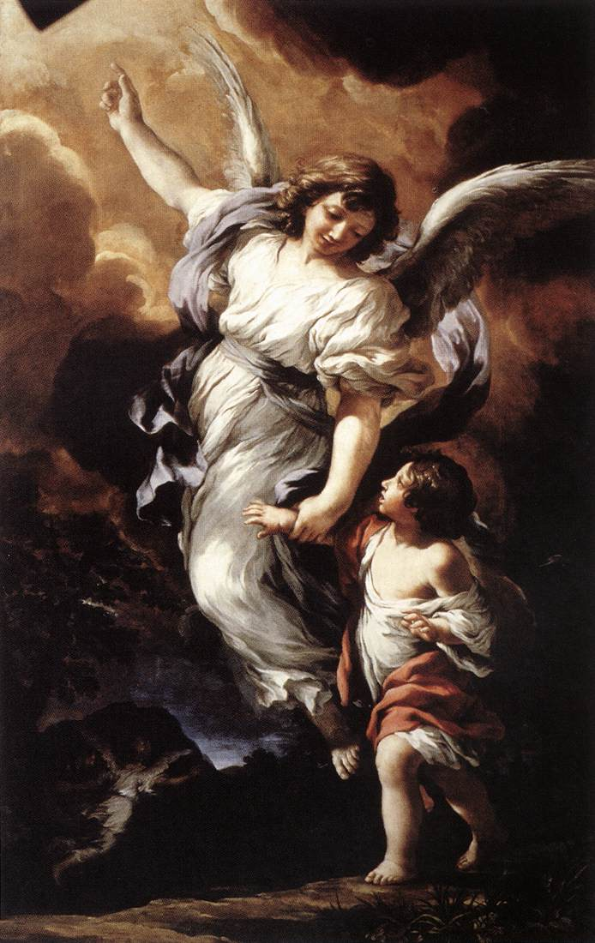
Guardian Angel by Pietro da Cortona, 1656
Best wishes
Father Behr

Your Prayers are asked for:
Those recently deceased:
Those ill or infirm: Wayne (Liz Dumbleton’s husband), Charlotte Elliot (daughter of Maureen Davidson), Joe Adams, Ellie Lawrence, Anne Bryant, Patricia Hook, Elena Peck (senior), Josie Payne, Pat Holland and all those self-isolating or suffering from COVID-19.
Those whose anniversaries of death occur at this time: Tony Russell, Angela Drummond-Brady, Stanislaw Iglinski, Andrew O’Brien, John Feetenby, Dorothea Banyard, Archbishop Peter Amigo, Kathleen Nolan and Sheila Fielding.

Please keep in your prayers the children who will soon be making their first Holy Communion.

This week’s services (25th September – 2nd October 2021),
Feasts and Mass intentions during the week.
Saturday 25th September  10am Mass  6pm Vigil Mass | The Blessed Virgin Mary  Denise Boddington RIP  David & Jade Wellbeing | Thursday 30th September  10am Mass | St Jerome, Priest & Doctor of the Church  Private intention
Sunday 26th September  10am Mass  12 Midday Traditional Latin Mass | Twenty-sixth Sunday (B)  People of the Parish | Friday 1st October  10am Mass | St Therese of the Child Jesus, Virgin & Doctor of the Church  Holy Souls
Monday 27th September  10am Mass | St Vincent de Paul  Holy Souls | Saturday 2nd October  10am Mass  6pm Vigil Mass | The Holy Guardian Angels  Big M  John & Emmy RIP
Tuesday 28th September 10am Mass | St Wenceslaus, Martyr  Private intention | Sunday 3rd October  10am Mass  12 midday Sung Traditional Latin Mass | Twenty-seventh Sunday (B)  People of the Parish
Wednesday 29th Sept  10am Service of the Word and Holy Communion | Sts Michael, Gabriel and Raphael, Archangels
Flowers: For 3rd October - Kathy

I am pleased to report that the parish website is now up and running again.
Please give it a try and let me know if there are still issues
Kind regards,
Jolyon

Don’t forget our repository in the porch where you can buy cards for Holy Communion and other occasions as well as rosaries, candles and other items. I will be there at the end of 10 am Mass on Sunday for anyone who may want to have a look. Pat Sargent

