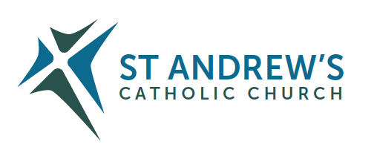
Parish Priest: Fr Behruz Rafat Telephone 01580 762785 Mobile: 07903 986646
Address: The Presbytery, 47 Ashford Road, Tenterden, Kent TN30 6LL.
Parish E-mail behruzrafat@rcaos.org.uk Parish Website: www.standrewstenterden.org
Deacon: Rev. Jolyon Vickers Telephone: 01580 766449 Email: jolyonvickers@rcaos.org.uk Hire of Parish Hall: Lesley McCarthy 07791 949652 E-mail: tenterdenparishcentre@rcaos.org.uk
Newsletter Editor: Patricia Sargent 01233 850963 E-mail: sargentpat51@gmail.com

Newsletter for the week commencing 16th October 2022
Twenty-ninth Sunday in Ordinary Time ( C )
Entrance antiphon: To you I call; for you will surely heed me, O God; turn your ear to me; hear my words. Guard me as the apple of your eye; in the shadow of your wings protect me.
First Reading: Exodus 17: 8-13
Psalm 120 Response: Our help is in the name of the Lord who made heaven and earth.
Second Reading: Second letter of St Paul to Timothy 3: 14-4: 2
Acclamation: Alleluia, alleluia! May the Father of our Lord Jesus Christ enlighten the eyes of our mind, so that we can see what hope his call holds for us. Alleluia!
Gospel: Luke 18: 1-8
Communion antiphon: Behold, the eyes of the Lord are on those who fear him, who hope in his merciful love, to rescue their souls from death, to keep them alive in famine.

Father Behr writes:
Dear Parishioners
I am delighted to say that Bishop Paul Hendricks will be coming to Confirm Jack Keeshan and Leon Thomas on Sunday 13 November(Remembrance Sunday) at the 10am Mass.
Please pray for Jack and Leon as they take this important step in their spiritual lives.
Bishop Paul is the new auxiliary bishop for the Kent area and we are grateful to him for coming to our parish. There will be a reception after Mass. If you would like to help with the reception please let me know.

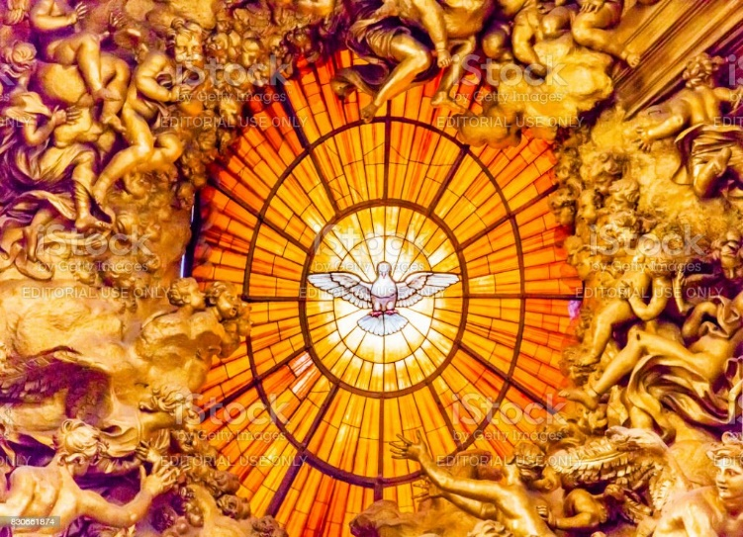

Bernini, Holy Spirit, Saint Peter's Basilica, Vatican Rome

Best Wishes
Father Behruz Rafat

Your Prayers are asked for:
Those recently deceased: Anne Bryant RIP
Those ill or infirm: Ailish Cantwell (Jones), Sylwia Dorosz, Joe Adams, Ellie Lawrence, Patricia Hook, Elena Peck, Josie Payne, Pat Holland and all those who are unwell and in need of our prayers.
Those whose anniversaries of death occur at this time: Bridget Boyle, Joan Chudzikowska, John H.M. Mitchell, Joe Cerullo, Norah Culley, Gladys & Frederick Hodges, John Williams, Ian D’Arts and Kathleen Collison.

Please pray for the repose of the soul of Anne Bryant RIP. Her Requiem Mass followed by Burial is on Thursday 20th October at 11am
This week’s services (15th-22nd October), Feasts and Mass intentions during the week.
Saturday 15th October  St Teresa of Jesus Virgin, Doctor of the Church | 10am Mass Father Anthony Logan RIP  10.30 -11am Confession  5.30pm Rosary  6pm Vigil Harry Walker RIP Reader: Kathy
Sunday 16th October  Twenty Ninth Sunday ( C ) | 10am Mass People of the Parish Reader: Brian  12 Midday Traditional Latin Mass
Monday 17th October  St Ignatius of Antioch, Bishop & Martyr | 10am Mass Mary Iglinski RIP (Maria)
Tuesday 18th October  St Luke, Evangelist | 10am Mass Donor’s Intention
Wednesday 19th October  Feria | 10am Service of the Word and Holy Communion
Thursday 20th October  Feria | 11am Requiem Mass for Anne Bryant RIP
Friday 21st October  Feria | 10am Mass Ferenc Zsigmondy RIP and Family  10.30 – 11.30am Adoration and Rosary
Saturday 22nd October  St John Paul II, Pope | 10am Mass Father Patrick O’Leary RIP  10.30 -11am Confession  5.30pm Rosary  6pm Vigil Guy & Catarina Beresford in Thanksgiving Reader: Charles
Sunday 23rd October  Thirtieth Sunday ( C ) | 10am Mass People of the Parish Reader: Frances  12 Midday Traditional Latin Mass
Flowers: for 23rd October - Suzanne
Readers: for Saturday 22nd October - Charles/Sunday 23rd October - Frances

Confession
Fr Behr is available for Confession every Saturday from 10.30am - 11am. He is also happy to visit those who are not able to come to church.
Coffee Morning for Bishop John Hine
Fr John Hine is celebrating 60 years of his ordination to the priesthood this October. We thought it would be good to have a coffee morning after Mass on Sunday 30 October to celebrate and say thank you.
Due to the lockdown restrictions we didn’t have the opportunity to say thank you properly to Father John when he stepped down.
Father John was ordained on 28 October 1962 for the Archdiocese of Southwark.

Rosary in October
We will pray the Rosary in our church during October on Friday morning during Adoration
at 10.30am and on Saturday evening at 5.30pm before the 6pm Mass.

Sr Lucia of Fatima said:
“The Most Holy Virgin in these last times in which we live has given a new efficacy to the recitation of the Rosary to such an extent that there is no problem, no matter how difficult it is, whether temporal or above all spiritual, in the personal life of each one of us, of our families… that cannot be solved by the Rosary. There is no problem, I tell you, no matter how difficult it is, that we cannot resolve by the prayer of the Holy Rosary.”

St Simon Stock Catholic School
Sixth Form Open Evening Thursday 3 November - 6pm to 8pm / Talk by Leader of the Sixth Form at 6pm
Please visit www.ssscs.co.uk for advance booking and further information
St Simon Stock Catholic School, Oakwood Park, Maidstone ME16 0JP Tel: 01622 754551

St Bernadette Relic Tour - the relics are due to visit St George’s Cathedral from the morning of Wednesday 19 October until the morning of Friday 21 October; they will also visit Aylesford from Monday 24 October until Friday 28 October. Please consult the website of each venue for further details.

Visit of the Relics of St Bernadette to Aylesford Priory - Volunteers needed.
The Relics of St Bernadette will be visiting Aylesford Priory from the evening of Monday 24th October to lunchtime on Friday 28th October. (See the Aylesford website) A full programme of events is planned, but this can only happen with the help of stewards and volunteers to help the many pilgrims that will be attending. Could you spare some time to help with this event? Please email cabbotson@thefriars.org.uk if you can help, letting her know what time you could spare.

We’re offering you an opportunity to attend an online ‘Building a Better Marriage’ course from 9am - 1pm on Saturday Oct 22nd 2022.
The course offered means that you can attend from your own living room and there is no group sharing!
We received this email after September’s Building a Better Marriage course from a husband …
“Building a Better Marriage
We were attracted by the opportunity of taking a kind of MoT test that would help us assess how we were fulfilling the promises we had made to each other, as we passed through the changing circumstances of our life together. Carole and Peter proved the ideal guides for this process. They kept faithfully to their promise not to be intrusive: no probing questions; only stories from their own experiences and helpful questionnaires for us to use in private – first individually, then sharing with each other. We have no hesitation in recommending this friendly, thoughtful session to any couple seeking to renew the joy and energy in their marriage.”

A date for your diary
Please come along to our November parish social. We have Bangers and Mash on Nov 5 after the 6pm Mass.

"March for Life UK are holding a solemn public witness in Parliament Square, London on Thursday 27th Oct 12.30pm - 2pm, commemorating the passing of the Abortion Act in 1967. Since then 10 million have been aborted. Please attend if you can - wear black (or as dark as possible). Don't bring posters. Full details at https://www.marchforlife.co.uk/2022/10/07/join-us-on-the-27th-october/"

Caritas
Canon Victor Darlington has been given the commission by Archbishop John Wilson of opening Caritas Southwark in the Archdiocese of Southwark. Caritas will have immense benefits to charitable projects by recognising, strengthening, supporting and unifying them. It has been a tremendous success in the Archdiocese of Westminster.

We know that your church/organisation has been involved with many commendable charitable projects and are therefore inviting volunteers to an important meeting to help with the formation of Caritas Southwark on Saturday 5 November 2022, between 10am and 1 pm. This will take place at Amigo Hall, next to St George’s Cathedral, 150 St George’s Road, London SE1 6HX.

Canon Victor will be present to explain the benefits of Caritas Southwark and to ask for volunteers from parishes in the Southeast, South West and Kent to give their valuable input and support.

If you would like any further information please contact Hipo Eze, Administrative Assistant to Canon Victor Darlington hipoeze@rcaos.org.uk, Canon Victor himself evcaritas@rcaos.org.uk or myself. Or to find out more about Caritas in general visit www.caritas.org

HELP YOUR MARRIAGE – Do you feel alone? Are you frustrated or angry with each other? Do you argue ... or have you just stopped talking to each other? Does talking about it only make it worse? Retrouvaille is a programme to support couples who have difficulties in their marriage. It brings a positive focus, new hope and helps nourish and grow your marriage. Tens of thousands of couples headed for divorce have successfully saved their marriages by attending and using the tools provided. The programme helps spouses uncover or re-awaken the love, trust and commitment that originally brought them together. It helps them through difficult times whether they are disillusioned or in deep misery. There is no group therapy or group work. For confidential information about ‘Retrouvaille’ or to register for the next programme (a Face-to-Face weekend in Welwyn Garden City on 24 - 26 February 2023), call or text 07887 296983 or 07973 380443 or email retrouvailleukinfo@gmail.com - or visit www.retrouvaille.org.uk

