**Some More Parish News: Parish news from 31 Nov 23.**

**Advent Wreath**

Lorraine is doing an Advent Wreath workshop for all the children on Sunday. The workshop was really well attended last year and everyone really enjoyed the activity.  Tea and coffee will also be available after Mass.

**Town Carol Service:**

The annual ecumenical event will take place in Saint Mildred’s at 7:30pm on Wednesday December 20th. You are advised to arrive early as seating is at a premium.

**Advent Course:**

The Sycamore course is an enjoyable and accessible way of deepening our faith.  We thought it would be good to combine this course with supper starting at 7pm.  A great way to prepare for Christmas. Please sign up so we can know how many to cater for.

There remain 3 topics:

* A GOD WHO SPEAKS

Friday 1 December 7pm

* THE BIBLE

**Friday 8 December 7pm**

* THE POWER OF PRAYER

**Friday 15 December 7pm**

If you’d like to see the films they are available here.

<https://www.sycamore.fm/pathways/b-formation-pathways/advent-course/>

**HOMES FOR UKRAINE:** A message from CARITAS SOCIAL ACTION NETWORK (CSAN). In partnership with St John of God Hospitaller Services, CSAN, an international Catholic charity with many services for the vulnerable in the UK and Ireland, are matching Ukrainian people displaced by the brutal war with people in the Catholic community willing to host them in their homes for six months. If you have room in your home and in your heart to consider welcoming a stranger displaced by war, then we’d love to hear from you. Visit <https://sjog-homesforukraine.uk/>.

**Mass Times for Christmas**

Christmas Eve Vigil Mass at 6.00 pm

Christmas Eve Mass at Night 9.00 pm

Christmas Day 10.00 am

Christmas Day Latin Mass 12.00 noon

**Ecumenical Evening Services**

The next one will be on Sunday December 31st at 4 pm in Saint Andrew’s.

**Ecumenical Evening Services**

The next one will be on Sunday December 31st at 4 pm in Saint Andrew’s.

**Community Carols**

The Christians in the Town will gather for a short open air Carol Service at 4pm on Friday 15th December on the Recreation Ground. This is our Christmas equivalent of the Good Friday witness event.

**Town Carol Service**

The annual ecumenical event will take place in Saint Mildred’s at 7:30pm on Wednesday December 20th. You are advised to arrive early as seating is at a premium.

**Community Carols**

**Offers of assistance on the night would be much appreciated, please see Father Behr or Deacon Jolyon.**

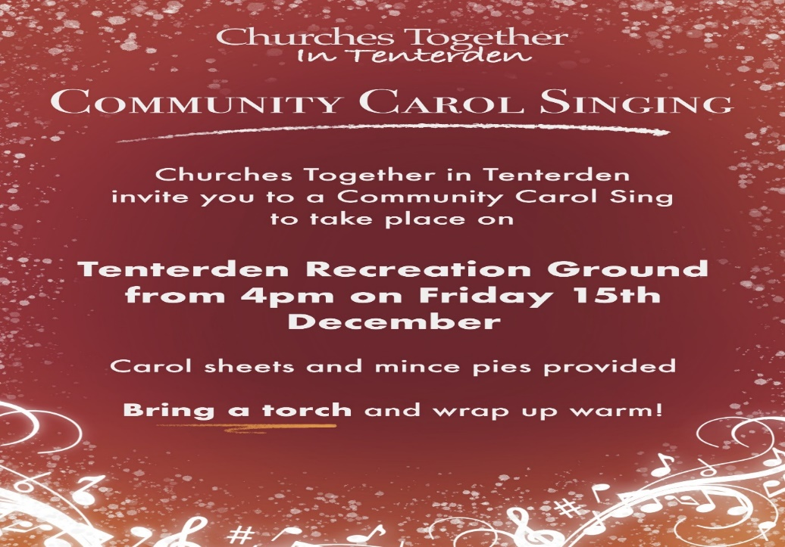

**Christian Breakfast:**

Many thanks to everyone, who helped with the recent Christian Breakfast hosted in our Parish Centre. 60 people were able to hear an entertaining and informative presentation from Lindsay.

“I could not have managed without your help” (Jolyon)

Please note the organising committee is looking for new members to help swell the ranks. Commitment is minimal, helping on the day and planning the annual programme of 6 events, two of which are a given (week of Christian Unity and Christian Aid annual appeal)