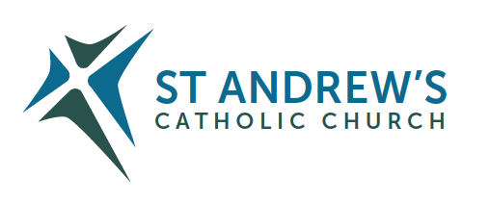

Parish Priest: Fr Behruz Rafat Address: The Presbytery, 47 Ashford Road, Tenterden, Kent TN30 6LL.
Telephone 01580 762785 Mobile: 07903 986646
Parish E-mail behruzrafat@rcaos.org.uk Parish Website: www.standrewstenterden.org
Deacon: Rev. Jolyon Vickers Telephone: 01580 766449 Email: jolyonvickers@rcaos.org.uk Hire of Parish Hall: Lesley McCarthy 07791 949652 E-mail: tenterdenparishcentre@rcaos.org.uk
Newsletter Editor: Patricia Sargent 01233 850963 E-mail: sargentpat51@gmail.co

Newsletter for the week commencing 3rd December 2023
FIRST SUNDAY OF ADVENT(B)
Entrance antiphon: To you I lift my soul, O my God. In you I have trusted; let me not be put to shame. Nor let my enemies exult over me; and let none who hope in you be put to shame.
First Reading: Isaiah 63: 16-17; 64: 1, 3-8
Psalm 79 Response: God of hosts, bring us back; let your face shine on us and we shall be saved.
Second Reading: First letter of St Paul to the Corinthians 1: 3-9
Acclamation: Alleluia, alleluia! Let us see, O Lord, your mercy and give us your saving help. Alleluia!
Gospel: Mark 13: 33-37
Communion antiphon: The Lord will bestow his bounty, and our earth shall yield its increase.

Father Behr writes:
Dear Parishioners
This Sunday is the First Sunday of Advent.
During the season of Advent and Christmastide we are going to pray the Angelus before Mass. Prayer cards will be given out at the beginning of Mass.

The Angelus Prayer
V. The Angel of the Lord declared unto Mary.
R. And she conceived of the Holy Spirit.
Hail Mary…
V. Behold the handmaid of the Lord.
R. Be it done to me according to thy word.
Hail Mary. . .
V. And the Word was made flesh.
R. And dwelt among us.
Hail Mary. . .
V. Pray for us, O holy Mother of God.
R. That we may be made worthy of the promises of Christ.
Let us pray: Pour forth, we beseech Thee, O Lord, Thy grace into our hearts, that we to whom the Incarnation of Christ Thy Son was made known by the message of an angel, may by His Passion and Cross be brought to the glory of His Resurrection. Through the same Christ Our Lord. Amen.

Fr Behr

Your Prayers are asked for:
Those recently deceased:
Those ill or infirm: John Crinnion, Mara McDermot, June Munton, Ailish Cantwell (Jones), Sylwia Dorosz, Joe Adams, Ellie Lawrence, Patricia Hook, Josie Payne, Pat Holland and all those who are unwell and in need of our prayers.
Those whose anniversaries of death occur at this time: Rose Hewer-Hearst, Edith Margaret Corbett, Alex Mickle, Eliabeth de Blaby, Agnes Finnan, Nora Cregan, Frances Kelly, Ann Collins, Nathaniel ‘Nat’ Kennell and Barbara Beresford.

This week’s services (2nd – 9th December), Feasts and Mass intentions during the week.
Saturday 2nd December  The Blessed Virgin Mary | No public Mass am  10.30 -11am Confession  6pm Vigil Mass People of the Parish Reader: Family Readers: Wendy & Melody
Sunday 3rd December  FIRST SUNDAY OF ADVENT (B) | 10am Mass Paul and Susan Casey and Son Reader: Kathy  12 Midday Traditional Latin Mass
Monday 4th December  St John Damascene, Priest & Doctor of the Church | 10am Mass Mary Iglinski RIP and Family
Tuesday 5th December  St John Almond, Priest & Martyr | 10am Mass Donor’s Intention
Wednesday 6th December  St Nicholas, Bishop | 10am Service of the Word and Holy Communion
Thursday 7th December  St Ambrose, Bishop & Doctor of the Church | 9am-10am Adoration  10am Mass Children and Young People
Friday 8th December  THE IMMACULATE CONCEPTION OF THE BLESSED VIRGIN MARY | 10am Mass Private Intention  10.30 – 11.30am Adoration
Saturday 9th December  Feria | No public Mass am  10.30 -11am Confession  6pm Vigil Mass People of the Parish Reader: Pat
Sunday 10th December  SECOND SUNDAY OF ADVENT (B) | 10am Mass Thanksgiving – Leahy Family Reader: Suzanne  12 Midday Traditional Latin Mass
For 2nd Sunday of Advent 9th/10th Dec – check wreath - Hilary
Cleaners: for 9th/10th Dec – Christine & Wendy
Confession
Fr Behr is available for Confession every Saturday from 10.30am - 11am. He is also happy to visit those who are not able to come to church.
Children’s Liturgy Children’s Liturgy at the 10am Mass on the first Sunday of every month. All children who have not made their First Holy Communion are welcome to attend. The next lesson with Lorraine is this Sunday, December 3rd
Advent Wreath
Lorraine is doing an Advent Wreath workshop for all the children on Sunday. The workshop was really well attended last year and everyone really enjoyed the activity. Tea and coffee will also be available after Mass.

ADVENT 2023
The season of Advent affords us an opportunity to contemplate infinite things. The scale of the Universe in which our galaxy, the Milky Way, is one of over one hundred billion other galaxies, is a marvel, a bewilderment, and probably beyond our capacity to grasp. The vastness of the Pacific Ocean is nothing compared to it. And yet the visible Universe, so physicists currently calculate, is only about seven per cent of all there is – in the ‘visible’ Universe.

Has the Universe got anything to do with Jesus? If you think not, think again. In the Nicene Creed, we profess that God is ‘maker of heaven and earth, of all things visible and invisible’.

This incomprehensibly massive Universe is part of God’s creation, and so are we. It is well to remember that God promised Abraham that his descendants would be as numerous as the stars (Genesis 15:5). It is also well to remember that Jesus told the Sadducees, who doubted life after death, that to God all humans continue to live in the hereafter:

‘But concerning the dead rising, have you not read about the burning bush in the Book of Moses, how God told him, “I am the God of Abraham, the God of Isaac, and the God of Jacob” He is not the God of the dead, but of the living. You are badly mistaken’ (Matthew 22:23–33; Luke 20:27–40). Our Lord Jesus is saying that death is by no means the end. God created humans to enjoy his infinite love and infinite beauty – for eternity.

However, without Jesus, the message of eternal life and the method to attain it, would not have reached us.

Every church you enter, every cathedral you visit, every Mass you attend is all because Jesus was born into this material world, this planet we call Earth, to lead us to the source of unbounded happiness, namely God: Father, Son, and Holy Spirit.

At Advent it is also well to remember that there had to be a ‘Yes’ to God for the portals of eternity to be opened for humanity. That yes to God’s majestic and merciful plans was given by a humble young woman over two thousand years ago. With that yes to Almighty God reality was for ever altered. Mary was that humble young woman, and her son was Jesus. Mary’s great love for God brought to us yet greater love through Jesus.

As we wait to celebrate the birth of Jesus, master of infinity, it is well to remember that he waits for you and me to say ‘Yes’ to his teachings, ‘Yes’ to receiving the sacraments to power up our love for God and neighbour, ‘Yes’ to forgiving those who have wronged us, ‘Yes’ to helping the downtrodden, ‘Yes’ to praying for an end to evil, and ‘Yes’ to sincerely wanting to reach Heaven and the infinite joys that it contains. He waits with open arms.

Advent Course
The Sycamore course is an enjoyable and accessible way of deepening our faith. We thought it would be good to combine this course with supper starting at 7pm. A great way to prepare for Christmas. Please sign up so we can know how many to cater for.

There are two topics:

THE BIBLE
Friday 8 December 7pm

THE POWER OF PRAYER
Friday 15 December 7pm

If you’d like to see the films, they are available here.
https://www.sycamore.fm/pathways/b-formation-pathways/advent-course/

In Partnership with Housing Justice, Caritas Southwark is hosting an online information session on 13 December 2023, 7.30-8.30 PM for people interested in becoming a host for a refugee. You can email Caritas directly and we can forward the link to you.
caritassouthwark@rcaos.org.uk

CAFOD Israeli-Palestinian Crisis Appeal
Donate to CAFOD’s Israeli-Palestinian Crisis Appeal at cafod.org.uk/ipc or call 0303 303 3030 to support those affected and get funds to local trusted experts in Gaza and southern Israel who have been working alongside communities helping those most in need. Your donation will help support aid workers providing urgent humanitarian aid including food, water and emergency shelter to those in need. Thank you for your prayers.”

Alternative Catholic Education: Puer Iesus College

Puer Iesus is a part-time college for 7-year-olds through to A Levels. Students spend two days a week at the college, and three days a week at home. There is an Open Day on Saturday 25 November, for September 2024 entry. Please visit our website for more details: pueriesus.org

HOMES FOR UKRAINE A message from CARITAS SOCIAL ACTION NETWORK (CSAN). In partnership with St John of God Hospitaller Services, CSAN, an international Catholic charity with many services for the vulnerable in the UK and Ireland, are matching Ukrainian people displaced by the brutal war with people in the Catholic community willing to host them in their homes for six months. If you have room in your home and in your heart to consider welcoming a stranger displaced by war, then we’d love to hear from you. Visit https://sjog-homesforukraine.uk/.

Mass Times for Christmas
Christmas Eve Vigil Mass at 6pm
Christmas Eve Mass at Night 9pm
Christmas Day 10am
Christmas Day Latin Mass 12pm

Ecumenical Evening Services
The next one will be on Sunday December 31st at 4 pm in Saint Andrew’s.

Community Carols
The Christians in the Town will gather for a short open air Carol Service at 4pm on Friday 15th December on the Recreation Ground. This is our Christmas equivalent of the Good Friday witness event.

Town Carol Service
The annual ecumenical event will take place in Saint Mildred’s at 7:30pm on Wednesday December 20th. You are advised to arrive early as seating is at a premium.

Parish News Magazine
Many parishioners will be familiar with the excellent publication, which comes out 10 times a year and is currently edited by our Church of England and Methodist Church colleagues.
With the forthcoming redefining of Deaneries within the Church of England/Canterbury Diocese, Tenterden with its 7 churches and Bethersden/High Halden/Woodchurch with its 3 churches and Biddenden and Smarden with their 2 churches will become a Deanery in its own right separating from the Romney Marsh deanery. The geography served will be very similar to our 125 square mile Catholic parish. In addition, the Zion Baptist church serves a similar area.
It has long been the aspiration of Churches Together in the Tenterden and District Area that the Parish News magazine becomes a magazine for all Christians in the “main stream” churches in this area, demonstrating to those outside of church life that despite our diversity, we are united in our mission to bring Christ to the world.
The magazine does not duplicate or replace regular newsletters produced by individual churches.
Zion Baptist Church and ourselves have been invited to join the editorial board.
To this end, anyone who would like to be on the editorial board is invited to a meeting at 17:00 on January 8th 2024, to meet the editors. Commitments will include checking the magazine before press day, commissioning and writing material and generally contributing to the work of producing a first-class publication.
If you are interested, please see Father Behr or Deacon Jolyon

Christian Breakfast
Many thanks to everyone, who helped with the recent Christian Breakfast hosted in our Parish Centre. 60 people were able to hear an entertaining and informative presentation from Lindsay.
“I could not have managed without your help” (Jolyon)
Please note the organising committee is looking for new members to help swell the ranks. Commitment is minimal, helping on the day and planning the annual programme of 6 events, two of which are a given (week of Christian Unity and Christian Aid annual appeal)

Community Carols
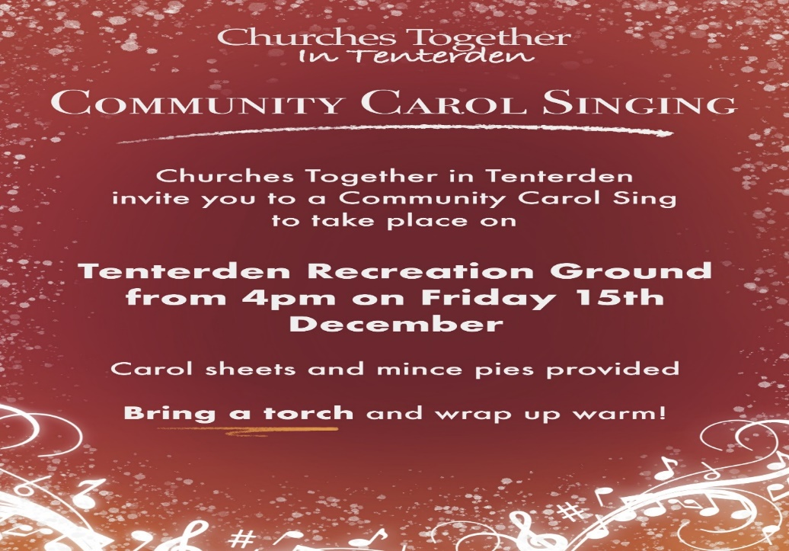
Offers of assistance on the night would be much appreciated, please see Father Behr or Deacon Jolyon

Christmas Tree Festival
Dear Christmas Tree Festival Entrants, November, 2023.
Firstly – a huge THANK YOU!!!! There would have been no festival without your hard work and commitment. We hope you enjoyed yourselves.
Secondly – CONGRATULATIONS!!! Well over 1,300 people came to look at the trees, to hear something of your stories about creating them, and to cast their vote. Some people wrote lovely comments on their voting slips. Some even drew pictures! Everybody said how difficult it was to choose, as each group’s tree had merits for different reasons. This year, the results were all very close!
Thirdly – our chosen local charities: TENTERDEN SOCIAL HUB and THE OLD SCHOOLHOUSE LARDER have benefited from the public donations we received. £926.05 was given in cash over the two days, and we have received some cheques. This means each charity will benefit by approximately £500, which will enable them to help local families and individuals. AMAZING!!!
This year we have awarded two prizes. The overall winner of this fourth Tenterden Christmas Tree Festival is: Rhythm of Life Choir’s “Music – Bringing the World Together at Christmas”. The young people’s group winner is: Rockits Sensory “Doves of Peace”. Well done everyone!!! St Andrew’s came second!
Finally, please give a huge thank you to all the members of your church who helped in welcoming the public, or serving coffee. To see Christians working together was a heartwarming witness which several people commented on.
Wishing you a Blessed and Peaceful Christmas.
THANK YOU ALL, ONCE AGAIN.Suzanne Martin Christmas Tree Festival co-ordinator.

Saint Andrew’s Church came second
Our tree, minus the decorations, which was donated by Hole Park, is now in the Hall lobby. We would be very happy if people would put a decoration on the tree - Fr. Behr is very happy for us to do this!

